DOES INCORPORATING DANCE INTO ELEMENTARY SCHOOL CLASSROOMS INCREASE ACADEMIC ACHIEVEMENT AND ENJOYMENT?

Honors Thesis

Presented in Partial Fulfillment of the Requirements
For the Degree of Bachelor of Education

In the College of Arts and Sciences
At Salem State University

By:
Brittney J. Bythrow

Professor Meghan McLyman
Faculty Advisor
Department of Music and Dance

***

Commonwealth Honors Program
Salem State University
2016

Abstract:
The purpose of this research was to determine if incorporating dance into elementary school classrooms increases academic achievement and enjoyment. Throughout this project, an experiment was done with second graders that supported this idea that by adding dance into classroom lessons, students achieve more. These students scored higher on an assessment after including movement into the lesson. Some of them enjoyed the lessons more with dance and others did not.
Previous research found that dance helps the student learning process due to its ability to meet diverse needs, its effect on the memory, and increase on student engagement. Dance also connects to Bloom’s Taxonomy and Gardner’s Theory of Multiple Intelligences. Student’s with different disabilities have also shown higher academic achievement when dance is used in their classrooms. It helps with attention and stimulating the brain.
Along with this research, four mini units are attached that incorporate dance for teachers to use as examples as to how to incorporate dance into their lessons. These include English Language Arts, Math, Science, and Social Studies lesson made for second graders using Massachusetts State Standards and National Dance Standards for second graders.
Through the experiment, research, and creation of lesson plans, it can be said that incorporating dance into elementary school classrooms increases academic achievement and may increase overall enjoyment.
Acknowledgments:
I would like to thank the Commonwealth Honors Program at Salem State University and the Honors Program faculty for all of their help in this project and throughout my college experience as a whole. They have helped me to become a more efficient and effective learner and a better person. A special thanks to Joanna Gonsalves, the Honors Program Coordinator at Salem State University who helped me discover a procedure to use to carry out this thesis project.
Also, I would like to thank my advisor on this project, Meghan McLyman a professor in the dance program at Salem State University, for guiding me through the organization and ideas for writing this paper. Without her help this would have been a much more difficult process than it was.
I would like to thank the L.D. Batchalder School, Principal Sean Killeen, and second grade teachers Jessica Avila, Jennifer Berry, Katherine Fay, and Kathleen Bythrow for making this research study possible by graciously allowing me to conduct this study in the second grade classrooms.
Lastly, I would like to thank my friends and family for their loving and caring support throughout this process. You have encouraged me along the whole way, not just through this project, throughout my life. I love you all.

Table of Contents:

Abstract…………………………………………………………………………………....1
Acknowledgments…………………………………………………………………………2
Table of Contents ................................................................................................................3
Introduction………………………………………………………………………………..4
Previous Research………………………………………………………………………………...…5
Experiment……………………………………………………………………………….13
Lesson Plans……………………………………………………………………………………...39
Math……………………………………………………………………………...39
English Language Arts…………………………………………………………...44
Social Studies…………………………………………………………………….48
Science…………………………………………………………………………...51
Conclusion……………………………………………………………………………….63
Work Cited……………………………..……………………………………………..….66

Introduction:
The purpose of this study is to discover whether or not incorporating dance into elementary school classrooms increases their academic achievement. Through this study, student enjoyment will also be examined and new ways to incorporate dance into the classroom will be found. The reason for the study is to provide ways to adapt to students’ learning styles and needs. What can teachers do to help students with different learning styles? What are the specific benefits of incorporating movement into the classroom? What parts of dance, besides being physically active, help the students in the classroom? How can we determine if students actually gain more academic success with dance when it is included in classroom lessons?
This thesis began by discussing previous research done on the topic and the possible conclusions that can be made from this research. The classroom study is explained and resources are included. Lesson plans that incorporate dance into teaching methods for mini units are included for math, science, social studies, and English language arts. The conclusion is formed off of the previous research, the experiment, and the creation of dance lesson plans.

Previous Research:
There has been in depth research involving the general benefits of movement and dance itself, as well as the benefits in the academic classroom.
Dance itself is very helpful for children at all ages and stages of development because it advances students’ motor skills; “motor development is the study of ongoing changes to movement abilities that are common to all people, and it looks at these changes through all the stages of life” (Krasnow and Wilmerding). Dance can help with balance, postural control, and much more. It can help students learn basic skills they should develop in their younger years such as walking, skipping, galloping, jumping, hopping, and more.
Dance examines the relationship to movement in space, time, and effort. Space can either be direct or indirect. Either it is a straight path or is flexible and goes in different directions. We can show students that they can move in different ways to get to a destination, not just in dance. Students can explore time whether it’s fast or slow. They can understand that there are certain times when they need to move quickly and other times when they need to move slowly and control their bodies. Effort is the combination of different types of movement; fast or slow, strong or light, direct or indirect, and free and bound. This shows children that they need to figure out how to move their body through life. This can help with sports, schoolwork, and other every day events (What is LMA Glossary, 1).
Incorporating dance and performances in the classroom can help students emotionally and cognitively. Dance helps students express their feelings without expressing it in words. Students who are shy and don’t like expressing themselves verbally can do so through movements with their body. Students who may have increased aggression can also express their feelings in this way instead of lashing out and physically hurting someone. Confidence can also be built. Students who are involved in performing dances in front of even just their own classmates can gain more self-confidence. They will have the experience of doing something in front of their peers and this will help them overcome some of their anxiety (McCutchen, 98-101).
Dance and movement together build classroom community through supportive personal interactions. The students build bonds through new experiences by accomplishing different dance projects while expressing their artistic side. Emphasis can be placed, if the teacher chooses, on the creative process, so it is low stress and students can have fun while working together (Kassing and Jay, 98-99).
Movement and dance are beneficial for elementary school students because it stimulates the brain in ways that prepares them for learning and helps with memory. Incorporating dance into elementary classrooms helps students who are kinesthetic learners. Research has shown how much of an impact dance and movement has had on students with learning disabilities as well.
The brain is strongly influenced by movement and therefore helps students learn. By exercising, more oxygen is brought to the brain, which helps stimulate the thinking process. It also releases dopamine, which helps enhance mood. If students are in a better mood, they are more likely to want to learn and participate in classroom activities. Movement creates more brain cells, which opens up more room for academic information to be stored in their memory (Jensen, 37-41).
There are many ways to incorporate dance into classroom lessons and physical education. Teaching Dance: The Spectrum of Styles by Elizabeth Gibbions discusses the steps to lesson scaffolding, a method where the teacher models, then does the task with students, and then the student does it independently, that can be used in both the dance and academic classrooms: cued response, practice, reciprocal, self-check, inclusion, guided discovery, divergent program-learners design, learner-initiated, and self-teaching (20-22).
Brenda Pugh McCutchen, in Teaching Dance as an Art in Education, says that the six main characteristics of both dance and education are comprehensive, substantive, sequential, aesthetically driven, contextually coherent, and inquiry based. Most lessons in the elementary schools are being taught to include many of these characteristics. Especially inquiry based lessons where students want to know more about what they are learning and are coming up with questions to discover through exploration (McCutchen, 8).
Another reason that dance should be included into elementary school classrooms is that each and every person learns in their own way. Howard Gardner’s Theory of Multiple Intelligences shows eight different learning styles; musical, linguistic, interpersonal, intrapersonal, naturalistic, visual, logical-mathematics, and bodily-kinesthetic. Every student has some of each category however one of them is usually stronger than others for each individual student. As teachers, we cannot possibly fit all of these components into every lesson. But making sure that throughout each unit they are all incorporated is key to meet the needs of all students is important (Dupuis). Dance is mainly a bodily-kinesthetic and a musical intelligence, but can be included in the other intelligences.
Physical dance movement is associated with the bodily-kinesthetic intelligence and when music is used, the musical intelligence. Dance involves linguistics when students listen to directions and teachers use metaphors for describing a movement. By including patterns, sequencing, and counting dance incorporates the logical-mathematics intelligence. It is visual-special by including form, space, direction, and time dimensions. In the sense of the naturalistic view, dancers need to be aware of the world around them to connect it to their dance movements and content. It is interpersonal when students work together and also are aware of their audience. It is intrapersonal when dancers are aware of their own body and movements. This is a way to reach out to those students who learn best in their own ways (Dance and Multiple Intelligences).
Dance and school are also incorporating Bloom’s Taxonomy of thinking. This is the thinking process students go through in order to fully understand something. It moves from knowledge, comprehension, application, analysis, synthesis, and then evaluation. The goal is to get students to this ultimate point of evaluation in which they can make judgments about topics and defend them. It moves from foundational thinking to critical thinking (McCutchen, 265). This is when students have inquisitiveness, open-mindedness, self-confidence, flexibility, produce in suspending judgments, and willingness to reconsider views (Ambrosio, 54). This is used not just in dance, but in the elementary school classroom as well.
Many people have found that dance and movement have helped out especially in children with special needs, ADD, ADHD and other disabilities. The article, How Movement in the Classroom can Help Your Child with Special Needs by Melissa Ferry, describes how our senses are most important to our learning. Therefore, using movement can help students activate senses they would not be using in school otherwise. For example, the vestibular sense is the one that helps us use movement to increase our cognitive processing. The proprioceptive sense is what connects our brain and our body, making them work together. Students with special needs, and many without special needs, have trouble staying in one place at a time and are concentrating on sitting and staying still instead of learning the content being taught. If they are moving their focus can be brought back to the material being taught.
The article, Movement & Inclusion Classroom by Holly Stephenson, discusses how students with special needs should be included in general education classrooms. It explains that teachers need to understand and accommodate needs of these students and have breaks throughout the day. If special needs students are given movement time they will perform much better in these classrooms. Not just these students need these breaks though; all students need breaks. Not even just students, but all human beings eventually need to get up and move around after sitting still for a while. Through dance, students can also be engaged a lot more in the topic. Getting up and moving during a lesson helps with “storage and retrieval” of information. Students also become much more interested in learning material.
Students who are diagnosed with ADD and ADHD often are kinesthetic learners and therefore this is a way to help them focus on what is being taught. It may prevent them from getting in potential trouble for fidgeting, getting up out of their seats, and shouting out. Instead they are able to move around and have the movement breaks to help them learn.
For students with any disability, and for a regular classroom full of students with different learning styles, differentiation in lessons is key. Dance is one way to do this. It speaks to kinesthetic learners and is another tool for all students to use when understanding material. It can also help with attention training. By having students learn movements they practice paying attention to ideas, which will later help them pay more attention to the material (Armstrong).
Dance is making its way into classrooms in a few different ways. One way is through Brain Breaks; they have been being slowly introduced into elementary schools all over the country. Brain Breaks were created by the Healthy Youth Program of the Linus Pauling Institute at Oregon State University and proved that physical activity does truly increase academic performance. When they were first developed, the idea was to have breaks during the school day that lasted about 5-7 minutes (Ore). Often now these breaks are being done in shorter time frames. This only works if they are doing what is suggested in many schools now, having students move after every 20 minutes of sitting and learning. If they are not doing movement this often, the breaks definitely need to be longer than just a minute or two.
The article Energizing Brain Breaks by David Sladkey discusses the main reasons these breaks are good to use. They say that they are fun and get the students engaged and laughing. The brain breaks should include crossing the midline of your body, so that students are activating both sides of their brain. Brain Breaks have also been shown to positively impact student’s emotional states and learning, refocus their neural circuitry, and refresh their thinking, enabling them to find new solutions to the problem (Sladkey).
Along the same idea of Brain Breaks, there is BrainGym. This is a series of twenty-six movements that take about thirty seconds at a time to do. These also incorporate crossing the midline. Teachers have started to create their own movement breaks along these lines as well. Dance movements have often been included into these breaks. (BAHTA Brain Gym 26 Movements).
Even if dance is not being included into the regular education classrooms, it should be taught in physical education classes. There are specific dance standards, set by the Department of Education and the government that mandates dance lessons in P.E. classes have to be taught throughout each year. Often P.E. teachers struggle teaching dance or don’t even really have a unit on it at all. There are many sources out there for them to use and learn from. PE Central is a website that is made to find ideas to match standards that need to be taught in physical education classes. Teachers can use this for step-by-step instruction.
Teaching dance is very important in these classes. It benefits them in many ways such as learning about heath related fitness, balance, coordination, learning about diverse cultures, memory, sequencing skills, self-expression, creativity, cooperation, and teamwork (Williston). One of the ways to incorporate dance into physical education is by teaching all of the different ways you can move such as shake, turn, stretch, fall, rise, twist, skip, pause, jump, drop, swing, and more (Gibbons, 170-171).
Through the research done on this topic of dance being incorporated into elementary school classrooms, it is clearly beneficial in many ways. It helps get students engaged and enjoying the lessons more than if they were just sitting in their seats learning. It is a way for them to get involved and participate, especially if they are uncomfortable verbally participating in the class. Dance is one way that teachers can differentiate their lessons, which helps meet the needs of all students who have different learning styles. It especially helps students with learning disabilities and disorders such as ADD and ADHD because it activates the part of the brain that their body needs. There are many different ways to incorporate dance into classrooms such as through Brain Breaks, including it into specific subject lessons, and physical education class. As time goes on, more and more research is being done on this topic but for right now, a majority of it agrees that incorporating movement into the elementary school classrooms improves academic achievement.

Song and Dance Experiment:
Question: Does incorporating dance into elementary school classrooms improve academic achievement and enjoyment?
Background Information: Researchers have said that getting students active during the school day helps the brain focus and learn better. Many students have trouble sitting still for too long during the day, and movement activities done in school can alleviate this. Classrooms that include movement throughout the day, turns students into active learners versus passive learners who are sitting and listening all day. This keeps students engaged and involved in the lesson.
Hypothesis: Students who have dance and movement incorporated into their lessons in elementary school classrooms will retain and understand more information. Students will enjoy lessons that incorporate movement and dance more than lessons that do not.
Purpose: To determine whether incorporating dance into lessons at school increases academic achievement and enjoyment.
Procedure:
- Get IRB approval
- Ask the four 2nd grade teachers at the L.D. Batchelder Elementary School in North Reading if I can teach for three days a mini science unit to their classes
- Get written permission from the principal
- Have student’s parents/guardians sign a permission slip allowing their child to participate
- Label classes a, b, c, and d
- Create lesson plans/ PowerPoint/worksheets (attached)
- Teach lessons
- Score assessments/collect data
- Analyze data

Data:
Scores with Movement | Scores without Movement | Enjoyment Rating with Movement | Enjoyment Rating without Movement
7 | 5 | Neutral | Least
8 | 5 | Neutral | Neutral
8 | 7 | Neutral | Neutral
9 | 7 | Some | Neutral
9 | 7 | Some | Neutral
9 | 8 | Some | Some
9 | 8 | Some | Some
9 | 8 | Some | Some
9 | 8 | Some | Some
9 | 8 | Some | Some
9 | 9 | Most | Some
9 | 9 | Most | Some
9 | 9 | Most | Some
9 | 9 | Most | Some
9 | 9 | Most | Some
9 | 9 | Most | Some
10 | 9 | Most | Some
10 | 9 | Most | Some
10 | 9 | Most | Most
10 | 9 | Most | Most
10 | 9 | Most | Most
10 | 9 | Most | Most
10 | 9 | Most | Most
10 | 10 | Most | Most
10 | 10 | Most | Most
10 | 10 | Most | Most
10 | 10 | Most | Most
10 | 10 | Most | Most
10 | 10 | Most | Most
10 | 10 | Most | Most
10 | 10 | Most | Most
10 | 10 | Most | Most
10 | 10 | Most | Most
10 | 10 | Most | Most
10 | 10 | Most | Most
10 | 10 | Most | Most
10 | 10 | Most | Most
10 | 10 | Most | Most
10 | 10 | Most | Most
10 | 10 | Most | Most
10 |  | Most
Scores:
Mean score with movement: 95.239%
Mean score without movement: 89.500%
Statistical Difference: .014

Enjoyment:
Mean score with movement: 3.6905
Mean score without movement: 3.4000
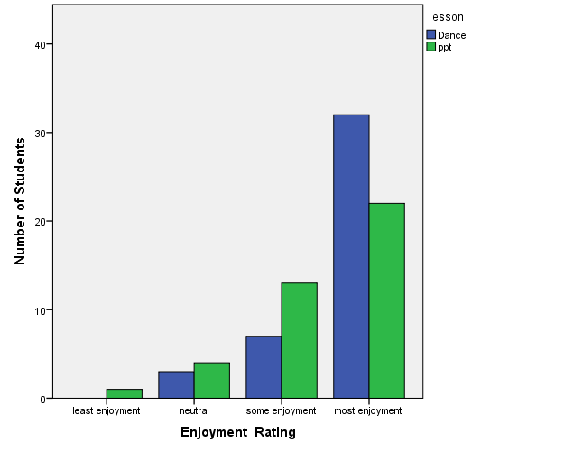
Statistical Difference: .064
Analyze Results: The results show that students who had the lessons with dance and movement averaged higher scores on their assessments. It also shows that students who had the dance and movement lessons enjoyed the lessons the most. Because the statistical difference for the level of enjoyment was .014 it is a significant difference and proves that there was a high level of increased academic achievement in the two classes that had the song and dance in their science lessons compared to the two classes that did not. The statistical difference of enjoyment was only .064 which is not considered a significant difference and therefore it shows that in this study, students did not have too much of an increased enjoyment with the dance being included.
Conclusion:
Based off of this research it can be seen that in this case, lessons that included dance and movement helped students learn information better than those without dance in them. Enjoyment level was not overly higher in the classes that had the song and dance though. This may have occurred for many different reasons. The students in the classes with dance may not have been too outgoing and comfortable moving around and singing. If this type of activity was incorporated more into their school days though, they may become more interested and may actually learn to enjoy dancing. Over time, hopefully the enjoyment would be higher with dance as students got used to it. Also, this was only done with one mini unit and four classes. If the study was done across more subjects, students, and grades the results may have been different. Some examples of how dance can be used in different subjects are included in the following section. If there was more time it would be helpful to do the same type of study with those lessons as well.
Principal Permission for Participation of Students in a Research Study
Salem State University Honors and Education Student
For Honors Thesis
Song and Dance in Education

Description of the research and your students’ participation.
You are invited to participate in a research study conducted by Brittney Bythrow. The purpose of this research is to see the effect of using song and dance in educational classroom lesson.
Their participation will involve learning about butterflies through either a traditional lesson or a song and dance.
The amount of time required for your classroom’s participation will be three 20 minute sessions in a school week.

Risks and discomforts
There are no known risks associated with this research.

Potential benefits
A potential benefit of your students being part of this study may be a better understanding of the transition a caterpillar experiences.

Protection of confidentiality
Your students’ identity will not be revealed in any publication resulting from this study.

Voluntary participation
Participation in this research study is voluntary. You may refuse to allow your students to participate or withdraw your students from the study at any time. Your students will not be penalized in any way should you decide not to allow your them to participate or to withdraw them from this study.

Contact information
If you have any questions or concerns about this study or if any problems arise, please contact Brittney Bythrow at b_bythrow@salemstate.edu or the Institutional Review Board at Salem State University by calling 978.542.7177.

Consent
I have read this principal permission form and have been given the opportunity to ask questions. I give my permission for my students to participate in this study.

Principal signature_______________________________ Date: _________________

Please keep the first page of this so you have a copy of this principal permission form.

Parental Permission for Participation of a Child in a Research Study
Salem State University Sports and Movement Science and Education Student
For Honors Thesis
Dance and Education: A Collaborative Effort

Description of the research and your child’s participation
You are invited to participate in a research study conducted by Brittney Bythrow. The purpose of this research is to see the effect of using song and dance in educational classroom lessons.
Your child’s participation will involve learning about butterflies through either a traditional lesson or a song and dance.
The amount of time required for your child’s participation will be three 20 minute sessions in a school week.
Risks and discomforts
There are no known risks associated with this research.
Potential benefits
A potential benefit of your child being part of this study may be a better understanding of the transition a caterpillar experiences.
Protection of confidentiality
Your child’s identity will not be revealed in any publication resulting from this study.
Voluntary participation
Participation in this research study is voluntary. You may refuse to allow your child to participate or withdraw your child from the study at any time. Your child will not be penalized in any way should you decide not to allow your child to participate or to withdraw your child from this study.
Contact information
Researcher: Brittney Bythrow: b_bythrow@salemstate.edu, 978.793.9669
Institutional Review Board: 978.542.7177
Faculty Advisor: mmclyman@salemstate.edu
Honors Advisor: jgonsalves@salemstate.edu

Consent

I have read this parental permission form and have been given the opportunity to ask questions. I give my permission for my child to participate in this study.

Parent/Guardian’s signature_____________________________

Date: _________________

Child’s Name: _______________________________________

Please keep the first page of this so you have a copy of this parental permission form.

Lesson Plan: Life Cycle of a Butterfly (classes a and b):

I. Setting the Stage:

- Curriculum Framework Standards:

- PREK-2.LS.3: Recognize that plants and animals have life cycles, and that life cycles vary for different living things.
- NDS.K-4. 1: Identifying and demonstrating movement elements and skills in performing dance
- NDS.K-4.3: Understanding dance as a way to create and communicate meaning
- NDS.K-4.7: Making connections between dance and other disciplines

- Generative Topic:
- The main concept for this lesson is life cycles of butterflies-they go through different stages as the change and grow.
- Many of the concepts learned in this lesson can be related to other aspects of science such as learning about other cycles (water cycle, moon cycle, carbon cycle, etc.)
- The concept of cycles can also be connected to cycles in literacy such as poetry cycles, character circles, and format of books.

- Measurable Objectives:

- Students will be able to recognize the stages of a butterfly and understand the metamorphic changes they go through.
- Students will be able to know the different parts of a butterfly and some additional characteristics of butterflies.

- End of Lesson Assessment:

- Students will show how they can relate the song and dance to the concept through discussion.

II. Content of the Lesson

- Content and Skills:
- Underlying principles, concepts, skills, or strategies:
  - Butterflies go through different stages included the egg, caterpillar, chrysalis, and butterfly.
  - Metamorphosis is the change in which they go through
  - The major body parts of a butterfly are abdomen, thorax, head, proboscis, legs, wings, antennae
  - Life span and body temperature of butterflies
  - Moths are their cousins but nocturnal

- Key terms (vocabulary for the lesson)
  - Metamorphosis
  - Egg
  - Caterpillar/Larva
  - Chrysalis/Pupa
  - Butterfly
  - Life Cycle

- Essential Question:
  - What are the stages of a butterfly?
  - What are some characteristics of butterflies?

- Rationale:

  - By learning about the stages of a butterfly’s life cycle, students will be able to better understand our own life cycle as humans.

III. Knowledge of Students:

  - This lesson can be taught to a variety of second grade students who may or may not be at different academic levels.
  - Accommodations can be made to fit each student’s needs.

IV. Preparation for the Procedures:

Materials:

- PowerPoint Slide Show (see attached)
- Projector or Smart Board
- Speakers
- Music: http://www.havefunteaching.com/songs/science-songs/butterfly-song
- Song lyrics with movements written on them (See Attached)
- Review Worksheet
- From Caterpillar to Butterfly by Deborah Heiligman
- Brain Pop Caterpillar/Butterfly Video
- Assessment
- Pencil

V. Sequence of Teaching-Procedures

Day | Beginning | Middle | End
1 | Ask students what they know about caterpillars and butterflies. Discuss what they know about their life cycle and anything else they may bring up. | Show students the PowerPoint and discuss. Have students listen to the song and then teach them the dance to it. Have students practice with the music. | Discuss with students new information they learned that they didn’t know before about caterpillars and butterflies.
2 | Have students fill out the review worksheet and go over with them. | Review the song and dance and go over each part individually. Talk about what the song is saying in those particular parts. | Discuss any questions they have about caterpillars and butterflies. Review information in question and answer form.
3 | Have students complete assessment. | Read From Caterpillar to Butterfly by Deborah Heiligman. Show Brain Pop video. | Discuss connections between book and video.

Lesson Plan: Life Cycle of a Butterfly (classes c and d)

I. Setting the Stage:

- Curriculum Framework Standards:

- PREK-2.LS.3: Recognize that plants and animals have life cycles, and that life cycles vary for different living things.
- NDS.K-4. 1: Identifying and demonstrating movement elements and skills in performing dance
- NDS.K-4.3: Understanding dance as a way to create and communicate meaning
- NDS.K-4.7: Making connections between dance and other disciplines

- Generative Topic:
- The main concept for this lesson is life cycles of butterflies-they go through different stages as the change and grow.
- Many of the concepts learned in this lesson can be related to other aspects of science such as learning about other cycles (water cycle, moon cycle, carbon cycle, etc.)
- The concept of cycles can also be connected to cycles in literacy such as poetry cycles, character circles, and format of books.

- Measurable Objectives:

- Students will be able to recognize the stages of a butterfly and understand the metamorphic changes they go through.
- Students will be able to know the different parts of a butterfly and some additional characteristics of butterflies.

- End of Lesson Assessment:

- Students will show how they can relate the song and dance to the concept through discussion.

II. Content of the Lesson

- Content and Skills:
- Underlying principles, concepts, skills, or strategies:
  - Butterflies go through different stages included the egg, caterpillar, chrysalis, and butterfly.
  - Metamorphosis is the change in which they go through
  - The major body parts of a butterfly are abdomen, thorax, head, proboscis, legs, wings, antennae
  - Life span and body temperature of butterflies
  - Moths are their cousins but nocturnal

- Key terms (vocabulary for the lesson)
  - Metamorphosis
  - Egg
  - Caterpillar/Larva
  - Chrysalis/Pupa
  - Butterfly
  - Life Cycle

- Essential Question:
  - What are the stages of a butterfly?
  - What are some characteristics of butterflies?

- Rationale:

- By learning about the stages of a butterfly’s life cycle, students will be able to better understand our own life cycle as humans.

III. Knowledge of Students:

  - This lesson can be taught to a variety of second grade students who may or may not be at different academic levels.
  - Accommodations can be made to fit each student’s needs.

IV. Preparation for the Procedures:

Materials:

- PowerPoint Slide Show (see attached)
- Projector or Smart Board
- Speakers
- Music: http://www.havefunteaching.com/songs/science-songs/butterfly-song
- Song lyrics with movements written on them (See Attached)
- Review Worksheet
- From Caterpillar to Butterfly by Deborah Heiligman
- Brain Pop Caterpillar/Butterfly Video
- Assessment
- Pencil

V. Sequence of Teaching-Procedures

Day | Beginning | Middle | End
1 | Ask students what they know about caterpillars and butterflies. Discuss what they know about their life cycle and anything else they may bring up. | Show students the PowerPoint and discuss. Read From Caterpillar to Butterfly by Deborah Heiligman. | Discuss with students new information they learned that they didn’t know before about caterpillars and butterflies.
2 | Have students fill out the review worksheet and go over with them. | Show Brain Pop video and complete quiz as a class. | Discuss any questions they have about caterpillars and butterflies. Review information in question and answer form.
3 | Have student’s complete assessment. | Have students listen to the song (link above). Teach them the movements) Practice. | Do the song and dance as a class.

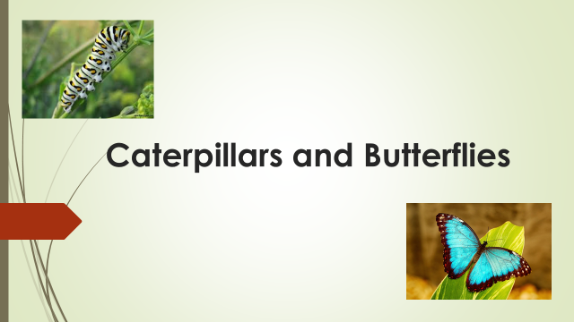
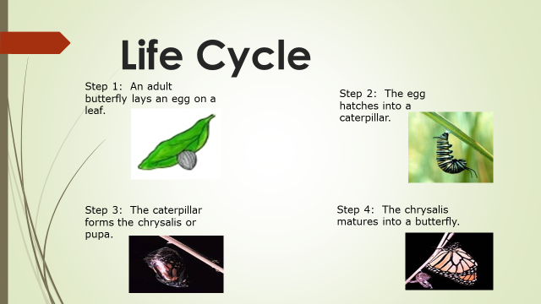
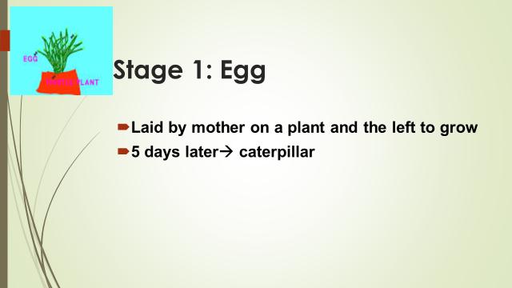
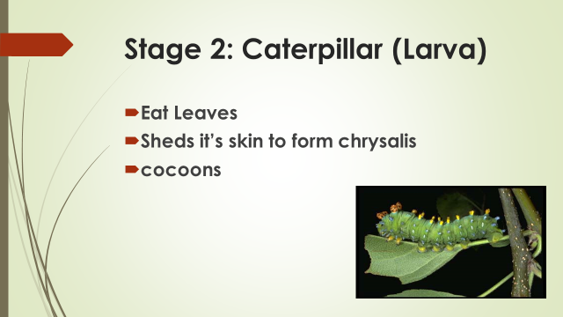
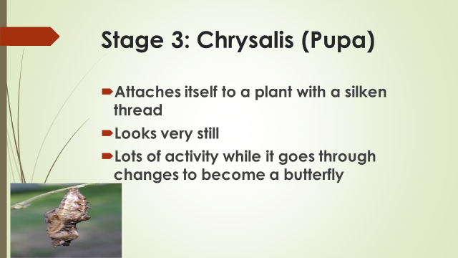
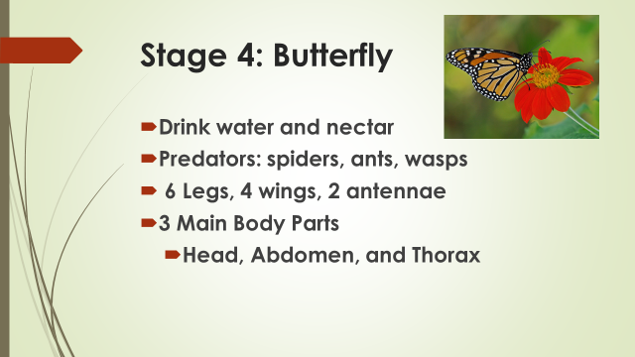
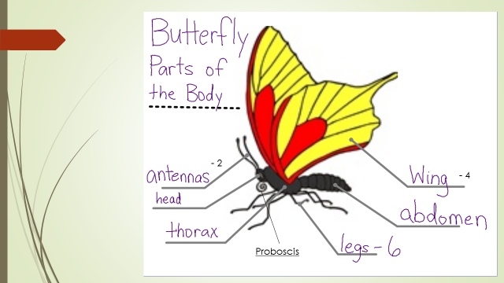
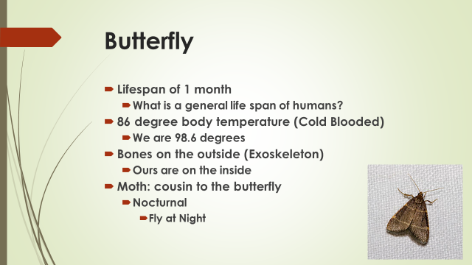
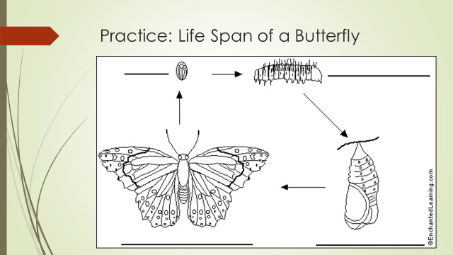
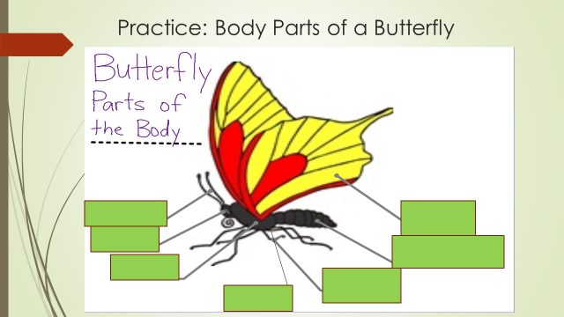

Butterfly Song
http://www.havefunteaching.com/songs/science-songs/butterfly-song
The first stage of a butterfly is the egg (curl into ball)
The second stage is the caterpillar, larva (arms slither up)
The third stage is the chrysalis, pupa (arms straight by side)
The fourth stage is a beautiful butterfly (flap arms as wings)

REPEAT

A butterfly has three main body parts (put 3 fingers out)
They have a head, a thorax, and an abdomen (point to each part of our body)
A proboscis that drinks food from a straw (hand on mouth, pretend to drink something)
Six legs, four wings, two antenna (touch legs, flap wings, put arms over head)

REPEAT

Butterflies drink water and nectar (pretend to drink something)
Eating leaves when they’re growing as a caterpillar (go on ground, pretend to eat)
Spiders, ants, wasps are the predators (crawl, stand up)
Why? Because they like the taste of butterfly (shrug shoulders, flap arms as wings)

REPEAT

The first stage of a butterfly is the egg (curl into ball)
The second stage is the caterpillar, larva (arms slither up)
The third stage is the chrysalis, pupa (arms straight by side)
The fourth stage is a beautiful butterfly (flap arms as wings)

REPEAT

The life span of a butterfly is one month (one, turn)
If it’s flying at night it’s probably a moth (arms in circle as moon above head, pretend to fly)
Butterflies see ultraviolet light (look with hand above eyes)
There are Swallowtails, Brushfooted, Skippers and Whites (point 3 different directions)

REPEAT
Butterflies drink water and nectar (pretend to drink something)
Eating leaves when they’re growing as a caterpillar (go on ground, pretend to eat)
Spiders, ants, wasps are the predators (crawl, stand up)
Why? Because they like the taste of butterfly (shrug shoulders, flap arms as wings)

REPEAT

The first stage of a butterfly is the egg (curl into ball)
The second stage is the caterpillar, larva (arms slither up)
The third stage is the chrysalis, pupa (arms straight by side)
The fourth stage is a beautiful butterfly (flap arms as wings)

REPEAT

A butterfly is a cold-blooded insect (hug self)
They can fly if their temperature is 86 (pretend to fly, put up 8 then 6 fingers)
A butterfly has bones on the outside (touch bones)
Exoskeleton of the butterfly (mime motion)

REPEAT

The first stage of a butterfly is the egg (curl into ball)
The second stage is the caterpillar, larva (arms slither up)
The third stage is the chrysalis, pupa (arms straight by side)
The fourth stage is a beautiful butterfly (flap arms as wings)

REPEAT

Review Worksheet: Caterpillars and Butterflies
Word Bank:
4 Moth Larva Egg Pupa
6 Head Wings Legs Antennae
2 Nectar Spiders Birds Two Months
Butterfly One Month 86 101 55

- There are _______________ stages in the life cycle of a butterfly, the egg, larva,

___________________, and ____________________.

- The three main body parts of a butterfly are the ___________________,

abdomen, and thorax.

- Butterflies have __________ legs, and _____________ antennae.

- Butterflies have four ________________.

- Butterflies drink water and _______________________.

- The lifespan of a butterfly is ____________________________________.

- The cousin to the butterfly that flies at night is a __________________.

- The temperature of a butterfly’s body is _________________________.

What Have You Learned About Caterpillars and Butterflies?
- Which is the correct order of the transitions a caterpillars goes through?
  - Caterpillar lava, egg, butterfly, pupa
  - Egg, caterpillar lava, pupa, butterfly
  - Pupa, butterfly, caterpillar lava, egg
  - Egg, caterpillar larva, butterfly, pupa

- Which is NOT one of the butterflies 3 main body parts?
  - Abdomen
  - Wing
  - Thorax
  - Head

- How long is the life span of a butterfly?
  - 3 Months
  - 1 Year
  - 12 Days
  - 1 Month

- When do moths fly?
  - During the afternoon
  - In the morning
  - At night
  - In the summer

- What temperature can butterflies fly at?
  - 86 degrees
  - 52 degrees
  - 101 degrees
  - 32 degrees

- What do butterflies drink?
  - Water and milk
  - Water and nectar
  - Nectar and milk
  - Nectar and juice

- How many legs does a butterfly have?
  - Six
  - Two
  - Four
  - Eight

Enjoyment of Lesson

- What face represents how you feel about the lesson taught today on caterpillars and butterflies?

Lesson Plan: Math- Geometry/Shape Attributes:

I. Setting the Stage:

A. Curriculum Framework Standards:

    - 2. G.1: Recognize and draw shapes having specified attributes, such as a given number of angles or a given number of equal faces. Identify triangles, quadrilaterals, pentagons, hexagons, and cubes.
    - 2.NDS.K-4.3: Understanding dance as a way to create and communicate meaning
    - 2.NDS.K-4.7: Making connections between dance and other disciplines

B. Generative Topic:

- The main concept of this lesson is attributes that different shapes have and how they define the shapes themselves.
- The concepts taught in this lesson can relate to the science and art frameworks by making observations and looking at information visually.

C. Measurable Objectives:

- Students will be able to identify triangles, quadrilaterals, pentagons, hexagons, and cubes from visual representations.
- Students will be able to know how many angles and sides these shapes have.

D. End of Lesson Assessment:
  - Students will draw any two of the shapes they learned about and label its’ edges and angles.

II. Content of the Lesson

- Content and Skills:

- Geometry
  - Different shapes have different amounts of edges and sides
  - Triangles: 3 edges, 3 angles
  - Quadrilaterals:4 edges, 4 angles
  - Pentagons: 5 edges, 5 angles
  - Hexagons: 6 edges, 6 angles
- Key terms:
  - Angles
  - Edges
- Essential Question: How many edges and angles does each shape have? How do we visualize these terms?

- Rationale:

  - Students can start to realize and look at all the places around them that shapes are being used such as shapes at the playground, in games, t.v, food packages, and more.

III. Knowledge of Students:

  - This lesson can be taught to a variety of second grade students who may or may not be at different academic levels.
  - Accommodations can be made to fit each student’s needs.

IV. Preparation for the Procedures:

Materials:

  - White Board and Markers
  - Math notebooks
  - Pencils
  - Song sheets
  - Review Worksheet
  - Grandfather Tang’s Story by Ann Tompert

V. Sequence of Teaching-Procedures:

Lesson | Beginning | Middle | End
1 | Students with teacher will review what shapes they know. Students will draw and name these shapes in their notebooks while teacher draws them on the white board. | Students will be taught what edges and angles are and look at how many of each are in the following shapes: triangles, quadrilaterals, pentagons, and hexagons. | Teacher will read Grandfather Tang’s Story and look at the different shapes in the story. They will discuss their edges and angles.
2 | Students will complete a review worksheet on the previous lesson. | Students will create shapes with their bodies and determine the angles, and edges of each. | Students will learn the song that goes with the shapes they create with their bodies.
3 | Students will review the song | Students will sing the song and do the movements to travel and make each shape with their bodies together. | Students will draw and label edges and angles of two shapes in which they learned about.

Name: ______________________________________

Review Worksheet:

Shape: __________________
Angles: _________________
Edges: __________________

- Shape: __________________
Angles: _________________
Edges: __________________

- Shape: __________________
Angles: _________________ Edges: __________________

- Shape: __________________
Angles: _________________
Edges: __________________
The Shape Song
To the tune of “Mary Had a Little Lamb”

(March with hands in triangle shape to spots making triangle)
A triangle has 3 edges
3 edges, 3 edges,
A triangle has 3 edges
And 3 angles.

(March with hands switching to make a square -2 sets of parallel lines) to spots making a square)
A quadrilateral has 4 edges,
4 edges, 4 edges
A quadrilateral has 4 edges,
And 4 angles.

(March with hands drawing a pentagon in the sky to spots making a pentagon)
A pentagon has 5 edges,
5 edges, 5 edges,
A pentagon has 5 edges
And 5 angles.

(March with two hands making parallel lines to make a hexagon to spots making a hexagon)
A hexagon has 6 edges,
6 edges, 6 edges,
A hexagon has 6 edges
And 6 angles.

Lesson Plan: English Language Arts- Understanding Texts:

I. Setting the Stage:

A. Curriculum Framework Standards:

- 2. RL. 1: Ask and answer such questions as who, what, where, when, why and how to demonstrate understanding of key details in a text
- 2. RL. 2: Recount stories, including fables, and folklore from diverse cultures, and determine their central message, lesson, or moral.
- 2. RL. 3. Describe how characters in a story respond to major events and challenges
- NDS.K-4.1: Identifying and demonstrating movement elements and skills in performing dance
- NDS.K-4.2: Understanding choreographic principles, processes, and structures
- NDS.K-4.7: Making connections between dance and other disciplines

B. Generative Topic:

  - The main concept of this lesson is plot, characters, and text’s messages.
  - This is connected to fables
  - It can be connected to the social studies curriculum by understanding main people, ideas, and places

C. Measurable Objectives:

  - Students will be able to understand key details of texts, retell stories, and understand characters actions in text through movement

D. End of Lesson Assessment:

  - Students will put on a performance of their mini dance, which will act out the stories they read, to the rest of the class

II. Content of the Lesson

A. Content and Skills:

  - When looking for key details ask who, what, where, when, why and how
  - Morals are the main message an author wants readers to understand from the text
  - Characters act different ways based on events and challenges they face

Essential Question: How can we read texts closely to determine key details of events, characters, and messages and embody them?

B. Rationale:

  - Students can use this unit to pick out main ideas from movies they watch, books they read for fun, conversations they have, etc.
  - Students can start to notice why people in their everyday lives act the way they do by thinking about events and challenges they are going through.

III. Knowledge of Students:

  - This lesson can be taught to a variety of second grade students who may or may not be at different academic levels.
  - Accommodations can be made to fit each student’s needs.

IV. Preparation for the Procedures:

Materials:

  - The Hare and the Tortoise retold by Helen Ward
  - The Ant and the Grasshopper retold by Amy Lowry Poole
  - Donkey Trouble retold Ed Young
  - The Nutcracker (movie and book)
  - DVD Player
  - Main Events Worksheet
  - Pencils
  - Projector

V. Sequence of Teaching-Procedures

Lesson | Beginning | Middle | End
1 | Teacher will go over what a fable is with the students | Students will split into reading groups and read one of the following fables:  The Here and A Tortoise, The Ant and the Grasshopper, and Donkey Trouble and fill out worksheet | Students will come to the rug and discuss their book with the group
2 | Students will be told how stories can be told through movement and dance | Students will read the part of The Nutcracker where the nutcracker is being taken. Students will then watch this part in the ballet DVD of The Nutcracker | Students will be asked to think about how they could represent the story that they read during the previous lesson in movements and discuss as a class
3 | Students will work in their groups to come up with the main ideas/events of their story as they fill out the worksheet | They will create a dance/movement phrase that goes along with each main event and ideas of the story and put them to music of their choice | Students will show what they have to the rest of the class

Name: ____________________________
Main Events
Beginning:
Who:
What:
Where:
When:
Why:
How:

MIDDLE:
Who:
What:
Where:
When:
Why:
How:
END:
Who:
What:
Where:
When:
Why:
How:
Lesson Plan: Social Studies- Traditions and Customs:

I. Setting the Stage:

- Curriculum Framework Standards:

- SS.2.8: With the help of the school librarian, give examples of traditions or customs from other countries that can be found in America today.
- NDS.K-4.1: Identifying and demonstrating movement elements and skills in performing dance
- NDS.K-4.5: Demonstrating and understanding dance in various cultures and historical periods.
- NDS.K-4.7: Making connections between dance and other disciplines

- Generative Topic:

- The main concept of this lesson is traditions and customs, specifically dances from different countries.
- The concept of conducting research can be used in the science and ELA curriculum as well.

- Measurable Objectives:

- Students will be able to determine what dances from other cultures can be seen in America today.

- End of Lesson Assessment:

- Students will explain and perform dances from different cultures and also explain how these dances are also seen in America today.

II. Content of the Lesson

A. Content and Skills:
- Underlying principles, concepts, skills, or strategies
  - There are many different cultural dances from around the world
  - Many of these dances are now being done in America
  - These dances are part of peoples traditions and customs
- Key terms (vocabulary for the lesson)
  - Tango (Argentina)
  - Ballet (Italy)
  - Waltz (Austria)
  - Salsa (Cuba)
  - Irish Step Dance (Ireland)

- Essential Question: What are some dances from other countries traditions and customs that are also seen in present day America?

B. Rationale:

  - By learning about other traditions and customs, students can better understand the people around them who may not share their own traditions and customs
  - Students can see how America has gained some of its traditions from other countries which will help students understand their own culture.

III. Knowledge of Students:

  - This lesson can be taught to a variety of second grade students who may or may not be at different academic levels.
  - Accommodations can be made to fit each student’s needs.

IV. Preparation for the Procedures:

Materials:

- Smart Board/Projector
- Speakers
- Laptop/IPOD
  - Songs and Dances Around the World ". https://www.youtube.com/watch?v=BxuiY9VYVW8
- Variety of books about different dances/cultures (any from the local library should work)
- Computer access

V. Sequence of Teaching-Procedures

Lesson | Beginning | Middle | End
1 | Students will be asked what types of dances they know | Teacher will explain that dance is part of culture and certain dances come from different places in the world. Teacher will give the following as examples:  Tango  Ballet  Waltz  Salsa  Irish Step Dance | Students will watch a video of different cultural dances: (YouTube clip above)
2 | Students will choose which of the dances talked about previously they would like to research | Students will go to the library/look at books/look online and find out as much as they can about the dance they choose and take notes | Students will be asked to learn the basic step of dance (listed above)
3 | Students will practice the basic steps of their dances | Students will get into groups with students who had different dances and share their notes and teach their dance step | Students and teacher will discuss how dance can represent culture and talk about what else represents culture

Lesson Plan: Life Cycle of a Butterfly:

- Setting the Stage:

          - Curriculum Framework Standards:

- PREK-2.LS.3: Recognize that plants and animals have life cycles, and that life cycles vary for different living things.
- NDS.K-4. 1: Identifying and demonstrating movement elements and skills in performing dance
- NDS.K-4.3: Understanding dance as a way to create and communicate meaning
- NDS.K-4.7: Making connections between dance and other disciplines

          - Generative Topic:

- The main concept for this lesson is life cycles of butterflies-they go through different stages as the change and grow.
- Many of the concepts learned in this lesson can be related to other aspects of science such as learning about other cycles (water cycle, moon cycle, carbon cycle, etc.)
- The concept of cycles can also be connected to cycles in literacy such as poetry cycles, character circles, and format of books.

          - Measurable Objectives:

- Students will be able to recognize the stages of a butterfly and understand the metamorphic changes they go through.
- Students will be able to know the different parts of a butterfly and some additional characteristics of butterflies.

          - End of Lesson Assessment:
- Students will show how they can relate the song and dance to the concept through discussion.

II. Content of the Lesson

- Content and Skills:

- Underlying principles, concepts, skills, or strategies:
  - Butterflies go through different stages included the egg, caterpillar, chrysalis, and butterfly.
  - Metamorphosis is the change in which they go through
  - The major body parts of a butterfly are abdomen, thorax, head, proboscis, legs, wings, antennae
  - Life span and body temperature of butterflies
  - Moths are their cousins but nocturnal

- Key terms (vocabulary for the lesson)
  - Metamorphosis
  - Egg
  - Caterpillar/Larva
  - Chrysalis/Pupa
  - Butterfly
  - Life Cycle

- Essential Question:
  - What are the stages of a butterfly?
  - What are some characteristics of butterflies?

- Rationale:

  - By learning about the stages of a butterfly’s life cycle, students will be able to better understand our own life cycle as humans.

III. Knowledge of Students:

  - This lesson can be taught to a variety of second grade students who may or may not be at different academic levels.
  - Accommodations can be made to fit each student’s needs.

IV. Preparation for the Procedures:

Materials:

- PowerPoint Slide Show (see attached)
- Projector or Smart Board
- Speakers
- Music: http://www.havefunteaching.com/songs/science-songs/butterfly-song
- Song lyrics with movements written on them (See Attached)
- Review Worksheet
- From Caterpillar to Butterfly by Deborah Heiligman
- Brain Pop Caterpillar/Butterfly Video
- Assessment
- Pencil

V. Sequence of Teaching-Procedures

Day | Beginning | Middle | End
1 | Ask students what they know about caterpillars and butterflies. Discuss what they know about their life cycle and anything else they may bring up. | Show students the PowerPoint and discuss. Have students listen to the song and then teach them the dance to it. Have students practice with the music. | Discuss with students new information they learned that they didn’t know before about caterpillars and butterflies.
2 | Have students fill out the review worksheet and go over with them. | Review the song and dance and go over each part individually. Talk about what the song is saying in those particular parts. | Discuss any questions they have about caterpillars and butterflies. Review information in question and answer form.
3 | Have student’s complete assessment. | Read From Caterpillar to Butterfly by Deborah Heiligman. Show Brain Pop video. | Discuss Connections between book and video.

Butterfly Song
http://www.havefunteaching.com/songs/science-songs/butterfly-song
The first stage of a butterfly is the egg (curl into ball)
The second stage is the caterpillar, larva (arms slither up)
The third stage is the chrysalis, pupa (arms straight by side)
The fourth stage is a beautiful butterfly (flap arms as wings)

REPEAT

A butterfly has three main body parts (put 3 fingers out)
They have a head, a thorax, and an abdomen (point to each part of our body)
A proboscis that drinks food from a straw (hand on mouth, pretend to drink something)
Six legs, four wings, two antenna (touch legs, flap wings, put arms over head)

REPEAT

Butterflies drink water and nectar (pretend to drink something)
Eating leaves when they’re growing as a caterpillar (go on ground, pretend to eat)
Spiders, ants, wasps are the predators (crawl, stand up)
Why? Because they like the taste of butterfly (shrug shoulders, flap arms as wings)

REPEAT

The first stage of a butterfly is the egg (curl into ball)
The second stage is the caterpillar, larva (arms slither up)
The third stage is the chrysalis, pupa (arms straight by side)
The fourth stage is a beautiful butterfly (flap arms as wings)

REPEAT

The life span of a butterfly is one month (one, turn)
If it’s flying at night it’s probably a moth (arms in circle as moon above head, pretend to fly)
Butterflies see ultraviolet light (look with hand above eyes)
There are Swallowtails, Brushfooted, Skippers and Whites (point 3 different directions)

REPEAT
Butterflies drink water and nectar (pretend to drink something)
Eating leaves when they’re growing as a caterpillar (go on ground, pretend to eat)
Spiders, ants, wasps are the predators (crawl, stand up)
Why? Because they like the taste of butterfly (shrug shoulders, flap arms as wings)

REPEAT

The first stage of a butterfly is the egg (curl into ball)
The second stage is the caterpillar, larva (arms slither up)
The third stage is the chrysalis, pupa (arms straight by side)
The fourth stage is a beautiful butterfly (flap arms as wings)

REPEAT

A butterfly is a cold-blooded insect (hug self)
They can fly if their temperature is 86 (pretend to fly, put up 8 then 6 fingers)
A butterfly has bones on the outside (touch bones)
Exoskeleton of the butterfly (mime motion)

REPEAT

The first stage of a butterfly is the egg (curl into ball)
The second stage is the caterpillar, larva (arms slither up)
The third stage is the chrysalis, pupa (arms straight by side)
The fourth stage is a beautiful butterfly (flap arms as wings)

REPEAT

Review Worksheet: Caterpillars and Butterflies:
Word Bank:
4 Moth Larva Egg Pupa
6 Head Wings Legs Antennae
2 Nectar Spiders Birds Two Months
Butterfly One Month 86 101 55

- There are _______________ stages in the life cycle of a butterfly, the egg, larva,

___________________, and ____________________.

- The three main body parts of a butterfly are the ___________________,

abdomen, and thorax.

- Butterflies have __________ legs, and _____________ antennae.

- Butterflies have four ________________.

- Butterflies drink water and _______________________.

- The lifespan of a butterfly is ____________________________________.

- The cousin to the butterfly that flies at night is a __________________.

- The temperature of a butterfly’s body is _________________________.

What Have You Learned About Caterpillars and Butterflies?
- Which is the correct order of the transitions a caterpillars goes through?
  - Caterpillar lava, egg, butterfly, pupa
  - Egg, caterpillar lava, pupa, butterfly
  - Pupa, butterfly, caterpillar lava, egg
  - Egg, caterpillar larva, butterfly, pupa

- Which is NOT one of the butterflies 3 main body parts?
  - Abdomen
  - Wing
  - Thorax
  - Head

- How long is the life span of a butterfly?
  - 3 Months
  - 1 Year
  - 12 Days
  - 1 Month

- When do moths fly?
  - During the afternoon
  - In the morning
  - At night
  - In the summer

- What temperature can butterflies fly at?
  - 86 degrees
  - 52 degrees
  - 101 degrees
  - 32 degrees

- What do butterflies drink?
  - Water and milk
  - Water and nectar
  - Nectar and milk
  - Nectar and juice

- How many legs does a butterfly have?
  - Six
  - Two
  - Four
  - Eight
Conclusion:
Through this research and the creation of dance incorporated lessons plans it has become clear that students need to be kept moving throughout the school day. It was shown through the caterpillar and butterflies lesson that when students have dance incorporated into their classes they score better on assessments and remember more information. In the future, more extensive testing will be conducted with other mini and larger lessons to see if the results are similar.
Using the information from the second grade class experiment and previous research, creating lessons that include dance seemed like the next step. Right now there are many movement activities for teachers to use during student breaks, but not much is written on how to specifically connect it into the curriculum being taught in the elementary school classrooms. If the material isn’t accessible to teachers they will not know how to bring it into their lesson plans. If these lessons are created already though, teachers will most likely be much more willing to get their students moving with dance in the regular classroom lessons.
These four lesson plans that are provided are a starting point. There are many more possibilities for dance and movement to be used. Hopefully, school curriculum programs will have the opportunity to examine this work, along with similar research, and start to include them into their written curriculum. For example, programs like EnVision Math and Know Atoms Science could keep their current curriculum ideas, but add additional lessons or adapt ones already created in order to incorporate movement and dance. If this is done by specific curriculum groups, teachers can not only use those, but then have examples to create their own lessons with dance integration.
Another way to educate teachers would be to offer professional development programs centered on dance in the classroom. There is a wide variety of professional development such as integrated curriculum training, internet use, journaling and more (The Alberta Teaching Association). A specific training program could be created to help teachers understand the importance of dance, the ease of incorporating dance into a lesson, and how the students respond to dance in the classroom. Many teachers do not necessarily have a dance background and a program such as this could help make them more comfortable and less likely to shy away from the idea. Offering this training to teachers will encourage dance in the classroom resulting in an increase in student scores and achievement.
Due to these findings, it also could be said that the government could consider enforcing the National Dance Standards into elementary schools. Yes, some dance is taught in physical education classes, but this is not enough. For example, in grades kindergarten to fourth, there are seven main standards that can easily be brought into other subjects without too much trouble.
In an ideal world, every unit being taught in schools would have some sort of dance portion to it. Whether it be big or small, it will help students learn information, focus, be more engaged and overall better learners. Also, each day students would not need to sit still for more than twenty minutes a day. Honestly, one of the best things that could be done is to eliminate the “at desk doing worksheets” approach to learning altogether. Students need a variety of ways of learning. Why have students sit still all day when they can learn just as well if not better using different methods including dance movement?
Overall, the goal for the future is to get students moving. Movement is what we do as humans. It is a natural instinct of the body. Who is better to show us this than elementary schoolers themselves?

Works Cited:
Armstrong, Thomas. ADD/ADHD Alternatives in the Classroom. Alexandria, VA: Association for Supervision and Curriculum Development, 1999. Print.
"BAHTA Brain Gym 26 Movements." BAHTA Brain Gym 26 Movements. N.p., n.d. Web. 04 Oct. 2015.
"Balancing the Needs of All Students in an Inclusive Classroom." Cases for Teacher Development: Preparing for the Classroom (2005): 161-78. Web. 4 Oct. 2015.
"Dance Units in Physical Education Can Help Academic Achievement - Dance Units for Middle School Students." Human-kinetics. N.p., n.d. Web. 04 Oct. 2015.
"Differentiation through Multiple Intelligences." Minds in Bloom. N.p., 04 Nov. 2014. Web. 27 Nov. 2015.
"Energizing Brain Breaks." Energizing Brain Breaks. N.p., n.d. Web. 04 Oct. 2015.
"Energy and Calm: Brain Breaks and Focused-Attention Practices." Edutopia. N.p., n.d. Web. 04 Oct. 2015.
"5 Creative Ways to Help Students With ADHD Thrive in the Classroom." 5 Creative Ways to Help Students With ADHD Thrive. N.p., n.d. Web. 04 Oct. 2015.
Gibbons, Elizabeth. Teaching Dance: The Spectrum of Styles. Bloomington, IN: AuthorHouse, 2007. Print.
"How Movement in the Classroom Can Help Your Child with Special Needs." Friendship Circle Special Needs Blog. N.p., n.d. Web. 04 Oct. 2015.
Kassing, Gayle, and Danielle M. Jay. Dance Teaching Methods and Curriculum Design. Champaign, IL: Human Kinetics, 2003. Print.
McCutchen, Brenda Pugh. Teaching Dance as Art in Education. Champaign, IL: Human Kinetics, 2006. Print.
"Membership." Strategies to Empower, Not Control, Kids Labeled ADD/ADHD. N.p., n.d. Web. 04 Oct. 2015.
Meyer, Fran Anthony. Implementing the National Dance Education Standards. Champaign, IL: Human Kinetices, 2010. Print.
Mirochnik, Elijah, and Debora Claiborne Sherman. Passion and Pedagogy: Relation, Creation, and Transformation in Teaching. New York: P. Lang, 2002. Print.
"Movement & Inclusion Classrooms." GoNoodle Blog RSS. N.p., n.d. Web. 04 Oct. 2015.
"News & Research Communications." "Brain Breaks" Increase Activity, Educational Performance in Elementary Schools. N.p., n.d. Web. 04 Oct. 2015.
Overby, Lynnette Young., Beth C. Post, and Diane Newman. Interdisciplinary Learning through Dance: 101 Moventures. Champaign, IL: Human Kinetics, 2005. Print.
"PD Activities for Professional Growth." The Alberta Teaching Association. N.p., 2016. Web. 4 Jan. 2016.
"Physical Education: PE Central's Dance Lesson Ideas and Plans." Physical Education: PE Central's Dance Lesson Ideas and Plans. N.p., n.d. Web. 04 Oct. 2015.
Skoning, Stacey. "Movement and Dance in Early Childhood." (2003): n. pag. July 2008. Web. 4 Oct. 2015.
"Songs And Dances Around The World." <i>YouTube</i>. YouTube, n.d. Web. 08 Jan. 2016.
Veevid4u. "Songs And Dances Around The World." YouTube. YouTube, 12 Sept. 2011. Web. 27 Mar. 2016.
"10 Tips for Teaching Dance." SPARK PE. N.p., n.d. Web. 04 Oct. 2015.

