PIVOTAL TRANSITION – A WOMEN’S SKATEBOARDING DOCUMENTARY

Honors Thesis

Presented in Partial Fulfillment of the Requirements
For the Degree of Bachelor of Science in Media & Communication

In the College of Arts & Sciences
at Salem State University

By

Maya Volpacchio

Prof. Peter Oehlkers
Faculty Advisor
Department of Media & Communication

***

Commonwealth Honors Program
Salem State University
2020

Abstract
This documentary examines the current state of women’s skateboarding during a pivotal time in the industry. Social media has allowed what was once a small, marginalized community to blossom into something much greater. In addition, the induction of skateboarding into the next Summer Olympics places the sport at an interesting crossroads. I begin with a personal reflection of my own journey in skateboarding, acknowledging how the lack of visibility for women and the male dominance made participating in the sport intimidating and difficult. I transition to talk about how once I began meeting other women skateboarders and building a network of friends, it allowed me to find a sense of belonging in a community that was diverse, encouraging, resilient and inspiring. Through eleven formal interviews, including two with professional skateboarders, I discover through the skater’s perspective what makes the women’s skateboard community unique, what barriers women in skateboarding still face, and where women’s skateboarding stands today. I address the gender divide that exists in skateboarding, and I gather various perspectives on what further changes will help to erase the gender divide and further equality in skateboarding. My interviewees discuss where they see skateboarding going in the years to come and how the Olympics will impact the sport. Finally, each woman discusses the greatest thing they’ve gained from skateboarding and what makes them continue. The documentary is accompanied by three montages of skateboarding clips and original music by the artist Jaguar Sun.

Table of Contents

Abstract………………………………………………………………………………... i Introduction……………………………………………………………………………. 1
The Filming Process…………………………………………………………………… 2
The Editing Process….…………………………………………………………….…... 7
Conclusion……….……………………………………………………………………. 10

Introduction
During the spring semester of 2020, the time I had been fearing since transferring to Salem State University arrived. It was time to develop a proposal for my Honors Thesis. While I didn’t know at first what form the project was going to take, when I learned that we could take on a creative project instead of writing the traditional research paper, my fears lessened. I wanted my thesis to be something I was passionate about, so it was no question for me that it would be about skateboarding, my greatest passion in my life. But I didn’t want to focus on skateboarding alone. I wanted my thesis to center on the community that allowed me to find a sense of belonging in the world, the women’s skateboarding community.
As a Media & Communication major, I have a strong interest in film, and the idea formed in my head that I could create a documentary about women’s skateboarding. I felt that film would be the perfect medium to communicate the impact that skateboarding has had on my life. Furthermore, I thought it would be powerful to have the voices of other females be heard, allowing them to express in their own words what challenges they experience from being a woman in the sport and what skateboarding means to them. I also realized that there hasn’t been a recent full-length documentary on women’s skateboarding. The last one was Underexposed in 2014, and a lot has changed for the industry since then. None of us are experts or know what is going to happen in the future of skateboarding; we can only speak from our own observations and personal experiences. But having a collection of varied perspectives allows each individual’s uniqueness to shine through, while also creating an undercurrent of unity.
By May, I had my proposal written for the documentary I hoped to produce over the summer and fall. It looked great on paper, but I was dubious for a couple months about how I would be able to complete the project, especially with the ongoing pandemic. I had plans for places I wanted to film and people I wanted to interview, but these plans had to be flexible given the state of the world. I had made plenty of videos in the past, but this documentary would be my most ambitious undertaking to date.

The Filming Process
Once I had my proposal, the rest of the documentary was all on me. There are so many little pieces that went into the project to allow it to come together. The first thing I had to figure out was what I was going to film with. The only camera equipment I owned that was of value to me was my tripod and a handheld grip for filming skateboarding. I didn’t own a video camera and it wasn’t in my budget to buy one. I asked one of my best friends to borrow his Canon Eos 60d, that he had never used before. The battery charger was missing from the box so I had to buy that in order to start filming. There was a learning curve with figuring out how to use the camera. I had some experience shooting photos with DSLR cameras, but I hadn’t filmed video with one in years. A few days were spent testing out the camera and learning how to operate it. I also realized I would need a lavalier microphone for the interviews, because the audio quality on the 60d was subpar. The microphone and battery charger were the only purchases I made to make the film. I produced the entire film on no budget.
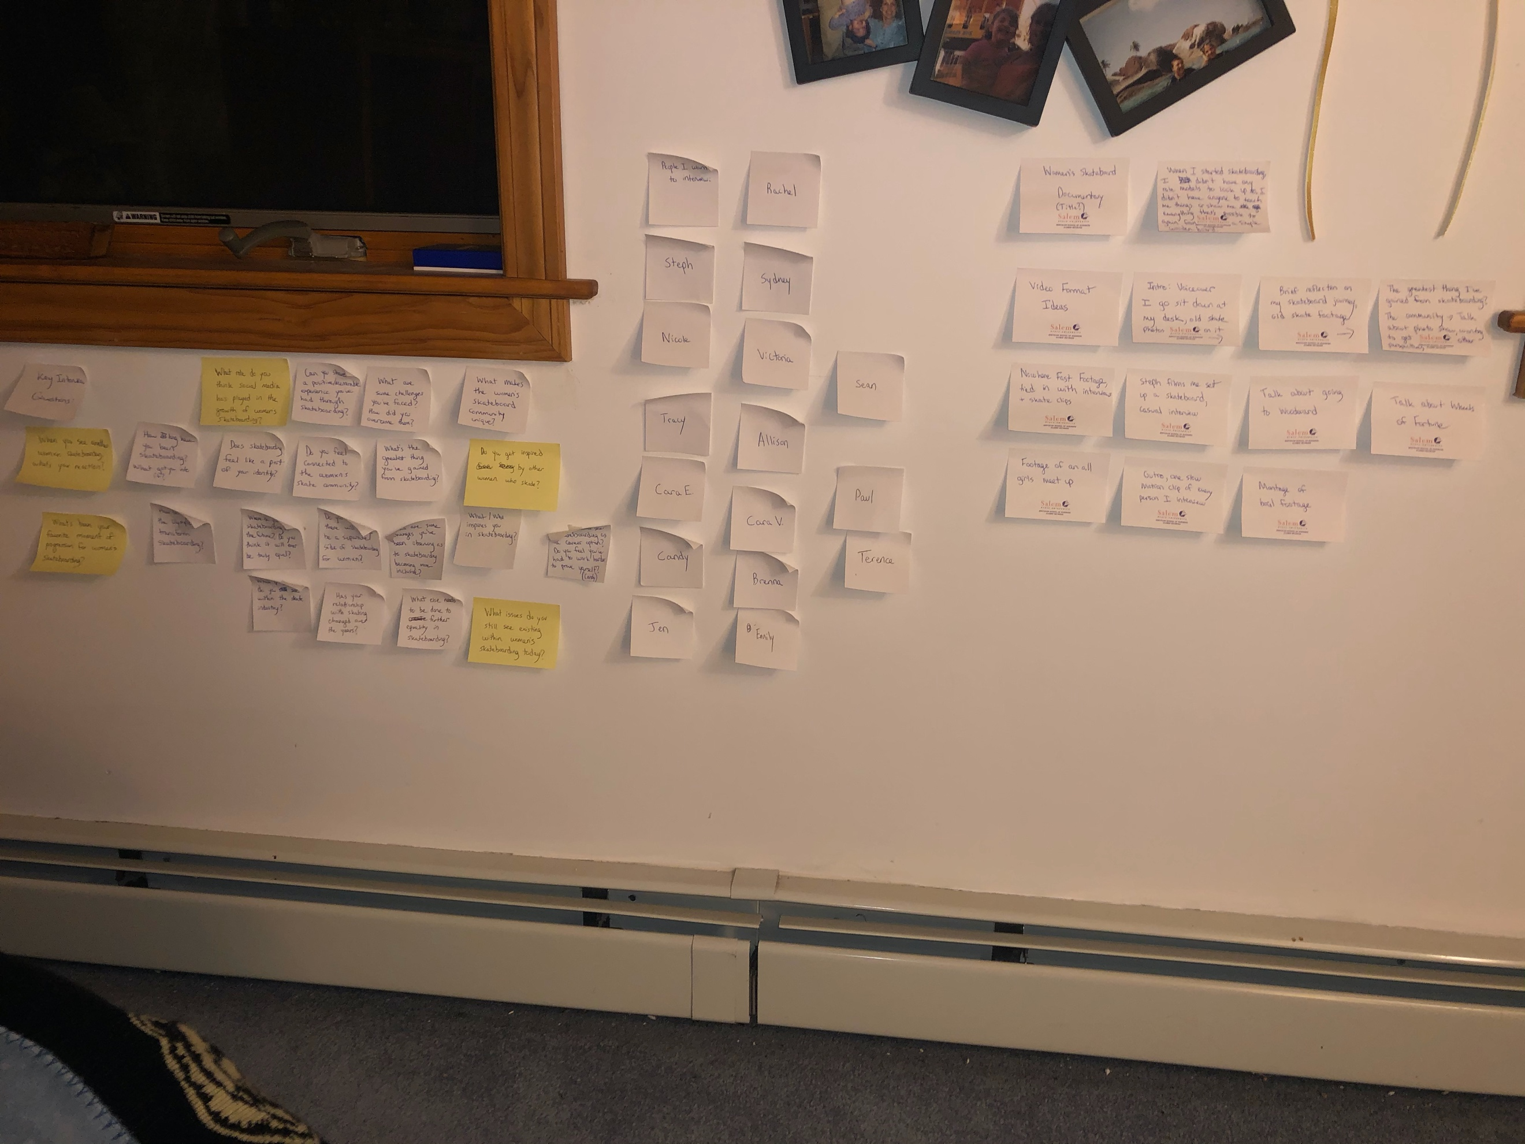
I wanted to start working on the documentary as soon as possible because I knew that it was going to be a long journey to the finish. However, the whole month of May we were still in quarantine and public skateparks were closed. I avoided seeing my friends for the sake of our health and safety. I spent most of the month trying to envision what I wanted my documentary to look like. Storyboarding was one thing that helped my ideas start to flow. I took sticky notes and placed them on my wall, separating them into three categories. I wrote out all the interview questions I could think of, the names of the potential people I could interview, and ideas for formatting/different scenes and sections of the documentary. Although this helped me create a picture in my mind of the finished product, it was hard to envision exactly what it could be because I hadn’t filmed anything yet.
My storyboard on my bedroom wall

During the month of May I received some disappointing news. I had been planning to work for Skate Like a Girl in Portland, OR for a month during the summer, and I wanted to film a decent portion of footage there for the documentary. The organization decided to cancel camp for the summer because of the pandemic. This left me without any summer plans. My backup plan was to work at Camp Woodward in Pennsylvania. I had worked there for a few summers prior, and I reached out to the hiring manager to see if there were still positions available. Thankfully, they were still hiring and I agreed to work for three weeks. Woodward made the decision to run camp, but they were only allowed to be at fifty percent capacity and there were many new rules in place to keep campers and staff safe. We didn’t have to wear masks if we were skating or in our living quarters, but we did when we were within six feet of someone or indoors. Leading up to leaving for camp, I prepared my interview questions, gathered my first few skate clips and filmed my first interview with my friend Steph. Before heading to Pennsylvania, I drove down to New Jersey to stay with my mom for a week. I filmed another interview there with my friend Victoria. I was finally gaining some momentum and feeling more confident in what I was creating.
My experience working at Woodward was different from any other summer I had been there, mostly because we were working in the midst of Covid-19. There I was in the Pennsylvania countryside, unaware of what was happening in the rest of the world. I wasn’t watching the news; I didn’t know what was happening back home. I was living in a little bubble and it felt surreal. A few of my good friends were also working at camp, and we were each other’s support system through those uncertain times. There were a few reported COVID cases while we were at camp, but we were not told who it was or given much detail due to privacy practices. COVID aside, this summer was the most fun I’ve ever had at Woodward, and it was thanks to my friends. I filmed a bulk of my skateboarding footage with my friends Susie and Allison, both of whom I interviewed. The Digital Media program had been cancelled for the summer, and no one was making use of the facility. I spoke with one of the camp photographers and he helped me set up professional lighting in the studio to interview Susie and Allison.
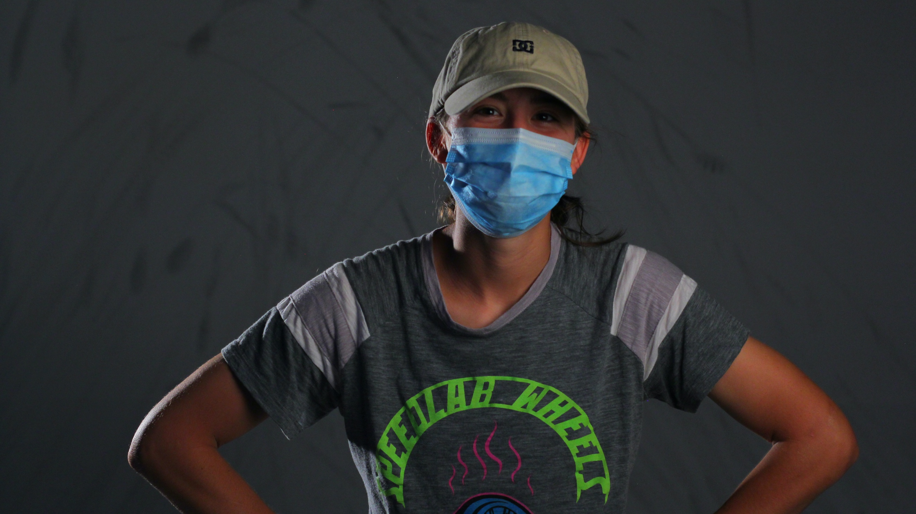
Setting up for Susie’s interview

I also filmed the outro shot to my documentary, in which Susie, Allison, and my friend Cara skated towards me as I filmed out the back of my Subaru with the trunk open. It was a one take shot and one of my favorites in the entire film. If it weren’t for Woodward and the support of my friends, finishing the documentary would have been significantly more challenging.
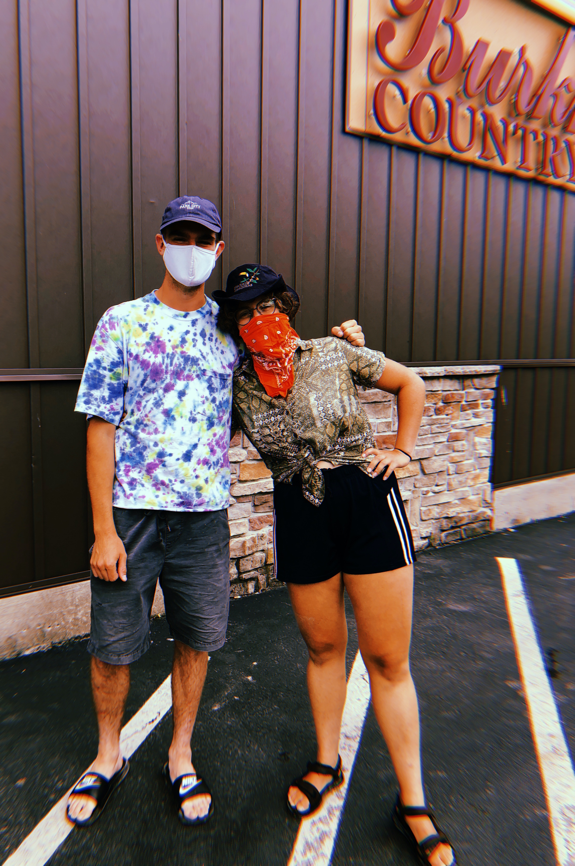
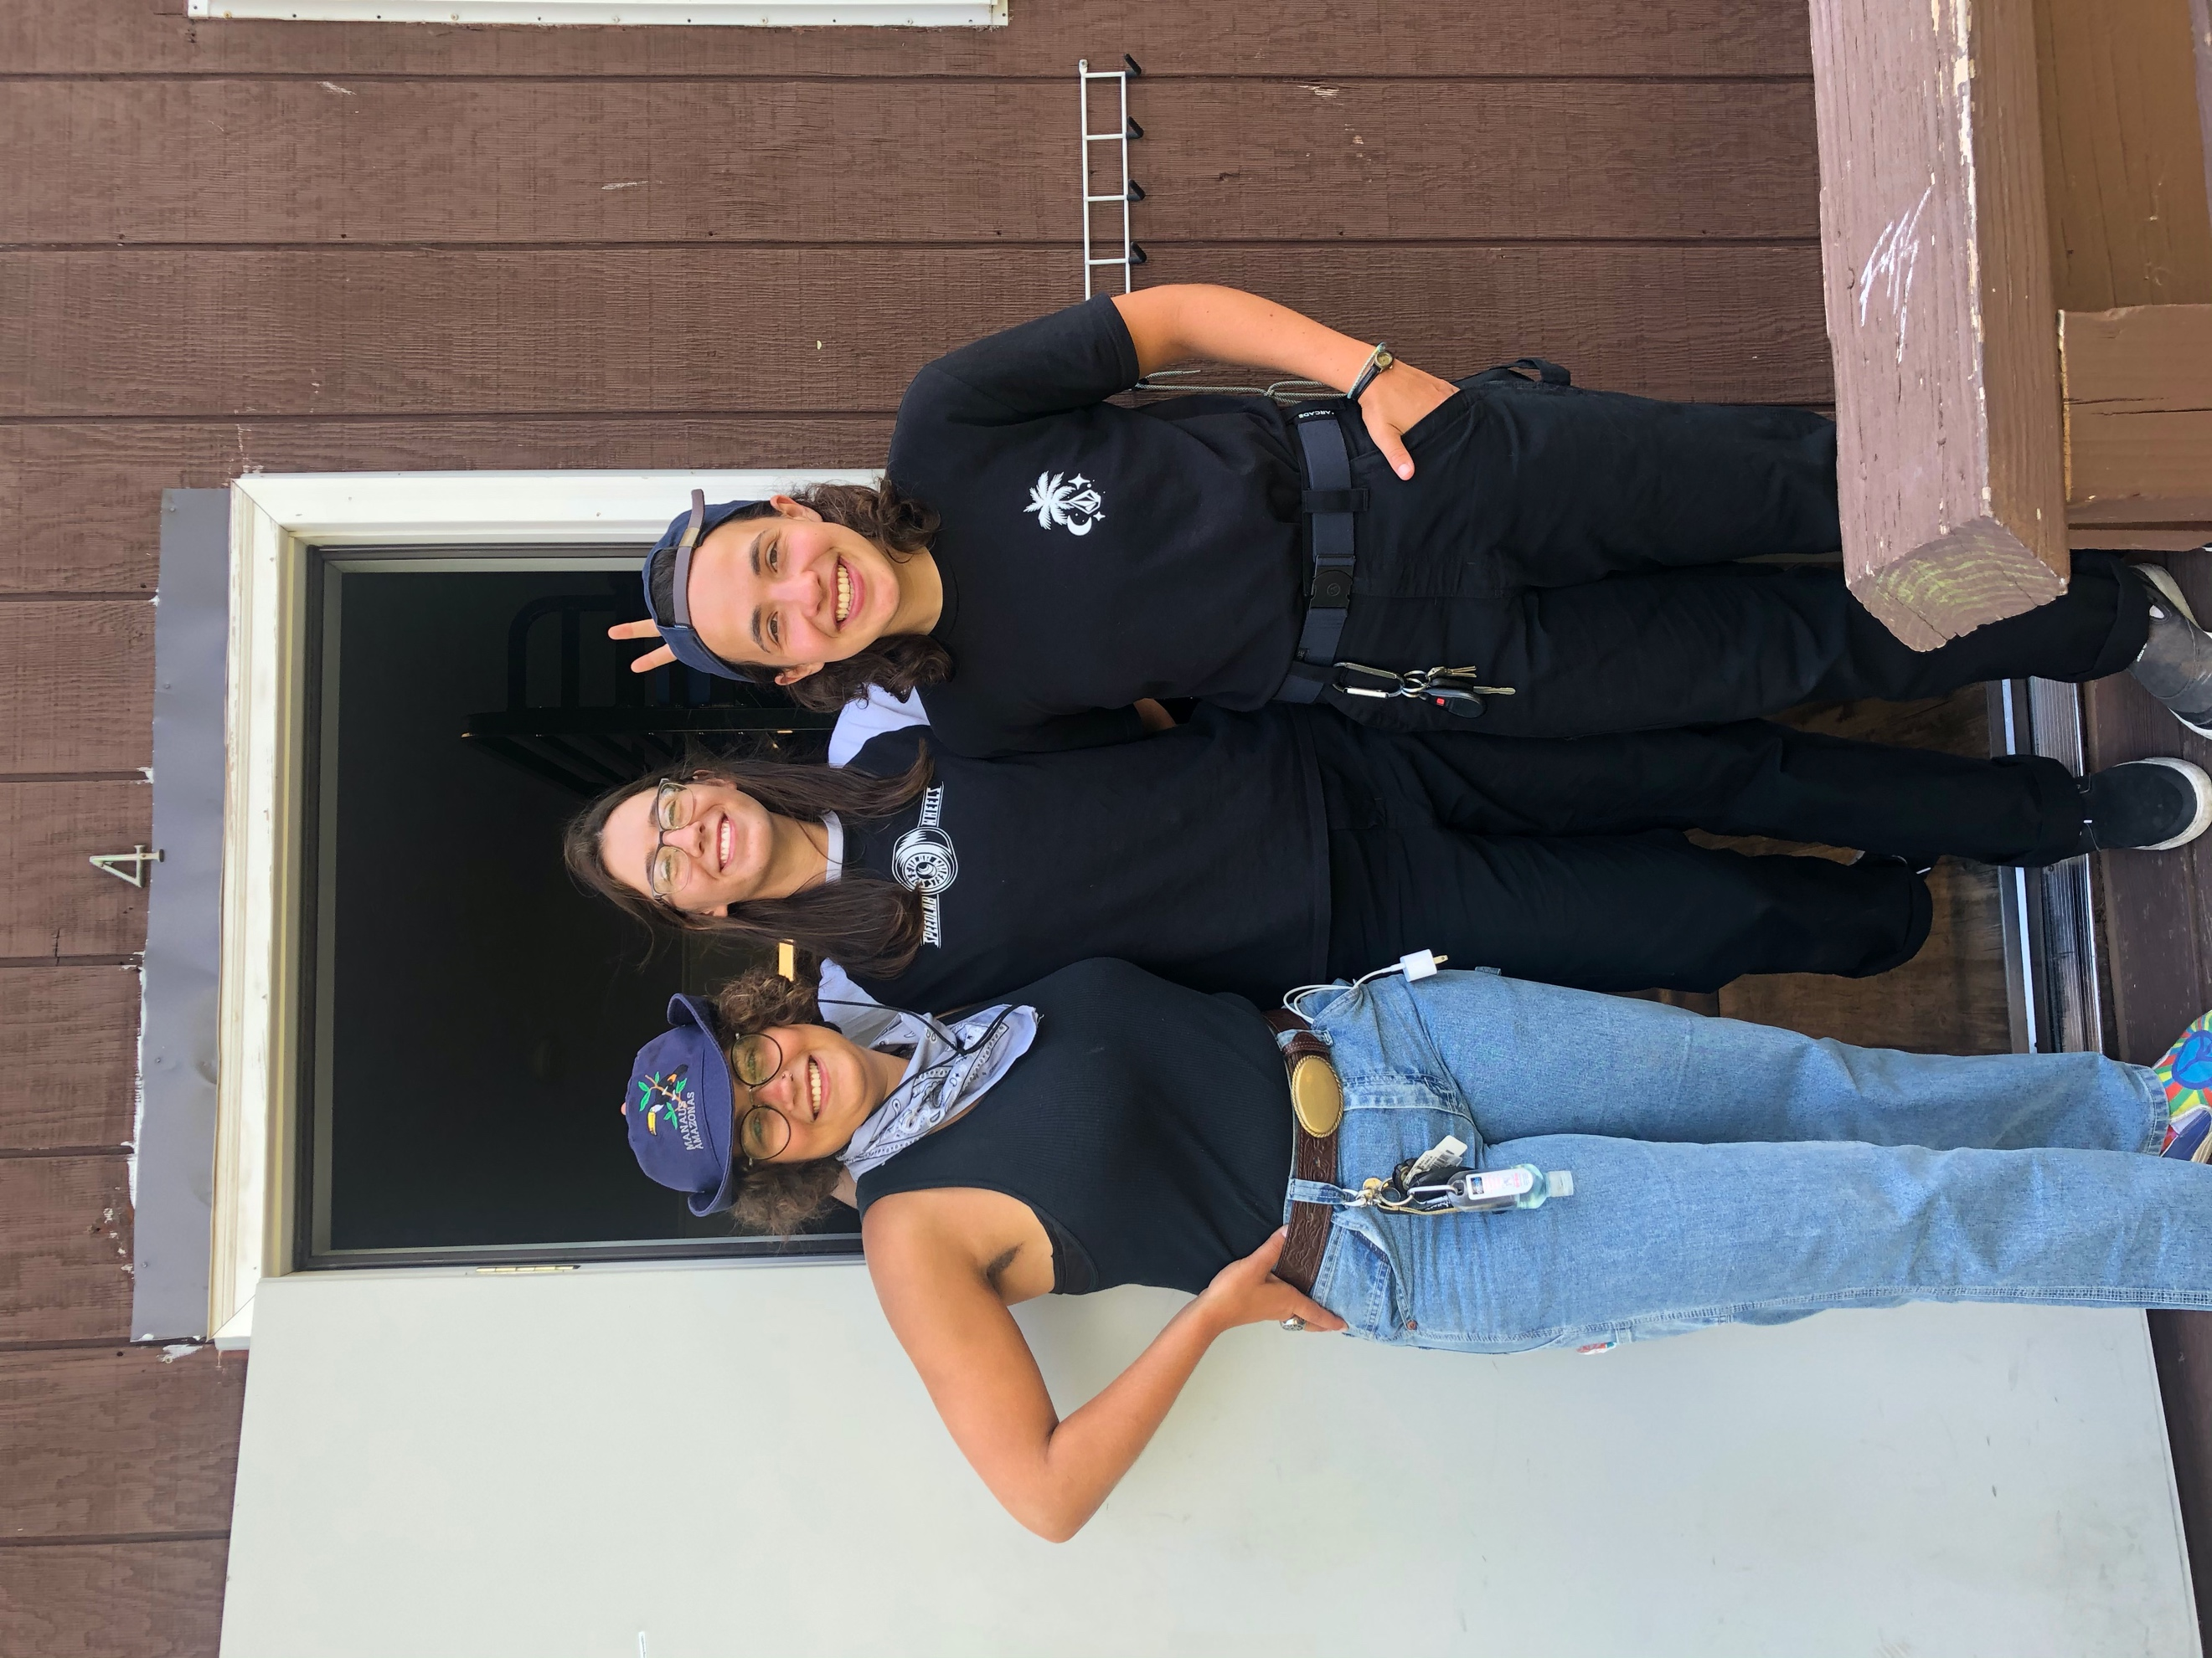
Woodward Friends

I returned from Woodward the first week of August, knowing that I still had to complete the majority of my interviews. During August and September, I filmed five more interviews and continued gathering footage to use as b-roll. As I collected footage, I couldn’t help but begin to edit it. The first clip I filmed was actually one of the last ones in the documentary, so it’s interesting how things take shape over time. While I wanted all of my interviews to be filmed in-person, I also wanted to get perspective from a couple different female professional skateboarders. I asked my friend Candy from the Netherlands and Annie from Canada if they would be willing to do an interview over Zoom. I had to remind Candy a few times, but they both came through and I am indebted to them for taking the time to talk with me. Getting input from professionals felt like the icing on the cake, and I knew it was going to help my documentary stand out that much more.
I put off filming my self-reflection until mid-September. I debated writing out what I wanted to say, but I wanted it to feel authentic and unscripted. I finally sat down at my desk one Saturday afternoon and spoke for 12 minutes, spilling all of the feelings I had about women’s skateboarding and the connection I feel to it personally. I’m honestly glad I waited until I had filmed the rest of the interviews before I did my own. It gave me a sense of closure before I moved on to post-production. I had to accept that at a certain point, I was done filming. I could keep interviewing and filming, but there was only so much that I could fit into a short documentary.

The Editing Process
I did some editing over the summer, but it wasn’t until late September that I jumped head first into it. In addition to the interviews, I wanted to have a few montages of only skateboarding clips. But before I could edit anything, one of the biggest factors I had to decide on was music for the documentary. I didn’t want to use royalty free music because I didn’t think it would fit with the feel I wanted my film to have. One artist’s music came to mind, and he released his first full-length album over the summer. The timing was perfect. The artist is Jaguar Sun, who I originally discovered in December 2018 on Spotify. At the time, he didn’t have many fans but I loved his music and reached out on Instagram to tell him. We’ve been following each other ever since and I sent him a message with a short segment I edited using one of his songs. I told him about the documentary and asked if he would be okay with me using his music. He loved the idea and sent me the downloads to all of his songs! When it comes to film, music is one of the most essential elements that makes or breaks it, in my opinion. Using music that was meaningful to me was something I valued, and being able to use Jaguar Sun’s music made me really excited to finish my documentary.
Editing a project of this scale was something new to me. One of the first problems I encountered was running out of storage space on my computer. I had to purchase an external hard drive to edit with and store all my video files on. In my proposal, I originally planned to have the documentary run between 10-20 minutes. Well, I realized halfway through that this time estimate was unrealistic if I were to address all the questions I wanted to. The finished documentary is 32 minutes long. Although it ended up being longer than I intended, the length felt right. I crafted the narrative that I wanted to, I had plenty of skateboarding footage, and I was able to include input from all of the women that I interviewed.
There were several times during the editing process that I felt stuck. Finding the editing flow was something that came and went in spurts. Some days I got a lot of editing done and other days I struggled. What helped me was taking some time away from the project in order to have a fresh perspective on it. One of the hardest parts was sorting through all the interview footage. That’s where organization was key. I tried to keep all of my video files organized in separate folders on my hard drive so that I could easily locate things. However, I still had a massive amount of footage and it was tedious at times to find certain files.
Before I could incorporate the interview footage into the rough draft, I had to piece together the clips from each interview. I watched through every interview and flagged specific parts that I thought I might be able to use in my film. After that, I wrote down the questions I wanted to address in the documentary. Out of the 20-something questions I asked each interviewee, I identified eight that I wanted to include. During the editing process, I received helpful suggestions from one of the employees at my internship with Salem Access Television. He had past experience making a couple documentaries, and he suggested that I find the answer to a specific question from every person I interviewed and put all of those answers together. That way, I could quickly sort through the answers to one question and decide what responses I wanted to use.
Editing my documentary felt like putting a puzzle together. Sometimes pieces would sort of fit, but it wasn’t right so I would have to move them somewhere else. Once I had the rough draft done, it was a huge relief for me. Creating this documentary from nothing, from an idea, fueled me to keep going. Even after the rough draft was done, I spent countless more hours fine-tuning it. This included things like titles, captions, color correction, audio and credits. I had a beginning, middle, and outro montage of skateboard footage, but I also looked through all of my footage again to put b-roll over some of the talking. This made the film more engaging because the skating was interspersed throughout and there weren’t huge blocks of just talking. Aside from the main project, I decided to make a one-minute trailer to promote the film before its premiere. Making a short trailer from a 32-minute documentary also proved to be a challenge. But, I persevered and managed to create a trailer that built the perfect amount of suspense for the real film.

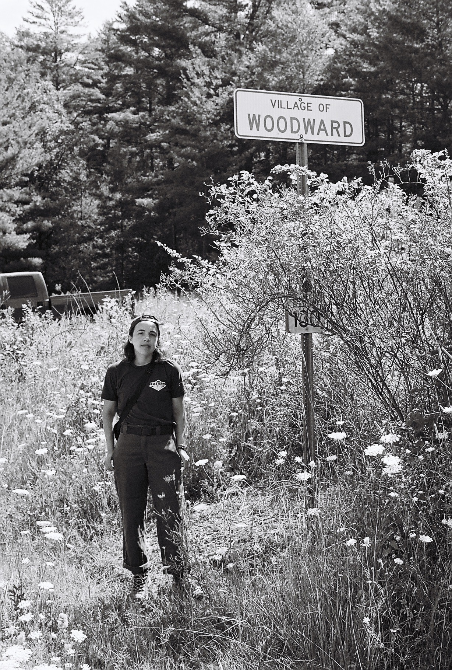

35mm film photo from just outside Camp Woodward

Conclusion
Making a documentary from start to finish is one of the most rewarding things I’ve ever done. I’m extremely proud of the work I put in. I truly believe I’ve created a work of art, in film form. I’ve captured the current state of women’s skateboarding, raising awareness of the struggles that women in skateboarding still face and suggesting changes that can be made to further equality in skateboarding. Not only will skateboarders watch my film; A much wider audience will be able to view it and I hope that they can learn something from it. Throughout the entire process, I struggled with self-doubt about what I was doing. Will people like it? Are there things that people will disagree with? I fear criticism. I know that it’s my first film and it will never be perfect. No matter how many times I watch it and little changes I make, there will likely be small things that I still notice. However, I remind myself that most people won’t notice the things that I see. What matters is the whole, and I’m proud of the whole. If I could change one thing, I would have interviewed a couple female skaters of color. All of the women in my film are white with the exception of one, and this doesn’t reflect the full diversity of women skateboarders that are out there. That being said, I did what I could in the time that I had. Making this film has inspired me to keep creating and filming. I want to make more documentaries, and that leaves me room for improvement in future projects.
At the time of writing this, it’s a little more than a week before the premiere. I’m a little nervous about sharing my work, but I’m more excited and eager than anything. Until I shared my trailer a couple days ago, no one aside from my friends knew what I was creating. Sharing my documentary with people will be the ultimate reward for the journey I went on. COVID may have shifted some of my plans, but I wouldn’t change anything about the decisions I made and the way I navigated the difficulties I faced. I’m ecstatic to share Pivotal Transition-A Women’s Skateboarding Documentary with the world.
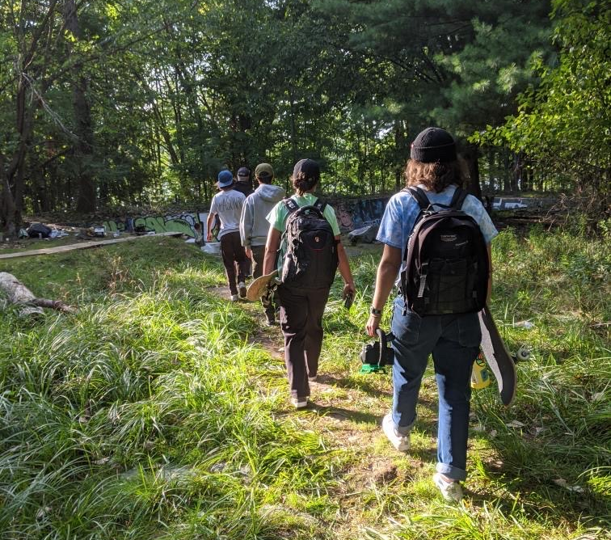

Filming mission in Albany, NY
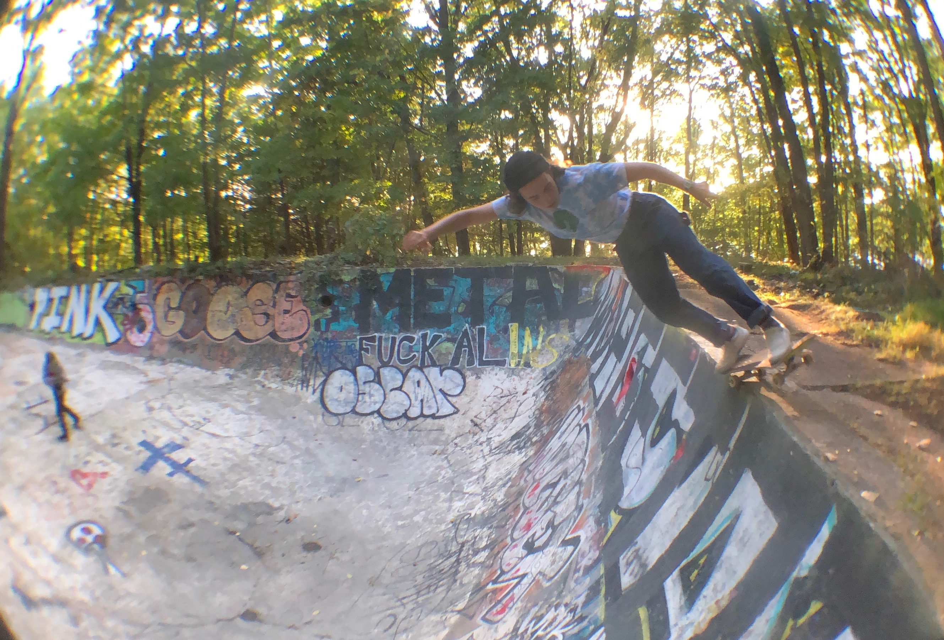

BS Feeble in the deep end of the pool

