NANU BARI: For People Who Love Desi Food – and Their Grandma
A Food Truck Business Plan

Honors Thesis

Presented in Partial Fulfillment of the Requirements
For the Degree of Bachelor of Science in Business Administration
In the Bertolon School of Business
at Salem State University

By

Shaima Azam

Dr. Robert B. “Ripp” Daniell
Faculty Advisor
Management Department
***
Commonwealth Honors Program
Salem State University
2020
Abstract
This thesis details the steps necessary to successfully start a mobile restaurant operation (food truck) in the greater Boston area. A primary issue to consider before starting this business venture is the permitting process and what permits are necessary to operate a food truck. As such, a business plan will be required in order to be able to obtain the permits. Along with the business plan, a detailed marketing section illustrating the brand for the business is needed. The marketing plan will include a mission statement or a “why” page to include in our marketing. The vision for this section is to craft a statement that customers can associate our business with; telling the story of my family’s culture, why we pursued the business and emphasizing the importance of food and family. Another primary consideration is where to buy a food truck, how much capital is required, and determining costs of all the necessary renovations. There are many potentially overwhelming steps to starting a food truck, but this thesis will break those steps down into manageable sections to create a comprehensive plan to follow in order to successfully open a competitive and appealing food truck business in the Greater Boston Area.

Table of Contents

Honors Thesis i

Abstract ii

Table of Contents iii

Acknowledgements iv

List of Tables and Figures v

Introduction 1

Executive Summary 2

Business Description 2

Products/Services 4

Market/Industry Analysis 8

Competitive SWOT Analysis 10

Organization and Management 12

Marketing and Sales 15

Financial Requirements 16

Financial Projections 20

Conclusion 22

Appendix 24

References 25

Acknowledgements
I wish to express my gratitude to my thesis advisor Dr. Ripp Daniell, I would not have been able to complete this proposal without you motivating me to work harder, your guidance, and extensive knowledge. I am grateful for having the chance to work with you on this proposal and for the valuable lessons you have taught me along the way. Thank you for your continued support and adaptability during this endeavor. Most importantly, thank you for inspiring me to one day pursue this business venture. I would also like to recognize Professor Scott Nowka and the Honors Program for the opportunity to create a project I am proud of and be part of a welcoming and ambitious community. Without this opportunity I would not have been able to create a project that I can one day utilize in the future.
Next, I would like to recognize my greatest support system and the biggest contributor to my growth in my undergraduate experience at Salem State, my team at Career Services. Thank you to everyone I have had the pleasure of working with and learning from, your support is unmatched. My sincerest gratitude goes out to Helaina Polito for being an incredible role model, supervisor, and for always presenting me with opportunities to help me move forward in my post-graduate career; and to Ruthann Reed for hiring me my first year and giving me the opportunity to make these connections. Thank you both for making an invaluable impact in my life.
Lastly, I would like to recognize my family and friends for their consistent support, for motivating me, and for making my undergraduate career at Salem State zoom by in the blink of an eye. Thank you all for making the tough times more bearable and making my whole experience memorable.

List of Tables and Figures

Table 1: Product Costs 5

Table 2: Cost per Serving 6

Table 3: Menu Item Cost, Price and Gross Profit 7

Figure 1: Sample Menu 7

Table 4: Start-up Costs 19

Table 5: Slow Week Sales 20

Table 6: Busy Week Sales 20

Table 7: Employee Wages 21

Table 8: Income Statement 21

Introduction
Food trucks are gaining popularity due to their mobile and temporary nature (Saxe, 2018). People are growing to love street-food, especially from other cultures. The bustling cities are packed with a variety of options for someone on their lunch break. The Greater Boston area is especially a hub of cultural food on wheels, food trucks like Bon Me (Vietnamese sandwiches), The Chubby Chickpea (Middle Eastern), Jamaica Mi Hungry (Jamaican), Mediterranean Home Cooking (Mediterranean), Moyzilla (Japanese), North East of the Border (Mexican) offer a range of foods from different continents (Twardzik, 2019). Presently, there is not a lot of food truck options that offer South Asian cuisine, or “desi food”, from countries like India, Pakistan, and Bangladesh. Although there are a variety of restaurants with cuisine from these countries, there’s a need for “desi-food” on-the-go.
Nanu Bari is going to be a successful business venture and the next popular Boston food truck. One identifying characteristic of desi food is that nobody ever measures the ingredients with teaspoons or measuring cups, they measure with their hearts and that’s why the food tastes so welcoming, there’s always a little extra love. “Nanu Bari” in Bangla, translates to “Grandma’s House”, because Nanu Bari Food Truck will provide that welcoming desi-food that you can find at your grandma’s house, that will fill the hearts (and stomachs) of people in the Greater Boston Area. The business plan will pave the way for this food truck to become a reality.

Executive Summary
We are a family owned food truck business. Our goal is to provide you with such wonderful quality homecooked food that you feel like you are part of our family. This food truck idea was a culmination of many business ideas thrown around by my dad and my uncles. Every idea they had didn’t seem to stick, until someone mentioned a restaurant. What better way to connect with people than food, right? My family is super close, and I wanted that to translate into our food. Everything we cook are “recipes” straight from my grandmother, aunts, and mom, so you can taste the love and care in every bite. We want our desi food to transport you to our dinner table and make you feel like you are part of the family. Nanu Bari food truck will provide the Greater Boston area with halal South Asian cuisine. Consumer preferences are constantly changing and everyone is looking for something unique, Nanu Bari food truck can offer that with exceptional customer service. We will work diligently to serve the best quality to our customers and the community. Marketing the business primarily through social media platforms will enable us to reach our target audience, ambitious people searching for fresh new foods.
Business Description
Nanu Bari food truck is a food truck business that provides South Asian flavors to the Greater Boston Area. Nanu Bari food is different than other food truck options, primarily because it will be serving halal food. Halal food is food prepared according to Islamic guidelines so that it is permissible to eat by Muslims, making them a target market; this gives Nanu Bari a competitive edge to the other food trucks in the Boston area because few of them offer halal options and South Asian cuisine. Although this food will be prepared according to religious guidelines, it will not take away from the unique South Asian flavors it can offer to consumers.
The food truck industry is increasing in popularity amongst consumers and the general public, especially because of the way that food trucks are starting to enhance public places (Kaufman, 2018). Their existence adds common ground for people in the community to connect with each other. They bring life to an otherwise quiet environment and can even help bring business to establishments in the surrounding locality.
In the food service sector, food truck operations have been one of the more prominently successful segments over the last few years since 2014 (Kumar, 2019). They have been popular amongst consumers due to their changing tastes, which food trucks have been able to keep up with because they offer different cuisines. Food trucks will continue to experience strong growth in the industry for the next five years as the competition in will increase as more business enter the field (Kumar, 2019).
The rules and regulations for food truck operations vary between cities in the United States. Regulations determine operating hours, operating location, and operations in its entirety. For example, the distance that a food truck can set-up from city blocks or other food trucks in the area. Entering the market may become more difficult in the future due to stricter guidelines for operations as well as increased parking regulations. Stringent rules can negatively impact a food truck business’s ability to sustain in the market. (Olsen, 2018). In an area like Boston, there are successful food truck operations in existence, thus, the strict regulations may slow the success rate.
However, consumer preferences are changing rapidly, people are constantly searching for the next best thing and brand-new flavors in food. Nanu Bari food truck will be adding another food truck option for consumers on the go, in the Greater Boston area. The target market will be consumers that are Muslim, and consumers looking for delicious new flavors and unique cuisine.
Nanu Bari will be marketed primarily through social media platforms to gain the attention of consumers that are always on social media. Apps such as Instagram and Twitter can allow for free advertising with simple hashtags. In popular culture consumers are constantly sharing the next best thing with one another. They want others to experience what they experienced, whether it was a delicious new meal, fantastic view, or interesting new products. Other sites such as Yelp and Google Reviews will be great platforms to engage with the community to really hear their compliments, and most importantly, critiques. Lastly, utilizing Facebook will be another essential method to stay connected with the community and share the business. Nanu Bari can be profitable because it will offer a new style of cuisine, with a competitive edge, competitive pricing, and exceptional customer service.
Products/Services
Nanu Bari will provide its customers with authentic halal South Asian cuisine. There will be chicken, beef, and vegetable dishes along with a snack option. They will embody the flavors of South Asian cuisine and will be paired with a side of white jasmine rice or naan.
- Chicken Options
- Tandoori style served with side of choice
- Classic Curry served with side of choice

- Beef Options
- Classic curry served with side of choice
- Bhuna bhaji (classic beef curry sautéed) served with side of choice

- Vegetable Option
- Sautéed cabbage, cauliflower, and potato blend

- Sides
- White rice
- Naan
- Simple Salad shredded cucumbers, tomatoes, minced onions, cilantro, lime, salt, chilli peppers*

- Snacks
- Pakora (Potato Fritter)

- Drinks
- Water
- Bottled drinks: Snapple

Table 1 below details the costs of the initial inventory. Each cost was recorded according to the purchasing quantity. The various locations that we will be sourcing our inventory from includes local wholesale stores like BJ’s Wholesale and Restaurant Depot. Online retailers like Amazon will also be utilized to source the necessary Indian spice mixes. To obtain fresh produce local grocery stores like Market Basket will be the source for those products. The most important product on the menu is the halal meat which needs to be sourced from an appropriate distributor. There are two separate halal meat distributors that we will source our meat from.
Table 1: Product Costs
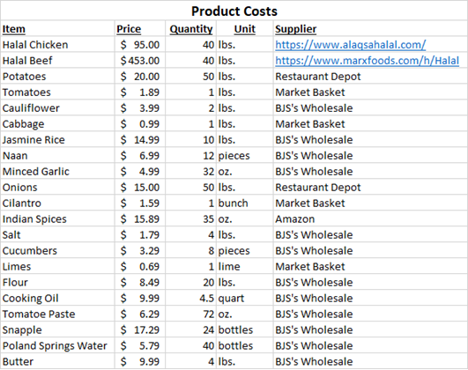
Utilizing the aforementioned individual product costs, the cost per serving was calculated in the following table.
Table 2: Cost per Serving 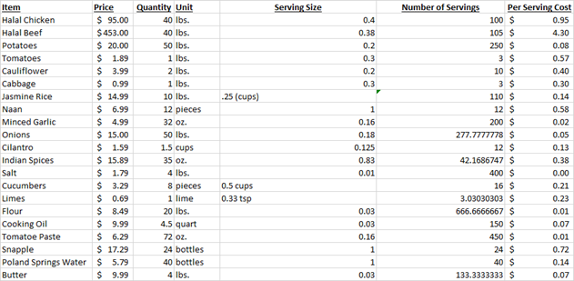

Based on the cost per serving of each menu item, labor and operation costs, and the prices of competitors in the area, the pricing for Nanu Bari Food Truck is as follows, chicken dishes with the side included will be $11.50; beef dishes with side included will be $13.50, vegetable dishes with the sides included will be $10.50. The price of individual sides will be $3 each for the rice, naan, and salads respectively. The price for the pakora snack will be $4.50 for a two count of pakora potato fritters. The price of the spring water will be $2.50, and the price of the Snapple juice will be $3.00. The costs, price and gross profit are detailed in the following table.

Table 3: Menu Item Cost, Price, and Gross Profit
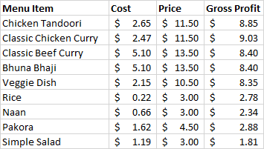
A sample menu for Nanu Bari food truck is included below
Figure 1: Sample Menu
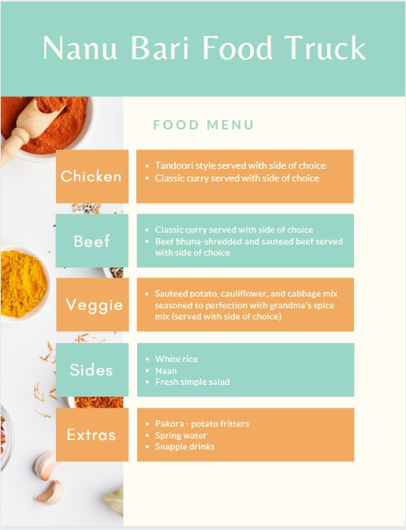

Market/Industry Analysis
The food truck industry is a lucrative and growing industry. According to IBIS World database, the statistics for food trucks are favorable. In the United States in 2019 food trucks had a total of $1 billion dollars of revenue and $77.4 million in profits. The annual growth of food trucks in the United States from 2014 to 2019 was 6.8 percent and is projected to grow 0.5 percent in the following years (Kumar, 2019). The food truck industry performs well due to the constant changes in consumer preferences, they are always searching for something new and unique. The success of food trucks is greatly attributed to consumers because they make their choices based on how much discretionary income they have. One setback for food trucks in the industry and those that want to enter the industry are the restrictions and guidelines for food trucks to operate set by each city and state (Kumar, 2019).
Quick and unique cuisine is gaining popularity among consumers because they are leaving behind traditional high-end dining options for more affordable options that can be found at food trucks. The advantage of food trucks in the Greater Boston area is that it is an urban area with many offices and business in the surrounding locale. Many office buildings house potential customers that may be looking for something new and quick to eat during their lunch breaks. Although there are numerous options throughout the city, at least half of the working professionals in the city will not have a strict routine and will want to look for the next new food option. A city like Boston is tourist city that brings in people from all around the area that are also potential consumers. It is also home to many universities’ students on a budget, that are more likely to spend their discretionary income on a quick meal with their friends than a luxury item. Although university students generally have little to no disposable income, they are still likely to splurge on food trucks because they are more connected to social media where they can be exposed to new food options that aren’t from their dining hall. The potential consumer population in Boston is diverse and consists of working professionals, tourists, and university students allowing food trucks great opportunity for exposure through word of mouth.
IBIS World breaks down the market segmentation of food trucks by age. The truck industry has the highest percentage of consumers in the age range of 25 to 44 years of age, holding nearly 50 percent of the market segment. The next highest segment is consumers under the age of 25 at 19.7 percent and following closely behind is the age group of consumers over 55 years of age. Lastly, the lowest market segment is consumers between the age of 45 to 54. Those in the highest market segment are more likely to spend on food trucks because according to IBIS World, this group are adults that are occupied with balancing work and home life so it’s more convenient for them to seek food trucks for quick lunch options (Kumar, 2019). In addition to this, generally consumers that have higher discretionary income and more time on their hands include those in the age group of 45 to over 55 year old, so they are more likely to opt for a formal food option as opposed to the fast-casual nature of food trucks. According to IBIS World database, the concentration in the food truck industry is low, meaning there is not one company that controls a large percentage of the market share. Although there are food trucks that are leading competitors, there is still an opportunity for a new food truck to gain traction if they are offering unique menu items (Kumar, 2019).
According to reviews on Yelp.com for various food trucks in the Boston area, consumers are overall greatly pleased with the convenient nature of food trucks, affordability, and uniqueness of their food options. Most reviews by consumers praised the quality of the food they got at the food truck as well as the quality of the service they received. On Instagram many consumers shared pictures of their meals from food trucks and an overwhelming amount of them were presented tastefully and featured vibrant colors in their dishes. Making food that is pleasing to the consumer and very eye-catching, is a great way to prompt them to share pictures of the food with their social media base. Therefore, presentation plays a role in how consumers experience their food and how they share it with the people they know. According to Twitter, consumers are opting for supporting local businesses, including food trucks. They are favoring the small-town business and the personalized experiences they get when they visit a food truck.
Competitive SWOT Analysis
Strengths
The greatest strength for Nanu Bari food truck is that we will be selling unique food and targeting a niche that does not have many options. Nanu Bari will serve Halal certified South Asian cuisine that will give the Muslim population in the Greater Boston area another food option. Presently, there are few fast-casual halal food options in Boston like the Halal Guys, Black Seed Café, Shah’s Halal, and Shah’s Halal. All of these locations offer halal food with middle eastern flavors. Presently, there is no fast-casual option for a halal food truck with South Asian cuisine. There are few restaurants that feature South Asian cuisine in the Greater Boston Area that are fast-casual.
Nanu Bari’s second greatest strength will be that it is a family-owned business; consumers prefer supporting local family-run business because it makes their experience feel more personal. Nanu Bari will offer exceptional customer service and ensure that every consumer’s experience leaves them feeling like they are welcomed into the family.
Weaknesses:
Nanu Bari Food Truck’s greatest strength is also its greatest weakness. Selling halal certified foods results in extra steps and costs in the food preparation process. The costs for providing halal certified food are slightly greater than regular meats. Another issue is being able to source the halal meats in bulk quantities because it is not readily available like regular meats. As a result, the price of the menu items for Nanu Bari food truck are also going to be slightly greater than the average food truck. Consumers are looking for affordable food options, so the population of non-Muslim consumers may opt for a more affordable option instead of Nanu Bari food truck, causing us to lose a segment of consumers.
Opportunities:
Nanu Bari food truck will have a great opportunity to grow in this industry because there is not currently one market leader. Consumer preferences are constantly changing, as well as their incomes. Therefore, Nanu Bari has a chance to gain more following as consumers are seeking out the next best food option. Being situated in Boston allows for great exposure and opportunity to get involved in the community. Partnering with local universities or offices can be an option to help promote the business as well as build relationships with community members. Another advantage to being located in Boston is there is a high population of international students and diverse populations that could be far away from home and are searching for food that reminds them of home. Boston is also home to many social events like the Boston Marathon, Boston Calling Music Festival, and Fireworks shows that have a lot of foot traffic allowing for a large number of potential consumers.
People are becoming more educated and exploring other cultures now more than ever, and this curiosity will only increase in the future. This is a great opportunity for Nanu Bari food truck to contribute to a consumer’s cultural experience, through food.

Threats:
The greatest threat to Nanu Bari food truck is that consumers are becoming increasingly health conscious and Nanu Bari food truck does not offer the healthiest options. Nanu Bari may be able to find healthy alternatives to ingredients or add menu items that are healthier, however, it may not be enough to draw them in. There are plenty of fast casual food options for consumers that are health conscious that will become strong competitors with Nanu Bari food truck. Due to the fact that Nanu Bari food truck offers very specific cuisine, it runs the risk of not being an incredibly lucrative business. There is a threat of incurring financial problems that may prevent Nanu Bari from expanding or adapting to the changing market. It may also prevent Nanu Bari from properly staffing the business. The threat of city and state regulations for food trucks are prominent and could change the operations of Nanu Bari food truck. In Boston, there is a very low likelihood of one food truck to be able to keep the same location for many consecutive years, as the locations are appointed on a lottery system. Because this is a mobile food operation, gas prices are relevant and can impact the finances of the food truck as well, if prices become too high unexpectedly, it may result in changes to net income.
Organization and Management:
Nanu Bari Food Truck will operate as a sole proprietorship initially. The benefit of a sole proprietorship business structure is that it is easier for small business to establish. This would allow me to have complete control over all decisions regarding the business and make any necessary changes that I see fit. Since this is a going to be a simple family owned business, there will be no need for initial shareholders or dividends, and we can avoid the capital gains tax associated with companies. However, with this structure avoiding double taxation would entail taking on personal liability because there is no distinction between the business and myself. Therefore, any debts of the business or any liabilities that the business incur will become my personal liability. This is a necessary risk that is part of running a new business. Once the business grows, I will consider switching the business structure to a corporation to allow for investment opportunities and to limit personal liability.
During the initial start-up phase, capital will be generally low. Therefore, one way to run the business and cut costs will be to enlist the help of family for our family owned business. The recipes will be coming directly from my family members and during the initial stages they will be cooking the meals and helping with food preparation. They will also be responsible for customer service, greeting customers, and building a rapport with them. Additionally, we will need someone to develop a relationship with suppliers as well as do the shopping for groceries. This duty will also require keeping track of inventory to ensure no food waste or shortage. Due to financial restrictions this role will also entail cleaning duties such as ensuring the trash is properly disposed of, equipment is prepped and cleaned, and to ensure everyone else is adhering to the health guidelines.
We will also need someone to fill the role of marketing and communicating with the community via social media. This role also entails overseeing branding the food truck, putting out advertisements, and getting involved in the community. It will entail planning and participating in community engagement events. One extra that this role will include is to manage the carbon footprint of the business and try to find cost-effective and environmentally friendly adaptations. These different roles will be fulfilled by family members in the beginning stages, then once business picks up and our customers start growing, we will be able to expand our service team and hire employees.
The location for Nanu Bari Food Truck will be in Boston. According to the City of Boston website, there are guidelines for picking a location. The City of Boston website also details the costs per each location and hours of operation. There is a total of three zones for food trucks and the pricing per shift varies for each. In order to procure a spot, each business must enter into a lottery (Food Truck Sites, 2019). The site costs are monthly and dependent upon how many shifts each business takes at each zone. Nanu Bari Food Truck will initially commit to Zone 1 which includes locations by City Hall Plaza, Boston Public Library, West End, Northeastern/Opera House. The hours of operation include breakfast from 7 am to 11 am, lunch from 11 am to 3 pm, and then dinner from 3 pm to 8 pm (Food Truck Sites, 2019). Each business has the ability to choose a combination of these shifts, so for Nanu Bari, we will first opt for the lunch shift. The preferred location will be Boston Public Library. Initially we will set up three lunch shifts a week for a month, which will total 12 shifts a month. The cost for 12 shifts in zone 1 is $1,225. There is also a choice of finding your own site and applying for a private site, but that comes with more challenges for an initial start-up. Eventually when the customer base for Nanu Bari Food Truck grows, then we will think about expanding our zones to reach more customers.
The management structure of Nanu Bari Food Truck will include two managers to be actively involved in everyday operations to ensure that business is running smoothly. One manager will be taking part in the food preparation and customer service aspect of the business. The other one will be actively involved in the logistics of the business such as keeping track of budget, inventory, ensuring policies are adhered to and staffing concerns.

Marketing and Sales
Nanu Bari’s mission statement is “To welcome every guest and treat them like family”. They will not only taste the food but experience a new culture in the process and leave feeling like they just ate at their grandmother’s house. When any customer tries their first bite of food at Nanu Bari food truck, they will feel like they are part of our family. Nanu Bari food truck will put a lot of time into marketing in order to reach their target markets that includes consumers searching for new food options, people looking for halal food options, and anyone in-between. Social media is popular, many people have access to it, and they use it to share their experiences with each other. Apps like Facebook, Twitter, and Instagram allow anyone to post anything both privately and publicly. Nanu Bari food truck will have one person appointed to spearhead all promotion efforts.
The first promotion action item for Nanu Bari Food Truck in terms of marketing is to create social media pages on Instagram, Twitter, Facebook, Yelp, and Google Reviews. With those we will be able to reach our target audience and the community easily. In order to gain hype on social media, we must present our product in such a way that people want to share it with their friends. This means that the presentation of the food must be very enticing. Next, we must keep in touch with our customers through social media by interacting with them when they post about our business. Simple interactions and thanking our customers can go a long way as it shows we truly care about their experience. Monitoring our socials will be a great way to see what customers are saying about us and what feedback they provide. Being active and communicating with our customers will help build a great relationship with them and increase our online presence.
On sites like Yelp and Google Reviews, it will be important to be active and communicate with customers to ensure that they are enjoying their experience. For both negative and positive comments, it’s important to respond with gratitude for their feedback and ensure that all valid critiques are addressed so that the customer experience can improve. Yelp is a good resource because businesses are able to share pictures and directed content to reach the appropriate audience and functions a lot like social media. Google reviews is similar to Yelp in which customers can leave their honest feedback for us. One method to increase exposure is to encourage positive reviews by incentivizing the customers with a free menu item on their next visit, contingent on the fact that it will be financially plausible.
Financial Requirements
Food Truck Costs
In order to properly conduct a food truck business, there are a number of financial requirements that must be fulfilled. Food Truck Empire website details a number of the important start-up costs associated with starting a mobile food operation. The number one most costly item is to procure a food truck. According to Food Truck Empire, the cost of the food truck itself varies widely depending on the features that come with each truck, they can range anywhere from $25,000 to $150,000 (Lindenberg, 2018). Just like purchasing a car, a food truck can be purchased used or new. The advantage of purchasing a new food truck is that it can be customized with all the right equipment and amenities that will allow for the perfect cooking kitchen
According to the Boston Food Truck Blog site, wraps can cost anywhere from $2,500 to $5,000 depending on the design and installation (Food Truck Wraps, 2015). It is important that the wrap is designed perfectly to reflect Nanu Bari Food Truck as well as catch the customer’s eye. This will be the first impression consumers will have of Nanu Bari Food Truck. Then, along with the big expenditures, comes the small licensing and permitting fees that add up.
Permits and Licenses (See Appendix for Documents):
One important step to consider in the start-up and operation of the mobile food business is the permits, insurance, and licenses necessary to conduct business. Since Nanu Bari Food Truck will be conducting business in the greater Boston area, the City of Boston website offered the list of permits and licenses. According to the City of Boston website, there are preliminary permits and steps to complete prior to obtaining a food truck permit. One of the first things that this website lists is to schedule a review of the building plans. Inspectional Services will need to go over the plans for the Food Truck. There are some important documents necessary for this review that include equipment plans and specification for the truck, a food truck review form that details other necessary permits, a completed health permit application, and a sample menu to help figure out the layout of the kitchen. There is also an annual health permit fee that equates to $100.
Another permit necessary is the Hawkers & Peddlers license; each worker is required to complete this form, and have it reviewed by the Police Chief. This cost for the application is $62 and the cost for Boston Police to review your criminal history is another $50. Then send this reviewed application and apply with the State of Massachusetts.
The next item that is required is a business certificate that includes the name and address of the business and the name and addresses of anyone that holds an interest in the business. One thing to note for this certificate is that the signature on the certificate has to be someone that is the “director” or “officer” of the business. This certificate costs $65 to file.
The next item on the list is to complete a Certificate of Liability Insurance Form. All costs associated with permits and licenses should be reflected in the start-up costs of the food truck.
After all of these conditions have been met, one can fill out a food truck application online at the City of Boston, the application fee is $500.
Equipment/Miscellaneous Costs
The next important costs to note are the start-up costs for the initial inventory and equipment necessary to run business. Webstaurant Store website has a list of purchases that are necessary for the food truck operation that include cooking equipment, warming and holding equipment, food prep equipment, serving equipment, refrigeration equipment, and janitorial equipment (Food Truck Equipment Checklist, 2019). Food Truck Empire provided a chart with the various expenses that can be adjusted for each business venture dependent on regulations and budget (Lindenberg, 2018). One thing to note is that the range for initial product inventory is about $1000 to $2000, however, since Nanu Bari food truck will be serving halal certified food, we will be allotting an extra $1000 in that range to account for the cost of specialty meats and grocery.
The start-up costs were determined on a low-end to high-end cost resulting in a cost range. Various companies were referenced in order to find the appropriate cost estimates, including, but not limited to Webstaurant Store, Home Depot, Wix, Custom Ink, Verizon.

Table 4: Start-Up Costs
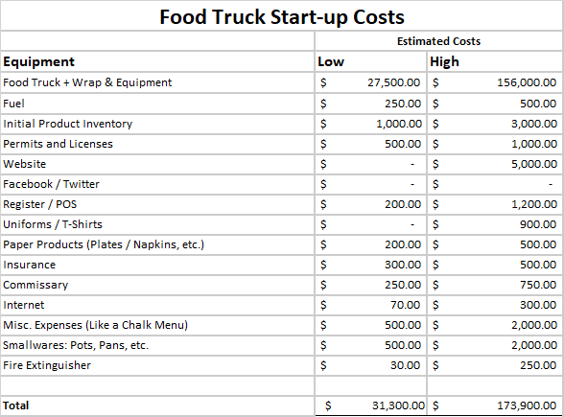

Financial Projections
The following are sales projection for one year based upon a total of 50 percent slow weeks and 50 percent busy weeks.
Table 5: Slow Week Sales Projection
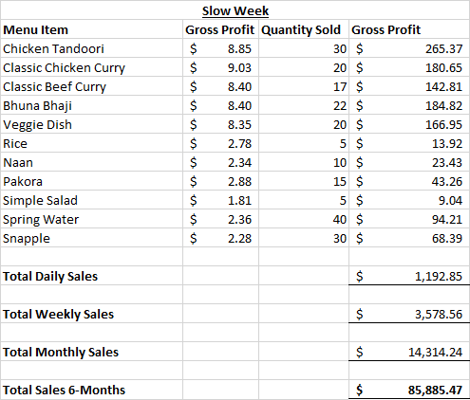
Table 6: Busy Week Sales Projections
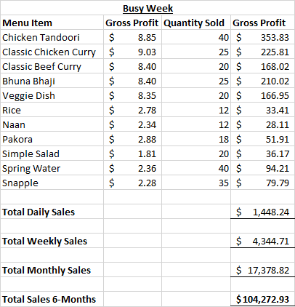
Table 7: Employee Wages
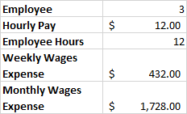
After calculating gross profit, the net income per month was determined. Since Nanu Bari food truck will be a sole proprietorship, the tax bracket it falls in is my personal tax bracket of 12 percent. Therefore, that percentage was utilized to calculate the tax liability for Nanu Bari food truck. The following table shows the income statement.
Table 8: Income Statement
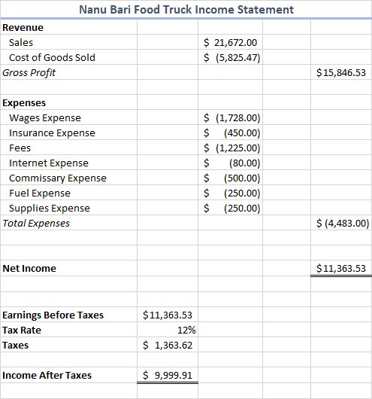

Conclusion
Nanu Bari food truck has the potential to become a successful business venture. Its unique menu items will be able to attract the attention of a population of consumers that are not overwhelmingly catered to in the restaurant industry, which are Muslim consumers. Nanu Bari food truck will serve certified halal South Asian cuisine and will be situated in the Greater Boston Area. Presently, there are options for halal food in Boston, however, most of the fast-casual options are Mediterranean style cuisine. There are restaurants that serve South Asian cuisine; however, a spot exists in the market for halal South Asian cuisine, “on-the-go”. Nanu Bari food truck will actively participate in community events and ensure that we take every opportunity to collaborate and partner with local business. It will take every measure to communicate with their customers via social media platforms to listen to express gratitude for their business, listen to customer feedback and continuously improve our service. Nanu Bari food truck will pride itself on being a small family-run business, build a relationship with the customer, and ensure their experience leaves them feeling like they just left their grandmother’s house, happy and with a full stomach.

Appendix
Mobile food Establishment Plan Review Document:
https://www.cityofboston.gov/images_documents/ISD_Mobile_Food_Establishment_Plan_Review_KD_tcm3-25600.pdf

Application for License to Peddle Document:
https://www.boston.gov/sites/default/files/updated_hawker_peddler_2019_0.pdf

Business Certificate Form Document:
https://www.boston.gov/sites/default/files/new-biz-cert.pdf

Certificate of Liability Insurance Document:
https://www.boston.gov/sites/default/files/cori-sample.pdf

Food Truck Application Document:
https://www.boston.gov/sites/default/files/food_truck_permit_application.pdf

Health Permit Application:
https://www.cityofboston.gov/images_documents/Mobile%20Food%20Establishment%20Plan%20Review%20Form.%20McAdams._tcm3-33294.pdf

Food Truck Equipment List:
https://cdnimg.webstaurantstore.com/uploads/images/2019/3/foodtruck_checklist.pdf

References

Food Truck Equipment Checklist. (2019, July 17). Retrieved from https://www.webstaurantstore.com/article/398/food-truck-equipment-list.html
Food Trucks, Carts, and Trailers For Sale. (n.d.). Retrieved from https://roaminghunger.com/marketplace/buy-a-food-truck
Food Truck Sites. (2016, July 1). Retrieved from https://www.boston.gov/departments/small-business-development/food-truck-sites
How to get a food truck permit. (2016, July 1). Retrieved from https://www.boston.gov/departments/small-business-development/how-get-food-truck-permit
How to get a food truck permit. (2016, July 1). Retrieved from https://www.boston.gov/departments/small-business-development/how-get-food-truck-permit
How to Write a Food Truck Business Plan. (n.d.). Retrieved from https://www.webstaurantstore.com/article/54/how-write-food-truck-business-plan.htm
Kumar, Tanvi. Industry Market Research, Reports, and Statistics. (2019, March). Retrieved from https://www.ibisworld.com/united-states/market-research-reports/food-trucks-industry/
Food Truck Wraps: Cost, Designs, and Alternatives. (2015, June 15). Retrieved from http://www.bostonfoodtruckblog.com/food-truck-wraps/
Huebsch, R. (2017, November 21). Why Start a Sole Proprietorship? Retrieved from https://smallbusiness.chron.com/start-sole-proprietorship-3946.htm

Kaufman, R. (2018, December 14). Food Truck Growth Continues to Shape Cities. Retrieved from https://nextcity.org/daily/entry/food-truck-growth-continues-to-shape-cities?gclid=Cj0KCQiAkePyBRCEARIsAMy5Scvqt3U9R2qkM1AhT2tTyqYz0FnQj5ab4kwvwIyHd0d76Tm3dPVwGJ0aAkVZEALw_wcB
Lindenberg, B., Brett, Lindenberg, B., & Brett. (2018, October 30). The Complete Breakdown of Food Truck Operation Costs. Retrieved from https://foodtruckempire.com/how-to/costs/
Mealey, L. (2019, August 22). Everything You Need to Write a Food Truck Business Plan. Retrieved from https://www.thebalancesmb.com/write-a-food-truck-business-plan-4066702
Olsen, M. (2018, April 24). Food Truck Market Trends. Retrieved from https://posbistro.com/blog/food-truck-market-trends/
Saxe, L. (2018, December 12). Want To Know The Future Of Food Trucks In 2019? Read This Report. Retrieved from https://www.forbes.com/sites/lizzysaxe/2018/12/12/want-to-know-the-future-of-food-trucks-in-2019-read-this-report/#ab48292398f8
Sugar, S. (2018, March 21). Here's How Much It Really Costs to Start a Food Truck. Retrieved from https://www.shopkeep.com/blog/how-much-does-it-cost-to-start-a-food-truck#step-1
Twardzik, Eric. (2019, April 23). The essential guide to 21 of Boston's best food trucks. Retrieved from https://www.boston.com/food/food/2018/04/27/best-food-trucks-boston
WebstaurantStore. (n.d.). Retrieved from https://www.webstaurantstore.com/food-service-resources/how-to.html
Your food truck business plan. (2016, June 30). Retrieved from https://www.boston.gov/departments/small-business-development/your-food-truck-business-plan

