CROWDSOURCING ANTIBIOTIC DISCOVERY FROM SOIL

Honors Thesis

Presented in Partial Fulfillment of the Requirements
For the Degree of Bachelor of Science in Biology

In the School of Biology
at Salem State University

By

Madison Angelli

Dr. Amy B. Sprenkle
Faculty Advisor
Department of Biology

***

Commonwealth Honors Program
Salem State University
2018

Abstract

Crowdsourcing antibiotic discovery from soil is a rising technique that is continuously inspired, in part, by the Tiny Earth Network. The main goal is to find bacteria that are producing antibiotics. Common diseases are getting more difficult to treat with antibiotics due to the bacteria evolving to be able to grow in the presence of the drug. It is no help that antibiotic resistance is growing quicker than the discovery of new antibiotics. This experiment involved examining different types of bacteria, found in random soil samples, that could possibly contain bacterial growth inhibiting properties and thus be used to make antibiotics. Gram staining and other biochemical tests were performed to determine the cell morphology and chemical characteristics of the isolated bacterium. Promising producers were observed, including one that showed a filamentous pattern which represents the Actinomycetes family of common soil bacteria. Although this family is known to produce useful antibiotics, under the attempted culture conditions no robust producers were discovered. The conclusions demonstrate the difficulties of obtaining an antibiotic producing soil bacterium, however the continued work of the Tiny Earth Network exploring soil samples for antibiotic production suggests the discovery of a new antibiotic may be just around the corner.

Table of Contents

Cover Page i
Abstract ii
Table of Contents iii
Acknowledgments iv
List of Tables and Figures v
Introduction 1
Background 2
Materials and Methods 3
Results 5
Conclusion 11
References: 13

Acknowledgments

I would like to express my special thanks of gratitude to my Microbiology professor and thesis advisor Dr. Amy B. Sprenkle for her inspiration, guidance, and commitment in helping me to complete this project.
I would also like to extend my gratitude to Scott Nowka, Honors Program Chair, who supported and encouraged me throughout this entire journey.

For those who have helped me in any way since I started this project, I am truly grateful for all you have done.

List of Tables and Figures

Table 1 Information on Soil Sample Collected 4
Table 2 CFUs/g of Soil for each Dilution 6
Figure 1 Serial dilution scheme for soil sample 5
Figure 2 Soil dilutions from 10⁻2 to 10⁻6 5
Figure 3 Soil dilution 10⁻2 6
Figure 4 Master patch plate on TSA-10% agar selected from the 10⁻5 dilution plate 7
Figure 5 Resistance test done using S. epi with colonies from master plate 7
Figure 6 Resistance test done using E. coli with colonies from master plate 7
Figure 7 Streak Dilution technique of Unknown #12 from master plate 8
Figure 8 Gram stain of unknown 12 under oil immersion (x1000) *taken with cell phone 8
Figure 9 Gram stain of unknown 5 under oil immersion (x1000) *taken with cell phone 9
Figure 10 Resistance test of S. epi and E. coli using a line of Unknown #12 9

Introduction

Due to the misuse and overuse of antibiotics, bacteria have grown resistant to treatments and continue to spread between humans and animals. The need for new antibiotics is in response to the antibiotic resistance crisis, which very likely will become life threatening if we do not get a grasp on the issue soon. The field of antibiotic stewardship has recently become important in clinical, veterinary, and agricultural areas alike.

Crowdsourcing antibiotic discovery from soil has grown popular within recent years and is an important technique in which the main goal is to find naturally occurring antibiotics that can be used to improve the antibiotic resistance crisis. Soil is used since many antibiotics that are presently used have been derived from bacteria or fungi in soil. Large advancements in technology and medicine have been made from the discovery of antibiotics from soil such as penicillin, streptomycin, chloramphenicol, and tetracycline. (Clardy et al., 2009)

With inspiration from the Tiny Earth organization, more and more universities are getting involved to help reduce the antibiotic resistance crisis. The Tiny Earth program is a network of instructors and students focused on student sourcing antibiotic discovery from soil. The mission of the program is two-fold: First, it seeks to inspire students to pursue careers in science through original laboratory and field research conducted in introductory courses with the potential for global impact. Second, it aims to address a worldwide health threat—the diminishing supply of effective antibiotics—by tapping into the collective power of many student researcher concurrently tackling the same challenge, living up to its motto “student sourcing antibiotic discovery.” (Tiny Earth, 2020)

Background

Antibiotic resistance (AR) is a devastating issue that is affecting global health and development. (WHO, 2020) Antibiotics are medicines used to prevent and treat bacterial growth in humans and animals. The first antibiotic was discovered early in the 20th century when it was observed that the growth of a fungal contaminant on a plate with bacteria was able to stop the growth of the bacteria. (OpenStax, 2019)

A major concern is that humans or animals do not become resistant, but the bacteria themselves do. AR reduces successful treatment of bacterial infections with antibiotics due to the bacteria evolving to be able to grow in the presence of the drug. Since the discovery of the first antibacterial drugs, resistance has advanced. This is due, in part, to the fact that bacteria have rapid reproduction rates and can quickly evolve resistance to drugs. The outcomes of antibiotic resistance include higher medical costs, longer hospital stays, and increased mortality. The global spread of resistance mechanisms is intimidating the ability to treat common infectious diseases. Diseases including respiratory, diarrheal, and sexually transmitted diseases are getting harder to treat with the increase of antibiotic resistance. (WHO, 2020) In some cases they are even impossible to treat, suggesting a post-antibiotic era, in which infections and injuries may once again lead to death. (WHO, 2020) The root of the problem is the way we prescribe and use antibiotics. Certain antibiotics can be obtained without a prescription, only leading to further spreading of resistance.

While the occurrence of AR microbes is climbing, the discovery of new antibiotics is lacking.

Materials and Methods

The soil sample details can be seen in Table 1 below. The first step performed was the soil dilution scheme (Hernandez, S. et al., 2018, p. 169-171) which reduces the dense culture of cells. A quick overview of the serial dilution process can be seen in Figure 1 below. The plates used were Luria-Bertani (LB) agar plates. The plates were incubated at 35ºC for 24-48 hours. To obtain a pure culture from the original environmental sampling plate, a master patch plate was made on 10% Trypticase Soy Agar (TSA-10%). The plates were incubated at 35ºC for 24-48 hours. The patches are not pure populations, so to obtain a pure culture the streak plate method was followed (Hernandez, S. et al., 2018, p. 185-190) to obtain isolated colonies. Only one-two specific bacteria from the master patch plate were chosen to be isolated. TSA-10% plates were used. The plates were incubated at 35ºC for 24-48 hours. The resistance of Staphylococcus epidermidis (S. epi) and Escherichia coli (E. coli) were tested against the whole master plate by the spread/patch method (Hernandez, S. et al., 2018, p. 162-163). TSA-10% plates were used. The plates were incubated at 35ºC for 24-48 hours. Gram staining (Hernandez, S. et al., 2018, p.150-152) was then performed on this bacterium to determine if it was Gram negative or positive and to determine the cell morphology. Additionally, the resistance of S. epi and E. coli were tested using a method similar to the Patch/Patch method (Hernandez, S. et al., 2018, p.159-160) however, a straight line is used not a circle. The patch/patch method determines if the bacteria are producing a soluble secondary metabolite that inhibits the growth of other bacteria.TSA-10% plates were used. The plates were incubated at 35ºC for 24-48 hours. Further Biochemical tests were performed. Included were the Catalase (Hernandez, S. et al., 2018, p.129-131) and Oxidase (Beaman, C. et al., 2007) Tests, Phenol Red Test (Hernandez, S. et al. 2018, p. 147-148), Simmons Citrate Test (Beaman, C. et al., 2007), MR-VP (Methyl Red-Voges Proskauer) Test (Beaman, C. et al., 2007), and SIM (Sulfur, Indole, Motility) Test (Hernandez, S. et al., 2018, p. 191-192).

Table 1 Information on Soil Sample Collected
Collected by: | Madison Angelli
Date of Collection: | 09/24/19
Depth: | ~5 cm
Condition of Soil: | dry
Air Temperature: | 22.7°C
Weather Condition: | Partly sunny, overcast clouds
Relative Humidity: | 77%
Location: | Reading, MA- chicken run area
GPS Coordinates: | 141° SE, 42°30’38”N, 71°6’8” W, Elevation 120 ft

1 g

SOIL SAMPLE 100 μL 100 μL 100 μL 100 μL
99 mL

900 μL diluent

0.1 mL 0.1 mL 0.1 mL 0.1 mL 0.1 mL
10⁻²
10⁻³
10⁻⁴
10⁻⁵
10⁻⁶

Figure 1 Serial dilution scheme for soil sample

Results

Figure 2 below shows the progression of the soil dilution process. Fewer colonies are observed on each plate since the dilution is increased. The first three plates, from left to right, contain a colony count that is greater than the statistical viable count (30-300 colonies). The fourth plate has 78 colonies while the last plate has only two colonies. In figure 3 zones of inhibition can be observed around some of the colonies on the crowded plate. These colonies were chosen to make the master plate.
Figure 2 Soil dilutions from 10⁻2 to 10⁻6
Figure 3 Soil dilution 10⁻2

Calculations for these dilutions can be seen in Table 2 below. The equation used to find the number of bacteria per gram of soil is [colony forming units (CFU)/ (Dilution*Amount plated(mL))].

Table 2 CFUs/g of Soil for each Dilution
Dilution | Number of Colonies | CFU/g of soil
10⁻² | >300 | N.A
10⁻³ | >300 | N.A
10⁻⁴ | >300 | N.A
10⁻⁵ | 78 | 7.8 X 10⁷
10⁻⁶ | 2 | 2.0 X 10⁷

Figure 4 below demonstrates the master patch plate. Unknown bacteria #5, 6, 8, and 12 all appear to be Actinomycetes colonies since they display a filamentous pattern. Actinomycetes have been reported to produce many useful antibiotics, and therefore we chose Unknown bacteria #5 and #12 to perform further tests on.

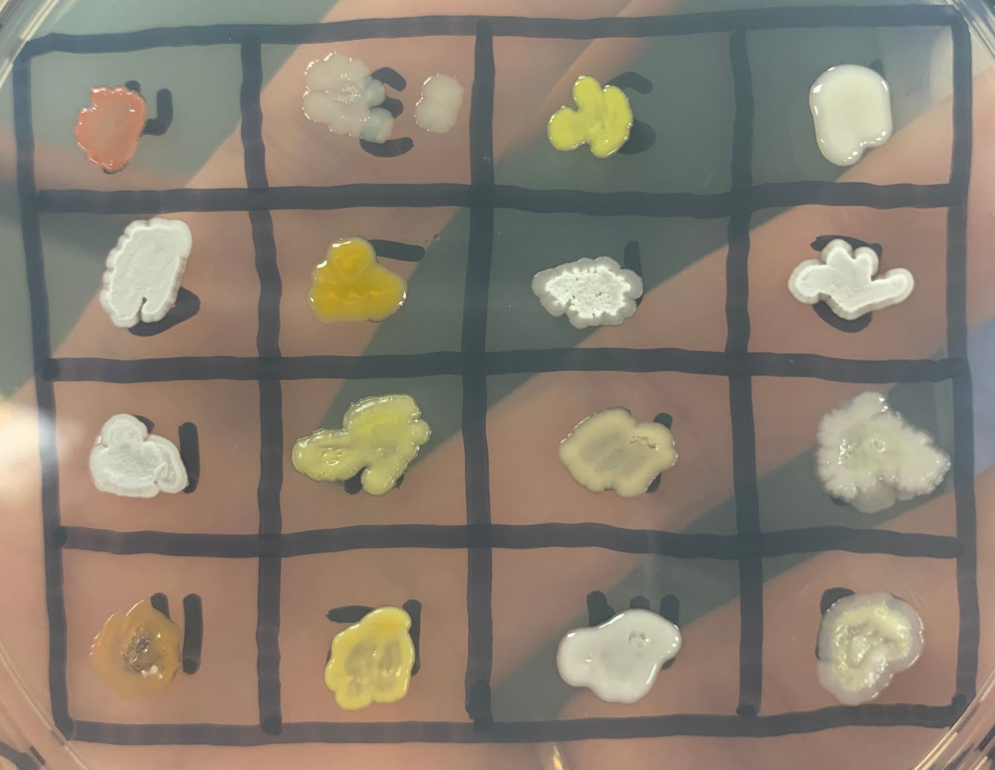
Figure 4 Master patch plate on TSA-10% agar selected from the 10⁻5 dilution plate

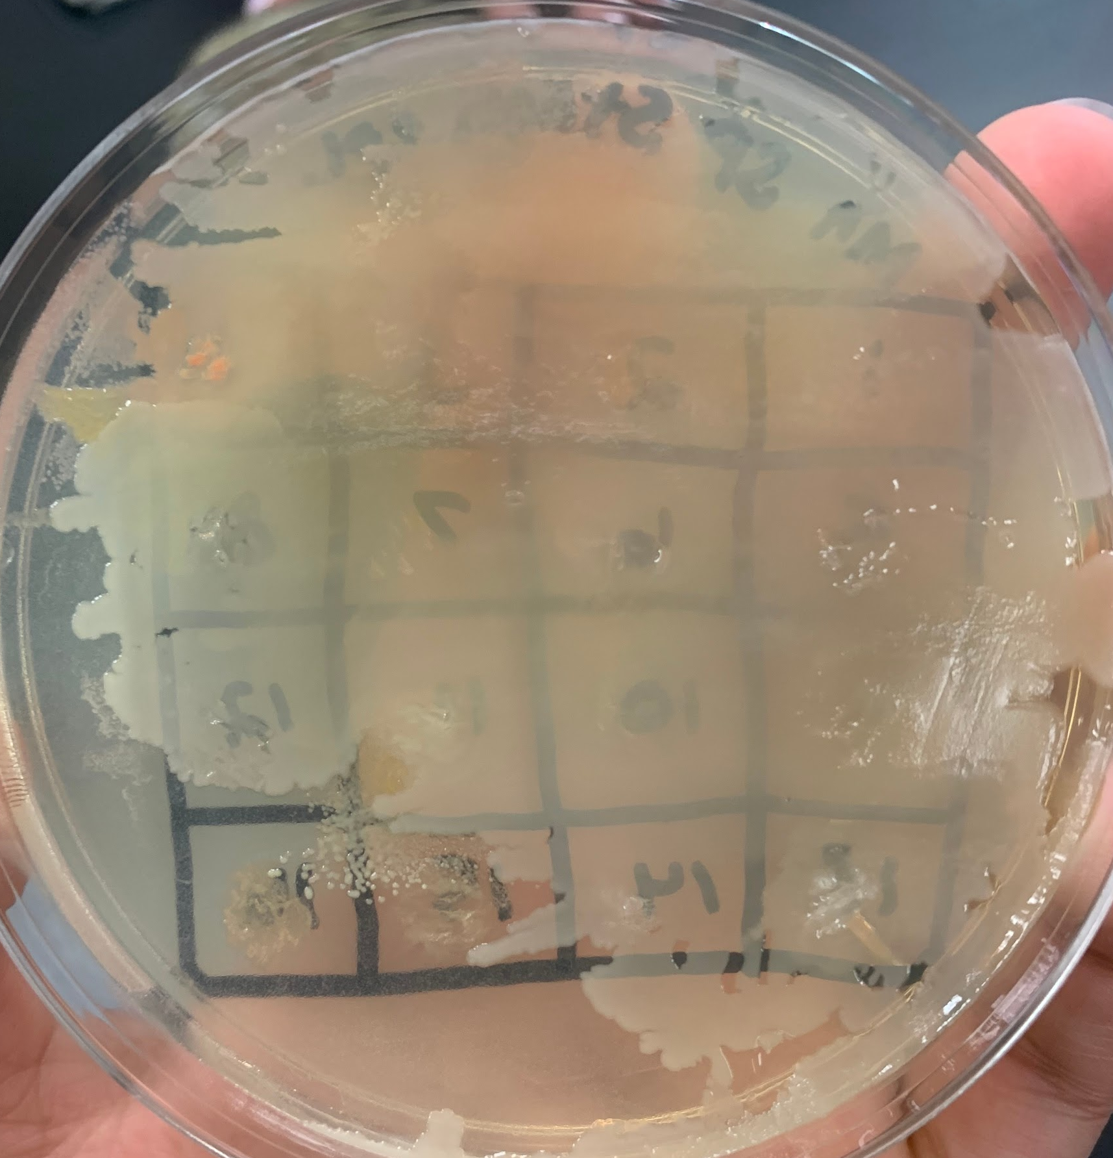
Figure 5 Resistance test done using S. epi with colonies from master plate

Figure 6 Resistance test done using E. coli with colonies from master plate

Figure 5 shows slight inhibition of growth in S. epi caused by Unknown #12 and #11. Figure 6 shows little inhibition of growth in E. coli caused by Unknown #5. Although the inhibition caused from Unknowns #5 and #12 was not that significant in terms of possible antibiotics, further tests were performed to rule out all possibilities.

Figure 7 depicts a streak dilution done with Unknown #12. Pure colonies were able to be taken from this plate to be utilized for other tests. There was no streak dilution done for bacteria #5.

Figure 7 Streak Dilution technique of Unknown #12 from master plate

Figure 8 Gram stain of unknown 12 under oil immersion (x1000) *taken with cell phone

Figure 9 Gram stain of unknown 5 under oil immersion (x1000) *taken with cell phone

a. b.
Figure 10 Resistance test of S. epi and E. coli using a line of Unknown #12

After examining stains of Unknown #12 and #5, both appeared to be Gram-positive rods. This is present in Figure 8 and Figure 9. There were also Gram-negative rods present in Figure 9, suggesting this was not a pure culture, but rather mixed or contaminated with another bacteria or bacterium. The results seen in Figure 10 a and b suggest that there was resistance of E. coli and S. epi against Unknown #12.

To further characterize the identity of the soil isolates, a series of biochemical tests were performed. All of our results were negative except the catalase test. This suggests Unknown #12 is positive for the catalase enzyme, which decomposes hydrogen peroxide to water and oxygen. Unknown #12 did not produce an acid or gas for any of the Phenol Red tests. This suggests no sugars were fermented. The Simmons Citrate test remained green which means Unknown #12 does not use carbon as a food source. The negative MR-VP test suggests no acids were produced and little acetoin was produced. A negative SIM tests means no sulfur was present, no Indole was produced after the addition of the Kovac Indole Reagent, and there was no motility.

To try to identify antibiotic production through a different method, in an experiment not shown, two lawns of E. coli and S. epi were made on two separate TSA-10% plates (4 plates total). Separately, #12 was grown in a lawn on a separate plate. Plugs of agar were taken from this pure culture of #12 bacteria. The plugs were placed on the E.coli or S. epidermidis lawns with one bacteria growth side down (in contact with the lawn) and the other with the bacteria growth side up (facing away from the lawn). The same was done for both agar plates. This technique allows the researcher to observe if the unknown bacterium produces any secondary metabolites with antibiotic properties that will inhibit other bacterial growth. It also allows the researcher to see if direct contact is needed in order for inhibition to occur. If the unknown bacteria have antibiotic producing properties then a zone of inhibition will be observed around the plug. Larger zones of inhibition indicate that the bacteria are more sensitive to the antibiotic introduced. The results yielded no sufficient evidence of inhibition of growth of either E. coli or S. epi on the agar for any of the plugs.

Conclusion

After pure cultures of bacteria from a random soil sample were obtained, multiple steps were taken to examine the characteristics of the bacteria. Careful measures were taken to ensure optimal growth of the cultures. For example, the incubator is important to control the temperature, humidity, oxygen, and carbon dioxide levels. The characteristics of the bacteria were used to determine whether or not they were possible candidates to produce antibiotics. The filamentous structures and chains of rods observed in Unknowns #12 and #5 were indicative of Streptomyces, which is the largest group within the family Actinobacteria. Although the fact that the bacteria tested appeared to be Actinomycetes was encouraging, all of the results obtained from this experiment suggest that the Unknowns #12 and #5 are not antibiotic producing bacteria. Based on the fact that all of the resistance tests under these circumstances show no inhibition of S. epi and E. coli from Unknown #12 or Unknown #5, it can be concluded that the Unknowns have no significant antibacterial properties when tested in this manner.

It is relatively simple to find bacteria in soil and coax them to grow in the lab. It is not so simple to create a pure culture and discover its identity with biochemical and molecular testing. It is more challenging still to determine if it is a potential antibiotic producer. Often microbes only make antibiotics as a secondary metabolite in certain phases of their growth curves, or only when forced to do so when in competition with other members of their ecosystem. In the past, many of the secondary metabolites produced in Actinomycetes have been successfully isolated and reported to produce many useful drugs. Additionally, the genus Streptomyces seems to be the species with the most abundant source of these metabolites. (Raja and Prabakarana, 2011) This is promising information since two of the unknowns in this experiment appeared to be Streptomyces. Slight inhibition was demonstrated on the master plate with S. epi, however neither unknown showed significant antibacterial properties. The work done so far has shown us the difficulties of obtaining a bacterium with antibacterial properties, and we can only try to optimize our protocols to continue the search. This experiment is important because of the antibiotic resistance crisis, which already has and will continue to have detrimental effects if we do not continue to research to find new antibiotics. Continuing to probe soil samples and test for antibiotic production under different conditions suggests the discovery of a new antibiotic may be just around the corner.

The Tiny Earth Network continues to offer new ways to further identify potential producers and study the metabolic networks that exist to create the antibiotic. The Tiny Earth Database is a repository for the microbes found by students in the program, and the Tiny Earth Chemistry Hub will take a proven potential producer and further characterize the antibiotic with regard to its chemical structure. Promising microbes will have their entire genome sequenced. Bacteria are efficient in their regulation of metabolism, and often networks of genes regulated together can be discovered using bioinformatic approaches to search the genome. (Tiny Earth, 2020)

References:
- Beaman, C. et al. (2007) ‘Citrate test.’ Welcome to Microbugz. Available from:
https://www.austincc.edu/microbugz/citrate_test.php
- Beaman, C. et al. (2007) ‘MR-VP tests.’ Welcome to Microbugz. Available from:
https://www.austincc.edu/microbugz/mrvp_test.php
- Beaman, C. et al. (2007) ‘Oxidase test.’ Welcome to Microbugz. Available from:
https://www.austincc.edu/microbugz/oxidase_test.php
- Clardy, J. et al. (2009). ‘The natural history of antibiotics.’ Current biology, 19(11): pp. R437–R441. Available from:
https://www.cell.com/current-biology/pdf/S0960-9822(09)00918-X.pdf
- Hernandez, S. et al. (2018). ‘Tiny Earth – A Research Guide to Student Sourcing Antibiotic Discovery.’ Acton, MA: XanEdu Publishing Inc. ISBN: 978-1-59399-493-8.
- OpenStax Microbiology Textbook. Rice University. (1999-2019) Available from:
https://openstax.org/books/microbiology/pages/14-1-history-of- chemotherapy-and-antimicrobial-discovery
- Raja, A. and Prabakarana, P. (2011) ‘Actinomycetes and Drug-An Overview.’ American Journal of Drug Discovery and Development, 1: 75-84. Available from: https://scialert.net/fulltext/?doi=ajdd.2011.75.84
- Tiny Earth. (2020). Fluida & WordPress. Available from:
https://tinyearth.wisc.edu
- World Health Organization (WHO). (2020) Available from:
https://www.who.int/health- topics/antimicrobial-resistance

