**INFLUENCE OF MENTHOL ON HUMAN TEMPERATURE PERCEPTION, REGULATION AND ENERGY EXPENDITURE**

**Honors Thesis**

**Submitted in partial fulfilment of the Requirements**

**for the Degree of Bachelor of Science in Sport and Movement Science**

In the College of Arts and Sciences

at Salem State University

By

Mitchell Snell

Dr. Jason Gillis

Faculty Advisor

Department of Sport and Movement Science

***

Commonwealth Honors Program

Salem State University

May, 2018

**Abstract**

In humans, menthol has been shown to produce a heat storage response that may be mediated in part by brown adipose tissue activation. The purpose of this study was to examine whether Menthol produces a cooling sensation, influences temperature regulation, and alters energy expenditure. To test this, seventeen healthy male participants (n = 17) between the ages of 18 and 35 were recruited to take part in this repeated-measures investigation. Participants rested supine in a temperature-controlled environment of 30℃ and 50% relative humidity. Participants rested for 30 minutes prior to Menthol or placebo gel application to establish a baseline temperature and metabolic value. A placebo gel with no Menthol and a 4.13% Menthol containing dose (Biofreeze, Performance Health, Warrenville, IL, USA) were applied to the anterior surface of each participant while they rested in the supine position at the 30-minute mark and measures were collected until the 60-minute mark. Measures collected were deep body temperature (Tre), RER, absolute VO2, relative VO2, supraclavicular skin temperature, skin blood perfusion, and thermal sensation. A one-tailed T-test and also a two tailed T-test (for metabolic data) were used to test for significance. Several measures did not show a significant response to Menthol, however, the reason for this remains unclear. The two values that showed a significant response to Menthol were deep body temperature and thermal sensation, suggesting that the Menthol containing dose had an effect on thermal sensation as well as some effect on temperature regulation. Menthol appears to cause the body to perceive that it is cooler than it is (lower thermal sensation score), while simultaneously causing it to store more heat (rectal temperature elevation). Despite the insignificant findings of several of the measures, the alternative hypothesis that Menthol produces a change in temperature perception and thermoregulation can be supported, and the hypothesis that menthol will cause no change in energy expenditure cannot be rejected.

**Acknowledgements**

I would like to thank Professor Gillis, for all the advice and edits, my team, Jill Walden, Kacey Nestor, Selena Capone, and Dave Manning for all their hard work in completing this research project, and my wife and family for all their support and encouragement along the way.

**Table of Contents**

Introduction…………………………………………………………. page 1 – 4

Methods……………………………………………………………… page 4 – 9

Results……………………………………………………………….. page 10 – 20

Discussion ………………………………………………………...… page 20 – 23

Conclusions………………………………………………………….. page 23

References ………………………………………………………....... page 24 – 25

**List of Tables and Figures**

**Figures:**

Figure 1. Influence of menthol on deep body temperature ………………………. page 10

Figure 2. Influence of Menthol on RER………………………………………….. page 12

Figure 3. Influence of Menthol on absolute VO2………………………………… page 13

Figure 4. Influence of Menthol on relative VO2………………………………..… page 14

Figure 5. Influence of Menthol on Supraclavicular Skin Temperature……….…... page 16

Figure 6. Influence of Menthol on blood perfusion………………………………. page 17

Figure 7. Influence of Menthol on thermal sensation…………………………….. page 19

**Tables:**

Table 1. Paired Two Sample for Means for deep body temperature …...………... page 11

Table 2. Paired Two sample for means for RER………………………………..... page 12

Table 3. Paired Two sample for means for Absolute VO2……………………….. page 13

Table 4. Paired Two sample for means for relative VO2………………………..... page 15

Table 5. Paired Two sample for means for Tsk-SC …………………………….... page 16

Table 6. Paired Two sample for means for blood perfusion …………………...… page 18

Table 7. Paired Two sample for means for blood perfusion ……………...……… page 19

**Introduction**

The purpose of this research project is to explore the influence of the chemical compound L-Menthol on energy expenditure in humans. L-Menthol is an isomer of Menthol, which is made either synthetically, or extracted from mint oils (PubChem, 2018). The L-isomer of Menthol is considered safe for humans when not in its pure, concentrated form and also is known to be the isomer with the strongest cooling effect (Eccles et al., 1988).  L-Menthol is often used in over-the-counter sport cream type products such as Biofreeze™ and Icy-Hot™.  Research by Gillis et al., (2015) and Gillis, House and Tipton, (2010) has shown that L-Menthol has an influence on human temperature regulation and perception.

Specifically, Gillis, House and Tipton (2010) investigated the impact of the application of L-Menthol solutions on thermoregulation and whether lowering of the concentration of L-Menthol from 0.2% to 0.05% optimizes any cooling sensation while minimizing irritation. In this within-participant design, all participants completed three exercise bouts in 30˚C and 70% relative humidity air and were sprayed with 100mL of solution that were divided into groups of either control 0% L-Menthol, 0.05% L-Menthol, and 0.2% L-Menthol.  Variables such as deep body temperature, mean skin temperature, mean body temperature, sweating response, skin blood flow, thermal comfort, thermal sensation, and irritation were assessed during testing. The researchers found that 0.05% L-Menthol spraying improved upper body thermal sensation, which was similar to 0.2% L-Menthol spraying. Further, 0.2% L-Menthol spraying caused a 0.2˚C elevation in deep body temperature that researchers were not able to explain.  However, it had no measurable result on mean skin temperature, mean body temperature, sweating response, or skin blood flow.  This study did not measure heart rate, or the volume of CO2 and O2 exchange during testing, which are all closely related variables to energy expenditure. The results of this study were notable because there was no measurable response to Menthol spraying during exercise, indicating that a non-exercising gel-based research protocol should be examined.

In a follow-up experiment, Gillis et al., (2015) investigated the single and repeated influence of Menthol exposure on human temperature regulation and perception. The researchers divided 22 participants into three groups that underwent one of three different upper-body sprays including: a 0.05% Menthol spray, and a 0.2% menthol spray, and a placebo (no menthol) spray. Each group was sprayed twice daily, every day for a week during a resting protocol, whereby they rested supine for 30 minutes, underwent spraying, and continued resting for an additional 30 minutes.  Measures of deep body, skin, and mean body temperature were taken along with heart rate, skin blood flow, thermal sensation, thermal comfort, and irritation. For the purposes of this literature review, the most relevant finding from this experiment is that acute Menthol exposure again resulted in a heat storage response that could now be attributed to cutaneous vasoconstriction as indicated by a reduction in skin blood flow measured using laser Doppler flowmetry. It was also found that there was no habituation of the enhanced vasoconstrictor tone that followed Menthol application which appeared to contribute to an increase in heat storage. Limitations regarding this study were minor, namely that participant gender was left unspecified.  This study is relevant because it helped to establish Menthol’s influence on body heat storage.

The above studies suggest that Menthol causes a heat storage response that is mediated by cutaneous vasoconstriction, but more recent research suggests that Menthol activates brown adipose tissue, which in turn might also be contributing to the Menthol-mediated heat storage response by increasing energy expenditure (Rossato et al., 2014; Velante et al., 2015). Energy expenditure is a term used to describe the caloric or metabolic cost of carrying out all physiologic functions, ranging from ventilation of the lungs to cellular respiration, both during rest and exercise. Various pharmacological methods have been shown to increase energy expenditure by increasing thermogenesis, which is an increase in sympathetic nervous system activity resulting in heat production.  These drug treatments do come with negative side effects, however. If Menthol did contribute to energy expenditure, it may serve as a safer option than other pharmacological methods for combating obesity. Two separate studies support the hypothesis that Menthol may activate brown adipose tissue and increase energy expenditure, both of which will be reviewed below.

Rossato et al., (2014) questioned whether human white adipocytes express the cold-sensing receptor TRPM8, and whether Menthol and icilin cause a rise in Ca2+ (Calcium) and UCP1 (Uncoupling Protein 1) expression, mitochondrial membrane potential, glucose uptake and heat production. Rossato et al. (2014) analyzed tissue samples collected during 5 (n=5) mild abdominal surgeries.  Glucose uptake, mitochondrial DNA quantification, TRPM8 detection, UCP1 presence, and infrared thermography in primary human adipocytes were measured. It was found that human white adipose tissue expresses the cold sensitive receptor TRPM8, activation of which induces the “brown-like” phenotype expression. Limitations to this study were that it had a very low number of total participants, bringing into question the reliability of their results. Furthermore, there was little information regarding their participants, other than that they were drug free.  This study is relevant to the current research project because it offers another possible explanation for the increased heat storage response observed by Gillis et. al. (2015), which could be an activation of BAT by L-Menthol, contributing to body heat generation.

In a closely related experiment, Valente et al., (2015) examined whether skin administration of L-Menthol would produce a greater effect of absorption/metabolism, metabolic rate, or thermogenesis in healthy men and women when compared to an oral administration route. Using repeated Mann-Whitney U tests to compare results between groups, 20 (10 male, 10 female) relatively fit and healthy participants were divided into two randomized groups, an ORAL group, and a SKIN group.  Each participant in the two groups were given treatments of (10 mg/kg of body weight) L-Menthol and a control treatment without L-Menthol within 6 days, for each of the four seasons in one year.  To compare results between treatments in the same group, multiple Wilcoxon signed-rank tests were used. Valente et al. (2015) found that a single skin administration of (10 mg/kg of body weight) L-Menthol via a gel cream did increase thermogenesis and metabolic rate in humans, but oral administration of L-Menthol produced a stronger effect. Although statistically weak, this study offers evidence that L-Menthol may increase energy expenditure in humans, as mediated by BAT activation. One notable limitation to this study was that metabolic rate indicators such as CO2 and O2 consumption were not measured. The results of this study are particularly relevant because it was based on a topical skin application of L-Menthol, and measures of thermal comfort, thermal sensation, deep body temperature, skin temperature, respiratory exchange ratio, and heart rate.

The above literature suggests that Menthol contributes to a heat storage response in humans, and that this is influenced at least by a reduction in skin blood flow (Gillis et al., 2015; Gillis, House and Tipton, 2010). Other research by Rossato et al., (2014) and Valente et al., (2015) raises the possibility that Menthol might also increase brown adipose tissue activation, and in turn possibly contribute to the Menthol-mediated heat storage response, but further research is required to test this hypothesis. The purpose of the present research project is to explore Menthol’s influence on body temperature regulation and energy expenditure in humans. Given the limited research in this area it is hypothesized that Menthol will not influence energy expenditure (null hypothesis).

**Methods**

**General approach to the problem**

Using a within-participant design, 17 participants (n=17) underwent either a 4.13% Menthol dose exposure and one placebo exposure on two separate days with a minimum of 24 hours separating visits. During each exposure participants rested supine in an environmentally controlled tent (30°C, 50% rh) for 30 minutes before their intervention was applied, and for 30 minutes thereafter. Perceptual measures included thermal sensation, thermal comfort, perceived exertion, and irritation. Thermoregulatory measures included skin blood flow (laser Doppler flowmetry at index finger), rectal temperature, skin temperature (chest, forearm, thigh, calf), and electromyographic muscle activation of the trapezius and pectoralis major as a surrogate of shivering. Brown adipose tissue activation and energy expenditure was measured indirectly using supraclavicular skin temperature, oxygen consumption and carbon dioxide production.

**Study site and participants**

This study was conducted in the Human Performance Laboratory at Salem State University. Prior to testing, participants received a study briefing, read an information sheet, were provided informed consent and filled out a health questionnaire. If any questionable characteristics were given; including allergy to Menthol or a family history of sudden death, the potential participant was excluded. Participants were tested for allergy to Menthol by pipetting a 2 mL sample of 4% menthol on the inside surface of the forearm prior to testing; if a rash presented, they were excluded from the study. Participants were also excluded if they had a history of peripheral cold injury, skin disorder (eczema, psoriasis), or excessive tattooing, or if their body fat percentage exceeded 20%, as Vijgen et al., (2011) observed an inverse relationship between it and brown adipose tissue activation.

Seventeen healthy male participants between the ages of 18 and 35 were recruited to take part in this repeated-measures investigation. Each participant refrained from strenuous physical activity and alcohol consumption for 24-hours prior to each trial and abstained from food consumption three hours before each experiment as well as caffeinated beverage/energy drink consumption on the day of data collection.

**Description of the resting sessions**

When participants arrived at the laboratory for their resting exposures, they were weighted and self-inserted a rectal thermistor. Following this, each participant entered a temperature-controlled tent (30 °C, 50 % relative humidity) wearing shorts (no shirt), where they were instrumented with a laser Doppler probe, five skin temperature probes, seven electromyography electrodes, a heart rate monitor and a mask to collect expired gasses (each measurement is described below). Participants rested in the supine position for 30 minutes, then underwent the intervention, followed by another 30 minutes of supine rest. The test was terminated thereafter. Thermal sensation, perception and irritation was assessed every 5th minute.

**Description of the control and menthol applications**

One placebo gel with no menthol and a 4.13% Menthol containing dose were applied to the anterior surface of each participant while they rested in the supine position (Biofreeze, Performance Health, Warrenville, IL, USA). The placebo gel contains no active ingredient, but smells the same as the Menthol gel, and has the same consistency. Both gels were stored at room temperature (20 °C) and transferred into the temperature-controlled tent (30 °C) three hours before testing; where they remained until application. Gel was applied to the anterior upper body surface of the participant using a syringe graduated to 1 mL and massaged into the participants skin by the same investigator wearing gloves. Precisely 40 mL of gel was applied to the anterior upper body surface of the participant using a syringe graduated to 1 mL. Specifically, 10 mL was applied to each arm, 10 mL was applied to the abdomen, and 10 mL was applied to the chest on the supra-clavicular region.

**Measurements**

*Brown adipose tissue activity.* Brown adipose tissue is most commonly seen in the supraclavicular and neck region. The current gold standard in BAT measurement is cold-induced 18F-fluorodexyglucose (FDG) positron emission tomography-computed tomography (PET-CT). Recently, Boon et al., (2014) found a strong correlation between supraclavicular skin temperature and BAT activation measured with PET-CT scanning. For this reason, a skin temperature thermistor (MSR electronics GmbH Switzerland) was secured to the left supraclavicular skin region using a single piece of adhesive tape (TegadermTM Film, 3M, U.K.). Measurements of oxygen consumption as an index of energy expenditure and non-shivering thermogenesis were obtained (TrueOne metabolic cart, Parvo Medics, UT), in addition to the respiratory exchange ratio to indicate fat metabolism.

*Shivering*. As shivering contributes to heat production, muscle activation at the belly of the right trapezius, pectoralis major (Israel & Pozos, 1989) and the sternocleidomastoid (Hong & Nadel, 1979) was monitored using electromyography (EMG). Electrodes attached to leads and a probe extension that was amplified and recorded every second (I-worx Physiological monitoring system, Dover, NH) on a personal computer (Dell, inspiron). All data was imported into an excel worksheet and averaged for each minute. These data will not be presented in the present paper.

*Skin blood flow (Laser Doppler perfusion units).* Skin blood flow (SkBF) was measured using a laser Doppler blood flow monitor (LDF100C and TSD140 sensor, BioPac Systems Inc, CA, USA). Laser light leaves the probe and enters the skin where it contacts red blood cells in the cutaneous circulation and is reflected back towards the probe. The Doppler frequency shift of the reflected laser light indicates the velocity of red blood cells, and the intensity of that reflected light indicates the concentration of blood cells. The product of these two (concentration and velocity) gives an estimate of flux. Flux measurements were made at the left middle finger using a fiber-optic probe lightly affixed to the skin with tape (TegadermTM Film, 3M, UK). The probes were calibrated before each use against a standard reference (flux standard, cod PFS) provided by the manufacturer. The standard used the Brownian motion of polystyrene microspheres in water to produce the reference signals. During testing, data will be sampled using an analogue to digital converter (MP150, Biopac Systems Inc CA, USA) every second on a personal computer (MSI-GE72 Apache Pro-242 17.3) using AcqKnowlege software (BioPac Systems Inc, CA, USA).  All data was imported into an excel worksheet and averaged for each minute.

*Thermometry (°C).* Rectal temperature (Tre) was measured using a calibrated rectal thermistor. Participants self-inserted a rectal temperature probe (MSR 145, GmbH Switzerland) to a depth equal to 15 cm beyond their anal sphincter. The contact area of the rectal thermistor was cleaned using a medical disinfectant (Cidex OPA, Johnson & Johnson, NJ, USA) between participant visits. Calibration of the thermistors took place in a small heated water bath against a known water temperature at 0.5 °C increments beyond a range of temperatures expected during experimentation (35 °C to 40 °C).

Participants were also instrumented with four skin temperature thermistors (MSR electronics GmbH Switzerland) located at the left chest (Tchest), left volar surface of the forearm (Tforearm), left vastus medialis (Tvm), and at the left lateral aspect of the calf (Tcalf) secured by single pieces of adhesive tape (TegadermTM Film, 3M, U.K.). Skin temperatures were logged by the MSR 145 portable data logger (MSR electronics, GmbH electronics, Switzerland) every minute of the experimental trial. The contact area of each skin thermistor was cleaned with an alcohol swab between participant visits. Calibration of skin thermistors took place in a small heated water bath against a known water temperature at 0.5 °C increments within a range of temperatures expected during experimentation (33 °C to 40 °C). Data from all thermistors was recorded every second on a personal computer (MSI-GE72 Apache Pro-242 17.3) and imported to excel and averaged by the minute. Skin temperature data will not be presented in the present paper.

Mean skin temperature (°C) (https://lh4.googleusercontent.com/zzWTeoNx5-iuwyF4lpqZfq5BLxX6JcaYiQLNhO1R5GbCQY-Hg4jAn16fOYCcIdRNjSO7BMREmRiTTNRzW93J89n9HgisVEk8UMe_Ts5WPCtmakWTdrnxmoyZGxIaGAblGXPjZoM6eFhpb1xgxQhttps://lh5.googleusercontent.com/Ap1rRz88ApyXQnlH5sCHVg8XDqCbx9AKI8XaurYJy2P593an7NV1WN2Ns493To0qYpTHqR1XAYK3AyWzE6gDLLzwl35l1pGNBDivXrPBtNLRXODdiQJkXOVUyTOZlRW7rG1RojYPGE0azM6EQQsk) was calculated using the four-site formula developed by Ramanathan (1964) [https://lh3.googleusercontent.com/JVVK_JT4lk6ibMM8Ri4WuhKfksHWF_7qtDHzmBwUDiTPfstH1zrWBg8hGfEjqYDXooi0rtHT0JO2eduIsHZtCub2et1fCiUF1pfAG--z59ICGsCdJipwabaqRdnBRLaANnGn1pqZ93O0pHLqCwhttps://lh3.googleusercontent.com/JC3IqtkpZlDFU2HEx7zCBLjwjNG6KLiGaxNP6_Pw1D5DMVd0pIGTo6A06Ui6rRLlyIcjfJgSNx0PMO6bTyjfbbJ_Fm0fJ8W4m5PCdb6MHcFLcNqgGKGSQ4OB27Mx5rJrT93UWW3ok0C5pPywFwsk = (Tchest X 0.3) + (Tforearm x 0.3) + (Tvm x 0.2) + (Tcalf x 0.2)]. Mean body temperature (°C) (https://lh5.googleusercontent.com/qFvHKwhF2_9HEG5y3-duL0ZiJXD0vrOuKIvc9n8K3VXC7lRPkLv9NZORNtIpbQh4uair5h7PocvgF6h0VWi5Bo8aiYD8L48hk54sARnzTe0MlJyA5wLT6oedbvwsw6Oi7J1nvVvfG7ss_hx6bghttps://lh5.googleusercontent.com/s3RjnmtuSNdMLKbPXiUYuNEGW8FddfUnSkslv4WfUYO-ZwWFCJGbbUT-euMaFQ7wyArO6FykVwx8ktpZZG3dAc0d0BGH62AlCDf5psyhznTDKrOrLEr-RyIq4S1jNGKF61AXEhCdkfE5AdyBZgbody) was calculated using the formula by Burton (1935) as it places a greater weighting coefficient on the periphery (skin) rather than the core; therefore, it is more suitable for use in neutral and cool environments, or when skin temperatures are lower than normal, as occurs when participants undergo a peripheral cooling intervention [https://lh3.googleusercontent.com/QU8e_SAB5vQkXIsEZzwRLJLQgyPaqoZVMMUArJb-ZSDjTnNhgnUhMiKWkE6uZJqHbatAo98Ex81Jx7MKKJpw5hFzWIMaUlEKw5-pMbKUchEsx1GLB0hT0e2Gr7H0mwOxKKE4dW7HeBH-hav4uQhttps://lh5.googleusercontent.com/88-FcQ2F2xC7E44OSz7FoSBHns1ey8LwZ_A6H5y88ev6zAki8fZ61_aii_r4-eENRlJqbAA-dY3-a696mH8cUpBy3R0kHRRHLrSUBq8HId3sxG3l9KceYZpJ9-_yn9np_a3ZxWiSDJP04yjAdAbody = (0.65 · Tre) + (0.35 ·https://lh4.googleusercontent.com/nBOwpbtHLvIiO8C0qsHpU8qlm-vZZ-lJ05Z4GgZ7nxFEEdsRXj67jlOpiQTEW7jPGWqWJi4wVHcTqK_lqFKkyUlGjBwTKNlBZj-35tRRbuWu1hXXPg8VXbAAXFlNgxY65tIMWo6H7fZ2Base6ghttps://lh5.googleusercontent.com/UjPsXRvja6ZN-Bi0BkQqSuQLuGhPrcEAelNKd-MkrlXdj-Qj9cvArWVhitwSkOKfk9v5A4ttNmSRu5mgYMdyJDJYRJNG9VqQVFPGB_pTSSxnRoVYuNtsvhajLIFLS6KPGMm2ZpkXO1nRB6l9nAsk)]. Both mean skin and body temperature data will not be presented in the present paper.

*Heart rate (b·min-1).* Heart rate was monitored using a heart rate monitor (Team System Polar, U.K). These data will not be presented in the present paper.

*Perception.* Thermal Comfort was assessed for the upper body using a 20 cm visual analog scale with the following words used to guide comfort voting: Very Comfortable (20 cm), Comfortable, Just Comfortable, Just Uncomfortable, Uncomfortable, Very Uncomfortable (0 cm) (Zhang *et al.,* 2004). Thermal Sensation (TS) was also assessed for the upper body using a 20 cm visual analog scale ranging from: Very Hot (0 cm); Hot; Warm; Slightly Warm; Neutral; Slightly Cool; Cold; to Very Cold (20 cm) (Zhang, 2003). Sensory irritation was measured using a labeled magnitude scale (LMS). The LMS is a category-ratio scale with labelled intensity descriptors (Green *et al.,* 1993). The scale was bounded at the bottom by ‘no sensation’ and at the top by ‘strongest imaginable sensation’.

*Perception.* Laminated paper scales for thermal sensation (TS), thermal comfort (TC), and irritation (IRR) were held directly in front of participants every 5th minute throughout the experiment. Participants placed a straight line at the location that described their perception for each scale. The location of the mark will be measured using a standard ruler (cm). After recording the participants’ score on a data collection sheet, the washable mark was erased. Thermal comfort and irritation data will not be presented in the present paper.

*Body composition (% body fat).* Body composition was determined from skinfold thickness measured at the right abdomen, chest/pectoral, and thigh, according to procedures described by the American College of Sports Medicine (ACSM, 2014). Body density will be calculated using the following formula: 1.10938-(0.0008267*(Sum of 3 skinfolds))+((0.0000016*(Sum of 3 sites2)))-(0.0002574*age). The percentage of body fat will be calculated using the following formula: (457/body density) – 414.2. These data will not be presented in the present paper.

**Data analysis**

For each participant, all dependent variables were entered in an excel spreadsheet and plotted against the experimental timeline, from minute 0 to minute 60. Due to the inherent variability that exists between participants, data were calculated as they changed from the 30th minute, as it was assumed that at this time participants would be in thermal equilibrium. These data were then plotted in figures, except for thermal sensation data, which was kept in its absolute form to retain meaning. The area under the curve (AUC) was then calculated for the last 30 minutes of testing by summing all values from minute 30 to minute 60 for each condition. The AUC data for each dependent variable was then compared using a paired T-test in excel, with an alpha level of 0.05. All thermometry and perceptual data used a one-tailed p-value, as previous research supported a directional hypothesis. All metabolic data used a two-tailed p-value, due to the limited research.

**Results**

**Deep body temperature**

In Figure 1 the influence of Menthol on deep body temperature is displayed as the change in deep body temperature (Tre) over a period of 60 minutes. Data were normalized to 0 at the 30th minute, after which gel was applied. Deep body average temperature between both conditions at the 30th minute was averaged to 36.86℃ with a standard deviation of 0.0499℃.

Area under the curve (AUC) was analyzed between the 30 and 60-minute mark for both conditions. Statistical comparisons were calculated using a Paired Two Sample for Means t-Test and can be seen in Table 1. An alpha level of >0.05 was used to test for significance. These data showed that the AUC calculation for a one-tailed P comparison test was 0.0039, which means that the alpha level was less than 0.05 and indicates that menthol had a significant effect on deep body temperature when compared to the placebo condition. After Menthol application, a very slight gradual rise in deep body temperature was observed, whereas after placebo application, deep body temperature continued to decrease.

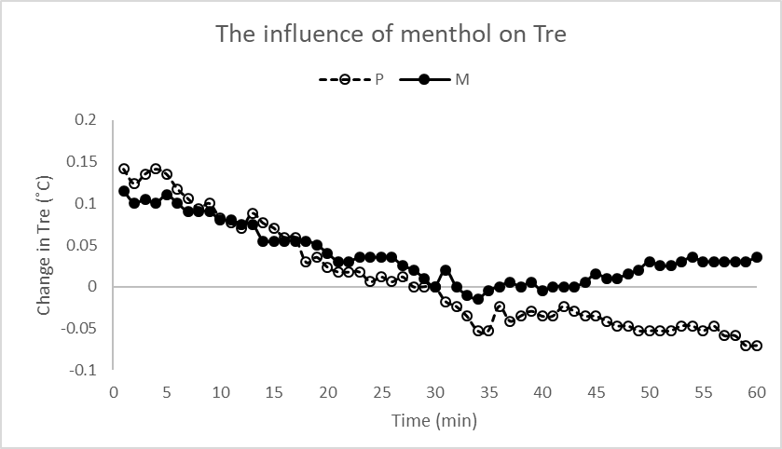

*Figure 1. Influence of Menthol on deep body temperature.*

*Table 1. Paired Two Sample for Means for deep body temperature t-Test statistical comparison*

|  |  |  |
| --- | --- | --- |
| ***Variable*** | ***AUC Placebo*** | ***AUC Menthol*** |
| Mean | -1.305882353 | 0.470588 |
| Variance | 3.039338235 | 3.072206 |
| Observations | 17 | 17 |
| Pearson Correlation | 0.048209848 |  |
| Hypothesized Mean Difference | 0 |  |
| df | 16 |  |
| t Stat | -3.036940227 |  |
| P(T<=t) one-tail | 0.003925063 |  |
| t Critical one-tail | 1.745883676 |  |
| P(T<=t) two-tail | 0.007850126 |  |
| t Critical two-tail | 2.119905299 |  |

**RER**

In Figure 2 the influence of Menthol on RER is displayed as the change in RER (respiratory exchange ratio) over a period of 60 minutes. Data were normalized to 0 at the 30th minute, after which gel was applied. RER between both conditions was averaged to 0.8006 with a standard deviation of 0.0535.

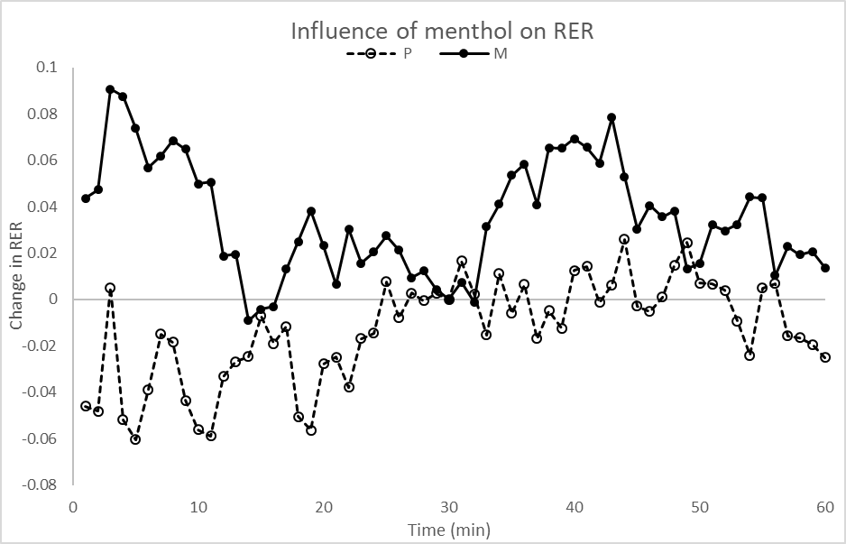

*Figure 2. Influence of Menthol on RER*

*Table 2. Paired Two sample for means for RER t-Test statistical comparison*

|  |  |  |
| --- | --- | --- |
| ***Variable*** | ***AUC  Placebo*** | ***AUC Menthol*** |
| Mean | -0.00984 | 0.970581 |
| Variance | 5.015806 | 0.099418 |
| Observations | 17 | 17 |
| Pearson Correlation | 0.569327 |  |
| Hypothesized Mean Difference | 0 |  |
| df | 16 |  |
| t Stat | -1.94688 |  |
| P(T<=t) one-tail | 0.034661 |  |
| t Critical one-tail | 1.745884 |  |
| P(T<=t) two-tail | 0.069323 |  |
| t Critical two-tail | 2.119905 |  |

AUC was analyzed between the 30 and 60-minute mark for both conditions. Statistical comparisons were calculated using a Paired Two Sample for Means t-Test and can be seen in Table 2. An alpha level of >0.05 was used to test for significance. These data showed that the AUC calculation for a two-tailed P comparison test were 0.0693, indicating that the alpha level was more than 0.05 and indicating that Menthol had no significant effect on RER when compared to the placebo condition. As can be seen on Fig. 2, these data are fairly chaotic, making it difficult to draw any meaningful conclusions from them.

**Absolute VO2**

In figure 3 the influence of Menthol on absolute VO2 is displayed as the change in absolute VO2 over a period of 60 minutes. Data were normalized to 0 at the 30th minute, after which gel was applied. Absolute VO2 between both conditions was averaged to 0.2648 with a standard deviation of 0.0214.

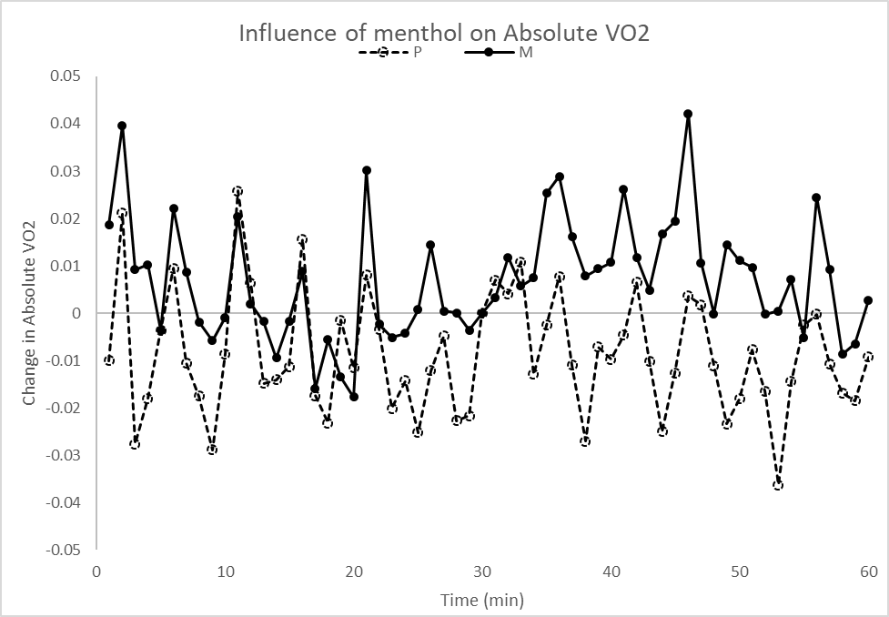

*Figure 3. Influence of Menthol on absolute VO2*

AUC was analyzed between the 30 and 60-minute mark for both conditions. Statistical comparisons were calculated using a Paired Two Sample for Means t-Test and can be seen in Table 3. An alpha level of >0.05 was used to test for significance. These data showed that the AUC calculation for a two-tailed P comparison test were 0.9073, indicating that the alpha level was more than 0.05 and further indicating that Menthol had no measurable effect on absolute VO2 when compared to the placebo condition. The Menthol containing dose, while reading higher than the placebo dose, does not change significantly after gel application.

*Table 3. Paired Two sample for means for Absolute VO2 t-Test statistical comparison*

|  |  |  |
| --- | --- | --- |
| ***Variable*** | ***AUC  Placebo*** | ***AUC Menthol*** |
| Mean | 0.265982 | 0.31709 |
| Variance | 1.441387 | 1.309025 |
| Observations | 17 | 17 |
| Pearson Correlation | -0.15619 |  |
| Hypothesized Mean Difference | 0 |  |
| df | 16 |  |
| t Stat | -0.11818 |  |
| P(T<=t) one-tail | 0.453699 |  |
| t Critical one-tail | 1.745884 |  |
| P(T<=t) two-tail | 0.907398 |  |
| t Critical two-tail | 2.119905 |  |

**Relative VO2**

In Figure 4 the influence of Menthol on relative VO2 is displayed as the change in relative VO2 over a period of 60 minutes. Data were normalized to 0 at the 30th minute, after which gel was applied. Relative VO2 between both conditions was averaged to 3.269with a standard deviation of 0.2854.

*Figure 4. Influence of Menthol on relative VO2*

*Table 4. Paired Two sample for means for relative VO2 t-Test statistical comparison*

|  |  |  |
| --- | --- | --- |
| ***Variable*** | ***AUC Placebo*** | ***AUC Menthol*** |
| Mean | 3.432968 | 3.909635 |
| Variance | 198.7949 | 192.1124 |
| Observations | 17 | 17 |
| Pearson Correlation | -0.04504 |  |
| Hypothesized Mean Difference | 0 |  |
| df | 16 |  |
| t Stat | -0.09724 |  |
| P(T<=t) one-tail | 0.461872 |  |
| t Critical one-tail | 1.745884 |  |
| P(T<=t) two-tail | 0.923745 |  |
| t Critical two-tail | 2.119905 |  |

AUC was analyzed between the 30 and 60-minute mark for both conditions. Statistical comparisons were calculated using a Paired Two Sample for Means t-Test and can be seen in Table 4. An alpha level of >0.05 was used to test for significance. These data showed that the AUC calculation for a two-tailed P comparison test were 0.9237, indicating that the alpha level was more than 0.05 and further indicating that Menthol had no measurable effect on relative VO2 when compared to the placebo condition. The Menthol containing dose, similar to absolute VO2, while reading higher than the placebo dose, does not change significantly after gel application.

**Supraclavicular Skin Temperature**

In Figure 5 the influence of Menthol on Supraclavicular skin temperature (Tsk-SC) is displayed as the change in Tsk-SC over a period of 60 minutes. Data were normalized to 0 at the 30th minute, after which gel was applied. Tsk-SC between both conditions was averaged to 34.54℃ with a standard deviation of 0.0949℃.

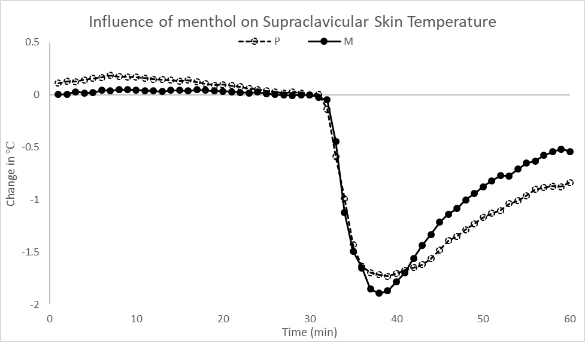

*Figure 5. Influence of Menthol on Supraclavicular Skin Temperature*

AUC was analyzed between the 30 and 60-minute mark for both conditions. Statistical comparisons were calculated using a Paired Two Sample for Means t-Test and can be seen in Table 5. An alpha level of >0.05 was used to test for significance. These data showed that the AUC calculation for a two-tailed P comparison test were 0.5320, indicating that the alpha level was more than 0.05 and further indicating that Menthol had no measurable effect on Tsk-SC when compared to the placebo condition. Figure 5 shows a measurable drop in Tsk-SC across both conditions upon gel application. However, the temperature response difference was not significant between conditions.

*Table 5. Paired Two sample for means for Tsk-SC t-Test statistical comparison*

|  |  |  |
| --- | --- | --- |
| ***Variable*** | ***AUC Placebo*** | ***AUC Menthol*** |
| Mean | -35.6427 | -30.9863 |
| Variance | 1035.498 | 582.2713 |
| Observations | 17 | 17 |
| Pearson Correlation | 0.459937 |  |
| Hypothesized Mean Difference | 0 |  |
| df | 16 |  |
| t Stat | -0.63872 |  |
| P(T<=t) one-tail | 0.266022 |  |
| t Critical one-tail | 1.745884 |  |
| P(T<=t) two-tail | 0.532044 |  |
| t Critical two-tail | 2.119905 |  |

**Laser Doppler**

In Figure 6 the influence of Menthol on blood perfusion is displayed as the change in blood perfusion units over a period of 60 minutes. Data were normalized to 0 at the 30th minute, after which gel was applied. Blood perfusion average temperature between both conditions was averaged to 436.9 blood perfusion units with a standard deviation of 77.54 blood perfusion units.

Area under the curve (AUC) was analyzed between the 30 and 60-minute mark for both conditions. Statistical comparisons were calculated using a Paired Two Sample for Means t-Test and can be seen in Table 6. An alpha level of >0.05 was used to test for significance. These data showed that the AUC calculation for a one-tailed P comparison test were 0.1346, which means that the alpha level was more than 0.05 and indicating that Menthol did not have a significant effect on blood perfusion. Notably however, the sample size for this condition was only n=6 participants due to an equipment malfunction.

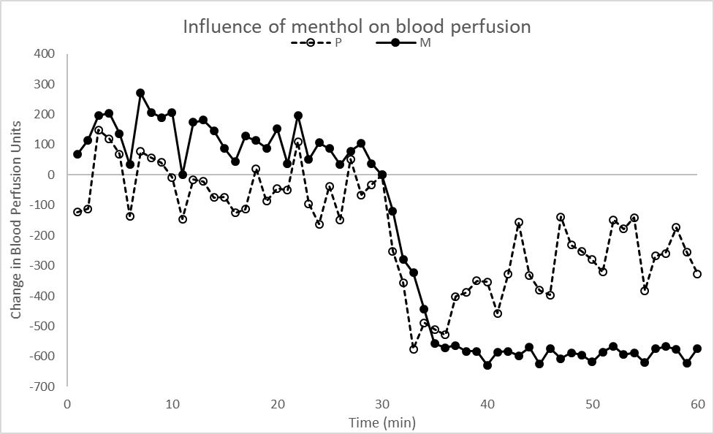

*Figure 6. Influence of Menthol on blood perfusion*

*Table 6. Paired Two sample for means for blood perfusion t-Test statistical comparison*

|  |  |  |
| --- | --- | --- |
| ***Variable*** | ***AUC Placebo*** | ***AUC Menthol*** |
| Mean | -9606.17 | -16453.1 |
| Variance | 94383729 | 34710699 |
| Observations | 6 | 6 |
| Pearson Correlation | -0.46414 |  |
| Hypothesized Mean Difference | 0 |  |
| df | 5 |  |
| t Stat | 1.242415 |  |
| P(T<=t) one-tail | 0.134587 |  |
| t Critical one-tail | 2.015048 |  |
| P(T<=t) two-tail | 0.269174 |  |
| t Critical two-tail | 2.570582 |  |

**Thermal Sensation**

In Figure 7 the influence of Menthol on thermal sensation is displayed as the change in thermal sensation over a period of 60 minutes. Due to the nature of the thermal sensation scale, raw data were used to display this change. Statistical comparisons were calculated using a Paired Two Sample for Means t-Test and can be seen in Table 7. An alpha level of >0.05 was used to test for significance.

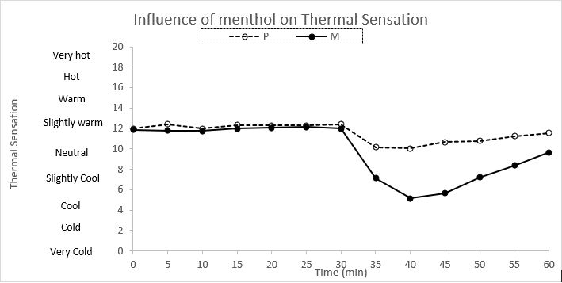

*Figure 7. Influence of Menthol on thermal sensation*

*Table 7. Paired Two sample for means for blood perfusion t-Test statistical comparison*

|  |  |  |
| --- | --- | --- |
| ***Variable*** | ***AUC Placebo*** | ***AUC Menthol*** |
| Mean | -7.60588 | -27.7647 |
| Variance | 85.94309 | 205.6974 |
| Observations | 17 | 17 |
| Pearson Correlation | 0.159914 |  |
| Hypothesized Mean Difference | 0 |  |
| df | 16 |  |
| t Stat | 5.266093 |  |
| P(T<=t) one-tail | 3.84E-05 |  |
| t Critical one-tail | 1.745884 |  |
| P(T<=t) two-tail | 7.68E-05 |  |
| t Critical two-tail | 2.119905 |  |

These data showed that the one-tailed P comparison test were 0.00003842, which means that the alpha level was less than 0.05 and indicating that Menthol had a significant effect on thermal sensation between the placebo and Menthol dose. This can be observed in Figure 7 with a dramatic dip in thermal sensation after the Menthol containing dose was administered.

**Discussion**

The experimental protocol of this study was adequately designed to indirectly address menthol’s influence on human temperature perception, regulation and energy expenditure. Specifically, the 30 minutes of rest prior to gel application did seem to cause thermal equilibrium for all participants and had the effect of lowering variability which allowed for a more controlled examination of menthol’s influence on the dependent variables. It should also be noted that the only difference between both conditions (placebo versus menthol) was menthol, which allowed any differences observed between conditions to be attributed to the action of menthol.,

The remainder of this discussion will address the main findings outlined in the results section, starting with deep body temperature. Figure 1 showed an increase in deep body temperature after Menthol application at the 30-minute mark. This should be contrasted with the placebo condition, which showed a continued drop in deep body temperature. Based on these findings, it can be concluded that Menthol produces a significant heat storage response. This finding supports the findings of Gillis et al., (2015), and Gillis, House and Tipton (2010) which were that Menthol spraying mediated a significant increase in deep body temperature when compared to their placebo conditions. The practical implication of this finding is that the resting protocol of this study was able to show a significant deep body temperature response to topical Menthol application.

Previous research by Gillis et al., (2015) has indicated that menthol-mediated cutaneous vasoconstriction was most probably the main factor leading to heat storage, but more recent research suggests that Menthol activates brown adipose tissue, which in turn might also be contributing to the Menthol-mediated heat storage response by increasing energy expenditure (Rossato et al., 2014; Velante et al., 2015). In an attempt to test this hypothesis, the present experiment assessed indirect markers of energy expenditure, including the respiratory exchange ratio, and oxygen consumption. In Figure 2, the influence of Menthol on RER can be seen, however, the results of this measure were not statistically significant. Because RER is an indirect measure of BAT activation, these results do not conclusively show that Menthol has no effect on BAT activation, but it does suggest that if any effect did exist, it’s probably not large enough to be measured using open circuit spirometry. This also suggests that any proposed BAT contribution to the heat storage response is probably small. It remains unclear why this measure showed such chaotic data. Previous research on the influence of Menthol on RER was not found in the literature review for this study. The implications of the results on this measure are that further research is warranted to establish an effect of Menthol on RER. In Figures 3 and 4, the influence of Menthol on absolute and relative VO2 can be seen; however, the results of this measure were not statistically significant. Because absolute and relative VO2 are also indirect measures of BAT activation, these results do not conclusively show that Menthol has no effect on BAT activation, rather they merely suggest it does not show a clear response to Menthol, and that any possible influence is small. Again, it remains unclear why these measures showed such chaotic data. Previous research on the influence of Menthol on absolute and relative VO2 was not found in the literature review for this study. The implications of the results for these measures are that further research is warranted to establish an effect of Menthol on absolute and relative VO2. In Figure 5, the influence of Menthol on supraclavicular skin temperature can be seen; however, the results of this measure were not statistically significant between conditions. Brown adipose tissue is known to be located at the supraclavicular region, and it could be hypothesized that an increase in it with menthol might be a sign of menthol-mediated BAT activation. However, any such elevation in skin temperature might also be due to an increase in blood temperature at the carotid artery, which happened *after* menthol caused cutaneous vasoconstriction in other body regions, and lead to the heat storage response.

As previously mentioned, the menthol-mediated heat storage response has traditionally been attributed to cutaneous vasoconstriction. In Figure 6, the influence of Menthol on blood perfusion can be seen, however the results of this measure were not statistically significant. While it does appear as if the Menthol and Placebo conditions have different responses, the difference was not large enough to establish an effect. Due to a software issue, all but six participant data sets were rendered unusable. Therefore it is difficult to establish significant findings with such a small sample size. Previous research on the influence of Menthol on blood perfusion (Gillis et al., 2015; Gillis, House and Tipton, 2010) did show a reduction in skin blood flow response to Menthol. The implications of the results for these measures are that further research with a larger sample size is warranted to establish an effect of Menthol on blood perfusion.

Separate from menthol’s influence on physiology is its influence on perception. In Figure 7, the influence of Menthol on thermal sensation can be seen, and the results of this measure were statistically significant. These data suggest a significant effect of Menthol on thermal sensation. Previous research by Gillis, House and Tipton (2010), Gillis et al., (2015) on the influence of Menthol on thermal sensation also showed similar effects. This study then, supports the findings of previous research in regards to the influence of Menthol producing an increase in cooling sensation when compared to a placebo gel.

**Limitations**

The current gold standard in BAT measurement is cold-induced 18F-fluorodexyglucose (FDG) positron emission tomography-computed tomography (PET-CT). Because we did not have access to such specialized equipment, indirect measurement of BAT was required. Recently, Boon et al., (2014) found a strong correlation between supraclavicular skin temperature and BAT activation measured with PET-CT scanning, so this measure was used, along with other indirect measures of fat utilization i.e. RER, and oxygen consumption, both calculated using open circuit spirometry. It should also be noted that a number of other variables were measured or calculated in this experiment but were not presented in the present paper in order to limit the scope of this undergraduate research project and improve its presentation. Other doses of Menthol were also tested in this experiment, but so as to limit the scope, their data are not presented here. Furthermore, the laser doppler blood perfusion measure failed and the opportunity to better describe what drives the Menthol-mediated heat storage response was missed. Also, while external metabolic influencing factors were well controlled for, and the 30-minute resting protocol seemed to be more than adequate, the respiratory measures collected in this study were very chaotic, rendering their results insignificant.

**Conclusions**

Menthol appears to cause the body to perceive that it is cooler than it is (lower thermal sensation score), while simultaneously causing it to store more heat (rectal temperature elevation). The alteration in perception is probably caused by activation of the cold receptor TRMP8 by menthol. The heat storage response is most probably mediated by TRPM8, leading to a reduction in skin blood flow, which causes the body to decrease the amount of heat that is lost to the environment. The results from the present experiment could not conclude that menthol activates brown adipose tissue. However, because only indirect measures of BAT activation were used, further research is warranted. While this study was not able to establish a clear BAT activation response to Menthol gel, these results are still promising. It could be hypothesized that PET-CT scanning would show a clearer effect of BAT activation if used in conjunction with a similar protocol.

Despite the insignificant findings of several of the measures, the alternative hypothesis that Menthol produces a change in temperature perception and thermoregulation can be supported, and the hypothesis that menthol will cause no change in energy expenditure cannot be rejected. This research study has helped establish that menthol has a physiological and perceptual effect on the body and that further research with PET-CT scanning is warranted.

**References**

Boon, M. R., Bakker, L. E., Rianne A. D. Van Der Linden, Arias-Bouda, L. P., Smit, F., Verberne, H. J., . . . Rensen, P. C. (2014). Supraclavicular Skin Temperature as a Measure of 18F-FDG Uptake by BAT in Human Subjects. PLoS ONE, 9(6). doi:10.1371/journal.pone.0098822

Burton, A. C. (1935). Human Calorimetry, The average temperature of the tissues of the body. The Journal of Nutrition, 9(3), 261-280. doi:10.1093/jn/9.3.261

Gillis, D. J., House, J. R., & Tipton, M. J. (2010). The influence of menthol on thermoregulation and perception during exercise in warm, humid conditions. European Journal of Applied Physiology, 110(3), 609-618. doi:10.1007/s00421-010-1533-4

Gillis, D. J., Weston, N., House, J. R., & Tipton, M. J. (2015). Influence of repeated daily menthol exposure on human temperature regulation and perception. Physiology & Behavior, 139, 511-518. doi:10.1016/j.physbeh.2014.12.009

Green, B. G., Shaffer, G. S., & Gilmore, M. M. (1993). Derivation and evaluation of a semantic scale of oral sensation magnitude with apparent ratio properties. Chemical Senses, 18(6), 683-702. doi:10.1093/chemse/18.6.683

Hong, S. I., & Nadel, E. R. (1979). Thermogenic control during exercise in a cold environment. Journal of Applied Physiology, 47(5), 1084-1089. doi:10.1152/jappl.1979.47.5.1084

Israel, D. J., & Pozos, R. S. (1989). Synchronized slow-amplitude modulations in the electromyograms of shivering muscles. Journal of Applied Physiology, 66(5), 2358-2363. doi:10.1152/jappl.1989.66.5.2358

Pescatello, L. S., & A. (2014). ACSMs guidelines for exercise testing and prescription. Philadelphia: Lippincott Williams & Wilkins.

PubChem: Levomenthol. (2018). Retrieved April 10, 2018, from https://pubchem.ncbi.nlm.nih.gov/compound/menthol#section=Top

Rossato, M., Granzotto, M., Macchi, V., Porzionato, A., Petrelli, L., Calcagno, A., . . . Vettor, R. (2014). Human white adipocytes express the cold receptor TRPM8 which activation induces UCP1 expression, mitochondrial activation and heat production. Molecular and Cellular Endocrinology, 383(1-2), 137-146. doi:10.1016/j.mce.2013.12.005

Toxnet: Menthol. (2015, December 23). Retrieved April 10, 2018, from https://toxnet.nlm.nih.gov/cgi-bin/sis/search/a?dbs hsdb:@term @DOCNO 593

Valente, A., Carrillo, A. E., Tzatzarakis, M. N., Vakonaki, E., Tsatsakis, A. M., Kenny, G. P., Flouris, A. D. (2015). The absorption and metabolism of a single L-menthol oral versus skin administration: Effects on thermogenesis and metabolic rate. Food and Chemical Toxicology, 86, 262-273. doi:10.1016/j.fct.2015.09.018

Vijgen, G. H., Bouvy, N. D., Teule, G. J., Brans, B., Hoeks, J., Schrauwen, P., & Lichtenbelt, W. D. (2012). Increase in Brown Adipose Tissue Activity after Weight Loss in Morbidly Obese Subjects. The Journal of Clinical Endocrinology & Metabolism, 97(7). doi:10.1210/jc.2012-1289

Zhang, H., Huizenga, C., Arens, E., & Wang, D. (2004). Thermal sensation and comfort in transient non-uniform thermal environments. European Journal of Applied Physiology, 92(6), 728-733. doi:10.1007/s00421-004-1137-y