The Evolution of Structural Racism

Ayana Green
Professor Levy
POL 500
1 December, 2015

With the election of our current president Barack Obama, many believe that racism had finally ended and equality amongst all has finally been achieved, unfortunately this is not the case. Although a lot has changed for people of color, such as an increase in opportunities for success, there is still a major disconnect between the playing field of Caucasians and people of color. The United States is run by a series of institutions that monitor its population, but it is these exact institutions that continue to cultivate inequality. Ta-Nehisi Coates describes racism as “the need to ascribe bone- deep features to people and then humiliate, reduce and destroy them” (Coates 2015, 7). Our political institutions such as political parties, courts, and branches of government have helped to promote racism since the ending of slavery. Although racism is not as blatantly overt as it used to be, it still hinders people of color from having equal opportunities for success.
Structural racism in the United States is the “system of hierarchy and inequity, primarily characterized by white supremacy- the preferential treatment, privilege and power for white people at the expense of Black, Latino, Asian, Pacific Islander, Native American, Arab, and other racially oppressed people” (Lawrence 2004). Structural racism is highly driven by personal prejudices that have been passed down from generation to generation. Ian Haney Lopez argues that “race remains a social system in which persons from different positions in the racial hierarchy seek, or contest their exclusion from social and material status” (Lopez 2006). Race can be determined based on three interrelated levels and perspectives.
The first is determined by physical features and lines of descent because society has associated certain characteristics with a variety of racial meanings. The second is the social process of ascribing racialized meaning to faces and forbearers that lie at the heart of racial fabrication. The third is the distribution of wealth and poverty which turns in part of the legal and social actions which have accepted ideas of race, with the resulting material conditions becoming part and reinforcement for the contingent meaning of race. Race is fully arbitrary and reinforces personal prejudices. Personal prejudice is “an unjustified or incorrect attitude (usually negative) towards a person or group of people, based solely on the individual’s personal beliefs or morals and not on true facts” (McLeod 2008). Both structural racism and personal prejudices are lethal to the progression of equality amongst all in the United States, but because these toxins remain hidden behind and protected by the institutions that run our country, they are subconsciously accepted and are damaging to the “non-white” community, as slavery was when it was first implemented in 1619, just in different severities.
As a society, the United States must recognize that the fight for equality is not over, but rather is as prevalent today as it has been in history. Michelle Alexander argues that “the fact some African Americans have experienced great success in recent years does not mean that something akin to a racial caste system no longer exist” (Alexander 2010). Structural Racism has never stopped evolving since it was first implemented into society, when 20 Africans were brought to Jamestown and were sold into slavery.
The first time one is introduced to structural racism is with the establishment of slavery in the early 1600’s. Slavery was solely based on the idea of ethnocentrism. Ethnocentrism is “the judging of another’s culture based solely on the values and standards of one’s own culture” (Random House n.d.). This is the idea that one’s race inherently is superior to the next. Before slavery began, indentured servants were used to perform cheap labor. There was no race associated with indentured servitude; they were merely the poorest of the poor. The transition from indentured servants to slavery occurred with the increase of demand for cheap labor. Africans were the best option for slavery because unlike Native Americans and poor whites, they were usually a part of a small group hugely outnumbered by the Europeans in the new land that they were brought to (Alexander 2010). To help decrease this fear of multicultural relations, the plantation elites offered special privileges to poor whites and the alliance was established, birthing the discrimination and isolation of African Americans.
The South’s economy depended heavily on slavery and cheap labor. Without the establishment of a racial hierarchy, it was thought that the South would surely collapse. The North did not fully understand the need for the slaves and this caused uncompromising differences between the free and slave states. The North and the South argued about the power of the national government to prohibit slavery in the territories that had not yet become states. These differences led to the Civil War and as a result, the demise of slavery and the demise of the South.
Structural racism was reconstructed during the first Civil Rights Act in 1866 and continued to form throughout the Reconstruction Era in 1867. The emancipation of slavery led to the desire to maintain the superiority of white men, justified by ethnocentrism. With the passing of the Thirteenth, Fourteenth and Fifteenth Amendments, Africans Americans began to obtain more power and were achieving more rights which were diminishing the separation established by Caucasians elite.
African Americans believed the passing of these new laws would end all racial inequality and the racial caste system would finally be eradicated almost two hundred years after its birth. Unfortunately, they were wrong. To counteract the passing of this equality based law, nine Southern states adopted vagrancy laws- which were the beginning of the Jim Crow laws. The second reconstruction of racism came with the Jim Crow Laws which promoted the fact that people of color could be considered equal citizens in law but only if they were isolated and prevented from acting on any of their legally given rights.
As African Americans began to obtain more power and become actually equal with the Caucasian citizens, whites reacted with panic and outrage and thus the Ku Klux Klan was founded in 1865. “As African Americans obtained political power and began the long march toward greater social and economic equality, whites reacted with panic and outrage” (Alexander 2010). The Ku Klux Klan’s campaign revolved around the major theme of fear. Their main goal through the use of terrorism was to redeem the South and return it back to the pre-reconstruction era (Project 2011). “Their campaign to redeem the South was reinforced by a resurgent Ku Klux Klan, which fought a terrorist campaign against Reconstructive governments and local leaders, complete with bombings, lynching’s and mob violence” (Alexander 2010). To help maintain the inferiority of African Americans, the Jim Crow laws were established and enforced by the state, but the Ku Klux Klan also played a huge role locally.
Almost one-hundred years later, the Civil Rights Movement was born. In 1950, with extraordinary bravery, civil rights leaders and activists began to launch boycotts, marches and sit-ins, protesting the Jim Crow laws. They endured a lot of inhumane punishments such as the bombing of their homes, beatings with fire hoses, public humiliation and lynchings. Yet, these things could not stop their will to achieve integration and equality. In 1963, the efforts of the civil rights leaders pressured a somewhat reluctant John F. Kennedy to take a stand with the movement for civil rights. However, with the assassination of Kennedy, Lyndon Johnson had to represent the federal government and continue to federally support the Civil Rights Movement.
The Civil Rights Act of 1964 dismantled the Jim Crow system of discrimination. Yet, the white elite in this nation is very resilient and in reaction to the end of the Jim Crow system, they decided to take a less aggressive approach to racism and discrimination, and thus the New Jim Crow was created. Because the New Jim Crow is not overt, it can only be tracked by identifying the inconsistencies of equality which are embedded within the institutions that run our nation.
The three most significant structures that over time have evolved to protect and hide inconsistencies, which lead to inequalities between whites and non- whites, are our housing, education and legal system. When it comes to land distribution, and who is allowed to live in certain cities and counties, our housing system in completely inconsistent and unequal.
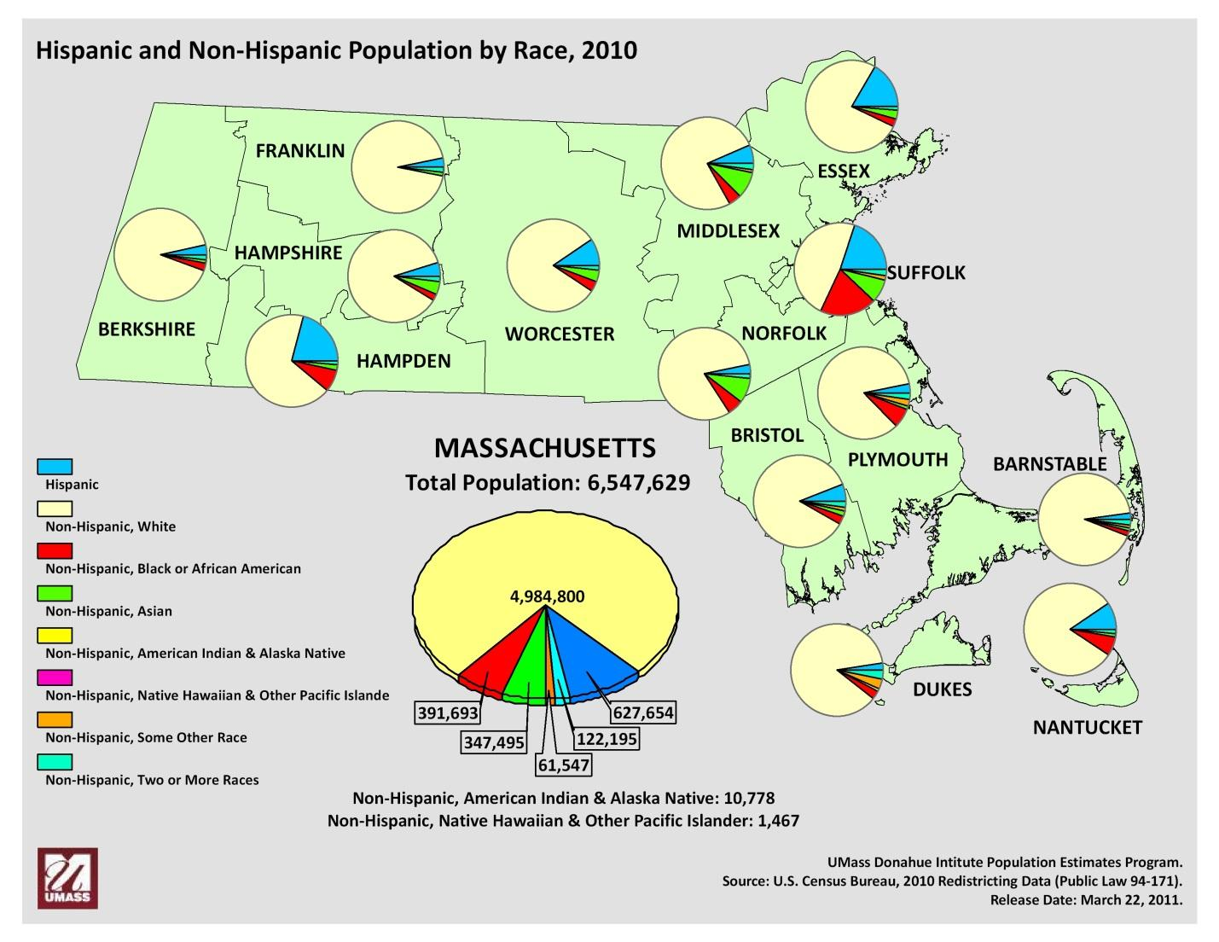
Figure 1: (MassBenchmarks 2015)
This image shows the different districts of Massachusetts and the demographics of each particular district. It shows the breakdown of each ethnic group that could be found in Massachusetts. In the middle of the image, there is a pie chart of all of Massachusetts population and it breaks down the division of ethnic groups and gives the exact number of how many members belong to each ethnic group.
It is very important to note where the majority of minorities are located, which is the Suffolk district. The Suffolk district includes Boston, Chelsea, North Chelsea, Revere and Winthrop.

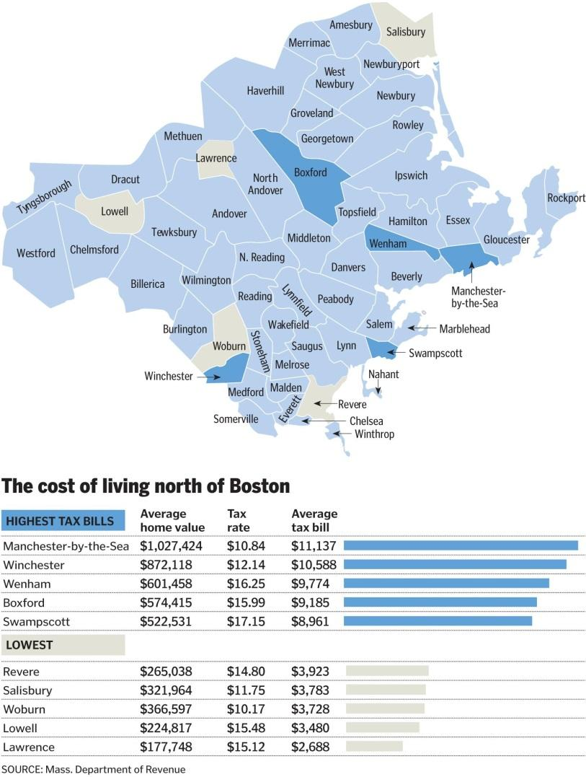
Figure 2: (Buote 2015)
This image shows the average home value, tax rate and average tax bill of the highest and lowest cities in Massachusetts. If you compare Figure 1 and Figure 2, it is obvious that the districts with the most minorities are also the districts with the lowest average home value and lowest average tax bill.
Public housing was first introduced to the United States in 1937, with the passing of the Housing Act by the federal government. “The Wagner- Steagall Act set very low maximum income requirements for public housing residents. This policy was intended to alleviate fears that public housing would compete with the private market, but it ultimately led to high concentrations of poverty within public housing projects (Boston n.d.). Public housing was not originally created to house the very poor, but was intended to help the working class (United States 1937; Bauman 1987; Atlas and Drier 1992; Marcuse 1995). It was created as an outlet for the middle class that was suffering tremendously from the Depression. After World War II, through the VA and FHA, working class people were able to buy homes using low- interest mortgages. This is the first time inequality is exemplified within the housing department. Whites were encouraged to move to the suburbs but blacks were kept concentrated in the cities and inner suburbs. “The distribution of federal benefits made it possible for mostly white working- class people to move out of public housing, and contribute to a downward income shift in the public housing population after the 1940’s (Massey and Denton 1993).
Public housing has now evolved into targeting the poorest of the poor, acting as a solution for inner-city poverty and isolation, fulfilling the basic human necessity of shelter. The idea then became to help protect the inner-city population by allowing them the humane right to shelter and protection, eventually increasing their livelihood. The exact purpose of the act was “…to alleviate present and recurring unemployment and to remedy the unsafe and insanitary housing conditions and the acute shortage of decent, safe and sanitary dwellings for families of low income” (United States 1937). This housing was intended to be consumed by “families in the lowest income group who cannot afford to pay enough to cause private enterprise…to build an adequate supply of decent, safe and sanitary dwellings…” (United States 1937). The only restriction for tenants is that their income could be no higher than five times the rental cost of the unit.
The Civil Rights Act of 1964 not only ended racial discrimination by no longer allowing racially segregated projects, but it also contributed to the movement of whites out of racial integrated projects. Over time a wait list was created, given those most disadvantaged, like the homeless or displace, preference. These changes encouraged by the Civil Rights Act of 1964 and the combination of income limits led to the public housing residents being drawn from the “poorest of the poor”, rather than from the middle class. Anyone who could afford to move elsewhere moved out of public housing. Whites had more opportunities than minorities and therefore they were able to take advantage of government subsidies that promoted homeownership.
The idea of public housing appealing to the poor only continued to expand with the elimination of rent ceilings in 1981. The proportion of tenants with incomes over 50% of median was limited and rents were changed to reflect 30% of adjusted income (Feins, Merrill et al. 1994). In 1987, rent ceilings were reintroduced but so were federal preferences for tenants. Public housing began to evolve into an institution that protected and nourished structural racism and inequalities between whites and non-whites. For example, in New York, “the Williamsburg Houses project in Brooklyn was built in 1935 for whites, and the Harlem River Houses project in Manhattan was built to house blacks” (Stoloff n.d.). Harlem River Houses was seen as a way to prevent demand by African Americans for access to the housing being provided in all- white communities (Marcuse 1986a).
There are many counter arguments as to why people of color need public housing, one of which is the idea that people of color are lazier than Caucasians and would rather depend on government assistance than to go out and work. Presidential candidate, Donald Trump, is one individual whose has mentioned this idea of people of color being lazy several times during his campaign. On October 25, at an event in Indiana, Trump said, “African Americans are very lazy. The best they can do is gallivanting around ghettoes, lamenting how they are discriminated. These are people America doesn’t need. They are the enemies of progress.”
Another example that exemplifies the inequalities protected within the institution of public housing is seen within Chicago’s public housing system in the 1960’s. Council members had veto power when it came to placing new public housing developments in their wards, and therefore all units were located in black areas of residence. The court case Gautreaux successfully challenged this situation but the implementation was faced with enormous resistance. This led to public housing being stalled for several years until the laws were changed and the Chicago Housing Authority was allowed to operate without city approval. The compromise that was mandated included issuance of Section 8 certificates that residents could use to move to privately- owned housing in mostly white suburbs.
The results of the successful cases were that the U.S Department of Housing and Urban Development (HUD) issued regulations prioritizing racial deconcentrating as a site selection factor (Stoloff n.d.). Unfortunately, HUD could not guarantee the enforcement of regulations or the compliance with the goal of desegregation. Some localities turned down federal money to avoid following the new regulations. Eventually it became subconsciously accepted that those who are wealthy, primarily white, lived in the suburbs and those who were closer to being poverty, non-whites, lived in the inner city. Because the wealthy can afford to pay higher property taxes and they have a significantly higher income than the minorities in the inner city, the inequity of resources and opportunities are extremely noticeable. The land distribution and upkeep of towns and counties are too very different. Because people of color are somewhat forced to remain in the inner city, their property value is significantly less than those of the suburban areas. This is a result of crime, crowdedness, and debris that is found in the towns and counties of the inner-city. The parks are also usually run down and the city itself just looks damned. As for the suburbs, their curb appeal is immaculate. Their houses are usually bigger, with a lot of land to accompany it. The roads are usually well taken care of and the parks are top notch. “The median net worth of white households is now 20 times that of black households” (Brown 2012)
These cases are a great example of the non-unitary nature of the United States government. Even when the Federal level of government might be committed to a certain policy, state and local governments which are opposed to it can frustrate it. Another perfect example of this is Obamacare. Although it was passed federally a lot of states had conflict with its purpose and prolonged its enforcement.
The idea of housing discrimination and racial segregation is supported through the encouragement of indeed; subsidize racial and economic segregation but the federal state and local housing policies. Real estate agents also play a huge role in maintaining the segregation seen within the housing institutions. Real estate agents “promote segregation- and deny African Americans- the opportunity to buy into high- value areas that would provide better education for children and greater return on their investments” (NY Times 2015). A study conducted by the Brookings Institution in 2001 shows that “wealthy minority neighborhoods had less home value per dollar of income than wealthy white neighborhoods”. This study also shows that “poor white neighborhoods had more home value per income than poor minority neighborhoods” (Brown 2012). Douglas Massey and Johnathan Tannen from Princeton researched the property value of neighborhoods in 1970. They found that “the average well- off black American lived in a neighborhood where potential home wealth, as measured by property values, stood at about $50,000- as opposed to $105, 000 for affluent whites and $56,000 for poor whites” (Massey and Tannen 1970). It is known that real estate agents make their living based on the commission they received when they show a home and their clients buy it. It is safe to assume that real estate agents have a subconscious desire to maintain segregation within the housing institution because it will keep their pockets full. If housing becomes desegregated, the property values of neighborhoods would lose its gap and shift closer towards equality.
The subconscious acceptance of inequality within our housing institutions has led to the subconscious acceptance of inequalities within our public education institution as well. States vary in the extent to which education is funded by local governments or state governments. “ For example, in Hawaii the state pays about 90% of educational expenses, as compared to New Hampshire, where 90% is paid by the local school district” (Government 2014). Most schools are funded by property taxes; many prosperous communities are able to collect more taxes than poorer communities, because property value is much lower. Education is a huge factor in the cycle of oppression. Because of the amount of money and resources public schools are given are determined based on the amount of money the town can compile in property taxes, it is obvious based on the housing institutions that the inner city schools struggle with resources, in comparison to the suburbs, because of their budget. With a bigger budget, there is more money that could be allocated towards extracurricular activities, textbooks, computers, art supplies, musical instruments, etc. These are all things essential to the proper development of our children. We as a nation depend on the education of our children because they are our future. We want our children to be well educated and well-rounded individuals, but the resources allocated to the inner city children, in comparison to the suburban children, only proves that our future will continues to have inequalities protected by the institutions that run our country.
Based on the Best Public Schools in Boston 2015- Sortable Chart, the top five districts with the best education for grade 10 are suburban. These five districts include: Stoneham, Norton, Hadley, Shrewsbury and Bourne. These districts are chosen based on low class sizes, low student-to- teacher ratios, and higher rates of per-pupil spending. Standardized testing scores also are taken into consideration (Boston 2015).

District Rankings for Achieving Good Performance
 | Grade 4 |  | Grade 8 |  | Grade 10
Rank based on the model* | School District | Rank based on actual scores | School District | Rank based on actual scores | School District | Rank based on actual scores
1 | Sutton | 53 | Nantucket | 52 | Stoneham | 28
2 | Clinton | 82 | Medway | 9 | Norton | 26
3 | Eastham | 47 | Clinton | 78 | Hadley | 43
4 | Hadley | 27 | Wellesley | 2 | Shrewsbury | 21
5 | Everett | 130 | Hamilton Wenham | 5 | Bourne | 90
6 | Oxford | 83 | Dighton Rehoboth | 49 | Provincetown | 149
7 | Monson | 41 | Hadley | 60 | Grafton | 34
8 | Lynnfield | 8 | Hanover | 39 | Harwich | 37
9 | Tyngsborough | 74 | Sandwich | 33 | Norwell | 8
10 | Methuen | 112 | Stoneham | 46 | Tyngsborough | 115
11 | Lenox | 15 | Central Berkshire | 42 | Gill Montague | 130
12 | North Brookfield | 78 | Methuen | 127 | Westborough | 15
13 | Southbridge | 143 | Lee | 72 | Dennis Yarmouth | 84
14 | Shrewsbury | 25 | Tyngsborough | 57 | North Adams | 106
15 | Medfield | 6 | East Longmeadow | 55 | Amherst-Pelham | 10
16 | Spencer East Brookfield | 108 | Milford | 106 | Hanover | 38
17 | Holbrook | 115 | Middleborough | 108 | Mendon Upton | 56
18 | Tewksbury | 85 | North Reading | 14 | Chelsea | 214
19 | West Bridgewater | 63 | Medford | 136 | Southbridge | 143
20 | North Attleborough | 65 | Hingham | 19 | North Brookfield | 65
21 | Franklin | 28 | Norwell | 25 | Webster | 165
22 | Southwick Tolland | 98 | Carver | 141 | Mansfield | 81
23 | Mansfield | 80 | Swampscott | 31 | Ayer | 120
24 | Walpole | 32 | Beverly | 54 | Hingham | 25
25 | Southborough | 24 | Hull | 145 | Bridgewater Raynham | 80
26 | Lee | 113 | Gloucester | 140 | Northboro-Southboro | 5
27 | Foxborough | 45 | Barnstable | 79 | Malden | 158
28 | Hatfield | 89 | Northampton | 67 | Pittsfield | 150
29 | Grafton | 61 | Leominster | 146 | Needham | 14
30 | Wachusett Reg. | 26 | Quincy | 110 | Sharon | 13
31 | Lexington | 4 | Arlington | 37 | Braintree | 68
32 | Mendon Upton | 17 | Greenfield | 152 | Reading | 30
33 | Westford | 9 | Chelsea | 189 | Nauset | 45
34 | Cambridge | 163 | Concord | 4 | Gloucester | 153
35 | Springfield | 205 | New Bedford | 188 | Belchertown | 62
36 | Littleton | 22 | North Attleborough | 83 | Greenfield | 147
37 | East Longmeadow | 14 | Attleboro | 153 | Westwood | 2
38 | Holyoke | 214 | Silver Lake | 89 | Cohasset | 7
39 | Norwood | 36 | Pittsfield | 149 | South Hadley | 112
40 | Easton | 52 | Amesbury | 93 | Ware | 203
41 | North Reading | 11 | Groton Dunstable | 22 | Sandwich | 55
42 | Dartmouth | 134 | Worcester | 179 | Milford | 107
43 | Chelsea | 212 | Amherst-Pelham | 32 | Lenox | 4
44 | Wellesley | 7 | Ralph C Mahar | 139 | Worcester | 194
Figure 3: (Boston 2015)

There are 215 different cities and towns located within Massachusetts. Figure 3 represents the top cities and towns in terms of good performance for grade 4, 8 and 10. As you can infer from the chart, the majority of well performing schools are from suburban towns and cities.
One thing that is overlooked whenever comparing different public schools in different cities and towns is the number of public schools that are available in each city and town. For example there are 125 Boston Public Schools in Boston, Massachusetts. For SY2016, 56,650 students were enrolled. 41 percent of students are Hispanic. 35 percent of students are Black. 14 percent of students are white. 9 percent of students are Asian and 1 percent of students are other/multiracial (Schools 2015).
Dover- Sherborn is the richest town in Massachusetts as of 2015. Finding the enrollment data for Dover- Sherborn was a lot more difficult than it was for Boston Public Schools. According to the Massachusetts Department of Elementary and Secondary Education (ESE) 2015 Enrollment Data, Dover- Sherborn is responsible for only four schools for the whole district. They have two elementary schools, one middle school and one high school. In 2014-15, 1,838 students enrolled into Dover- Sherborn schools. 2.1 percent of students were African American. 6 percent were Asian. 2.5 percent were Hispanic. 86.5 percent were white and 2.9 percent were multi-race or non- Hispanic.
In the inner city, resources are already slender because of the amount of property taxes being paid, but to add on to the inequality, there are a lot more schools in this district. This means that the already small budget must be split between each school, allowing even less resources to be available for students. The better school or town with the so- called better schools, Dover, has 86 percent of white children and 2 percent of black children. The more crowded and less funded schools, BPS, have 41 percent black children and 14 percent white children. Brown v. Board of Education ruled against “separate but equal” in 1954, which was 61 years ago. Yet, our schools systems have are still somewhat segregated. Inequality is still a big problem and there is no effort to change this system. Once again, we as a nation subconsciously have accepted structural racism by accepting the inequality of education for our children. Yet, as a nation, we still wonder why crime rates in the inner city are higher than that of the suburbs.
Our legal system is embedded with structural racism and that is another reason why crime is high in the inner city, in comparison to suburban areas. Our legal system protects and hides the inequalities that keep structural racism alive. In America, mass incarceration has been normalized because of inconsistencies within our legal system. When the corrections system was first created in the 1500s, it was created with the intent to rehabilitate criminals, not punish them. Sociologist, David Garland argues that “the corrections system was commonly seen as a way to prepare offenders to rejoin society but since then; the focus has shifted from rehabilitation to punishment and continues to stay there” (Papachristou 2011, 22). So the question of the day is, why are the punishments allocated to criminals increasing in severity, if crime rates are falling? There is no definite answer to the question but we must recognize that imprisonment rates have continued to rise while crime rates have fallen and this is because of structural racist practices.
One thing to note though is that the majority of criminals in America’s prisons are minorities. So America’s need to be more punitive towards criminals is not equally distributed amongst race but instead is targeted towards minorities, especially those of African American and Latino descent. It is evident that our legal system is outdated, bias and prevents a lot of minorities, especially African American males, from achieving a decent living. The inconsistencies within our legal system began with the introduction of drugs by the CIA. The CIA is responsible for intensifying the war on drugs. “The CIA admitted in 1998 that guerrilla armies in Nicaragua were smuggling illegal drugs into the United States- drugs that were making their way onto the streets of inner- city black areas of residence in the form of crack cocaine (Alexander 2010). Unfortunately, drugs are a quick and easy way to make money. For a young poorly educated non- white male, living in poverty, drugs seemed like the best and most efficient way to support his family. With two of the most vital institutions working to make the life of minorities harder, it is no mystery as to why young non-white males fell into the drug world.

It is hard not to note that America’s prison system is geared toward isolating and in criminalizing minorities. 90 percent of all criminal convictions come from negation pleas. 1/20 white men will be imprisoned during their lifetime. 1/3 of black men will be imprisoned during their lifetime. 1/6 of Latino men will be imprisoned during their lifetime. 1/111 white women will be arrested during their lifetime. 1/45 Latino women will be imprisoned during their lifetime and 1/18 black women will be arrested during their lifetime. There are 313.9 million citizens in the United States as of 2012. There are approximately 151.4 million male citizens and 158.6 million female citizens. 77 percent of the United States populations are made up of white citizens. 16 percent of the population is made up of Latinos. 13 percent of the population is made up of blacks. 5 percent is made up of Asians. 2 percent are made up of two or more races and one percent is made up of Native American (Alexander 2010). What do these numbers mean? Basically being that the majority of the population is white, you would think that the prison system would reflect that. In all actuality, the prison system is the exact opposite of that the prison system should look like. One then wonders, why are the United States prison systems so racially unequal? There are four simple answers to this question; the war on drugs, Unlawful search and seizures and lack of trials.
The first factor to examine is the war on drugs. Basically the CIA admitted to the fact that they were aware of drugs being smuggled into the United States and they did not try and stop them from entering. Also, they were aware of the fact that these drugs were being presented in black neighborhoods and chose instead to increase the amount of stop-and-frisks and raids. President Nixon was the first to declare a war on drugs. Nixon was in office during the 60s and early 70s and he connected the war on drugs with civil disobedience and increase in crime levels, but actually during the declaration of a war on drugs, America’s crime rate was on a decline. Ultimately, Nixon tried to blame all of the chaos of the streets on minorities. Nixon specifically said, “The increasing crime rate can be traced directly to the spread of the corrosive doctrine that every citizen possesses an inherent right to decide for himself which laws to obey and when to disobey them.” He was referring to the boycotts, protest lead by civil right activist during this time and the antiwar movement. John Ehrlichman used the words of President Nixon to help support his ideology that “we have to face the fact that the whole problem is really the blacks. The key is to devise a system that recognizes this while not appearing to” (Alexander 2010). This system of which he speaks is the legal system, hints as to why there is a racial inequality seen in our prison systems.
Another major reason as to why there is an ethic gap seen in prison is because of how arrests are being made. Unlawful stop-and-frisks are occurring each day and are one of the leading causes of arrest in the inner city. In New York, citizens were stop and frisked 191,000 times. 88 percent were innocent. Of the 191,000, 56 percent were black, 29 percent were Latino and 11 percent were white (NYCLU Stop and Frisk Data 2013).This unjust use of trying to arrest citizens leads to another unlawful act, commonly seen in our legal system, which is the lack of trial. Now it is lawful to resist trial and take a plea, but like stated above, 90 percent of all convictions are made without trial. A lot of people who are arrested are over charged and face an overwhelming amount of jail time.
To avoid this conviction they are advised by the prosecutor to take the plea. Their attorney, if present, is frequently either fresh out of law school or is so busy they advised the client to take the plea, even if they are completely innocent. That is the major problem with America’s legal system. Not only does this form of justice act against the innocent but what many forget is the fact that once you are arrested and convicted you lose all rights to vote, public benefits, and in many cases employment. If you are arrested but not convicted you still lose the right to vote and in many cases employment. The white supremacist that used the prison system as the third form of racial reconstruction was smart. They could continue to ensure minorities stay inferior through the use of the prison system, using the assumption that people of color are more violent as the base for the reasoning behind the inequality seen in the prison system. Think about it. If the majority of minorities are the ones getting arrested, they can never compete in the real world because of the fact they lose all rights once arrested. They cannot vote, leading the people who have not been arrested (white supremacist) to vote. Minorities lose the opportunities for employment meaning that there is less competition for jobs.
It is apparent that racism still exists today but because it is not as overt as slavery or the Jim Crow Laws, it is subconsciously accepted and unfortunately has become a part of the United States culture. There are three major institutions that influence the livelihood of every United States citizen. These three institutions are Housing, Education, and the Legal System. Inconsistencies within our housing has stemmed from the development of public housing. Because of the allocation of districts and real estate’s agents need to maintain segregation, there is inequality between urban cities and suburban cities. Due to the lack of consistency between property taxes in the urban areas and the suburban areas, there is a lack of constancy with resources allocated to urban public schools and suburban public schools. There is a lack equal education. Due to the fact that the majority of minorities live in the urban areas and whites live in suburban areas, there is a somewhat segregation of education. The lack of equal education and opportunities put minority on a lower playing field for success and they must overcome several impediments before they can even attempt to compete with the suburban children. Finally with the inconsistencies within our legal system, there is no hope for equality for our minorities. From the time they are born, they are doomed to inferiority. The lack of equal opportunities places them into a cycle of oppression in which the majority of the time they cannot escape from. Although there are instances in which minorities work hard and they are able to overcome all impediments placed in their paths, there are just an overwhelming majority of minorities who do not succeed in life and fall into the cracks of structural racism.
Slavery and the Jim Crow laws are a period in time in which the United States accepts great shame, but I think as a nation we should still be shameful. The fact that we as a nation turn a blind eye to the inequalities embedded in our institutions is shameful. The fact that slavery ended 150 years ago and non-whites are not much closer to equality, is shameful. The fact the legal system, which was established to enforce equality and prevent chaos, is inveterately working against minorities to keep them inferior, that is shameful. Racism is as harmful today as it was during slavery. We as a nation are still beating, selling, and degrading non-whites. We are beating minorities each and every time a police officer enforces police brutality and gets away with it. We are selling minorities to prison, each time an adequate lawyer or a prosecutor encourages a plea deal. We are degrading minorities by allowing our districts to remain segregated. We are degrading minorities by allowing resources allocated to our education system to remain unequal and we are degrading minorities by subconsciously accepting the establishment of structural racism.

Works Cited
(ESE), Massachusetts Department of Elementary and Secondary Education. "Dover- Sherborn Regional High (06550505)." 2015.
Alexander, Michelle. The New Jim Crow. New York : The New York Press , 2010.
Boston. Best Public Schools in Boston 2015- Sortable Chart . 2015. http://www.bostonmagazine.com/boston-best-schools-2015-chart/ (accessed September 28, 2015).
Boston, The Fair Housing Center of Greater. 1937: Housing Ace (Wagner- Steagall Act). n.d. http://www.bostonfairhousing.org/timeline/1937-Housing-Act.html. (accessed September 28, 2015).
Brown, Dorthy. How Home Ownership Keeps Blacks Poorer Than Whites . December 10, 2012. http://www.forbes.com/sites/forbesleadershipforum/2012/12/10/how-home-ownership-keeps-blacks-poorer-than-whites/ (accessed September 28, 2015).
Buote, Brenda J. Property Tax Bills Add to Cost of Living in the Suburbs. February 1st, 2015. https://www.bostonglobe.com/metro/regionals/north/2015/02/01/property-tax-bills-add-cost-living-suburbs/YvXYfcVNgPaCGf6Fc4JazO/story.html (accessed October 15, 2015).
Coates, Ta-Nehisi. Between the World and Me. New York: Spiegel & Grau, 2015.
Government, American. 12c. Who pays for Education . 2014. http://www.ushistory.org/gov/12c.asp (accessed October 28, 2015).
Lopez, Ian Haney. White by Law . New York : New York Univeristy Press, 2006.
MassBenchmarks. County Characteristics, 2014 Estimates. June 25, 2015. http://www.massbenchmarks.org/statedata/news.htm (accessed October 28, 2015).
McLeod, Saul. Prejudice and Discrimination. 2008. http://www.simplypsychology.org/prejudice.html (accessed October 28, 2015).
Papachristou, Alexander. Blind Goddess. New York : The New York Press , 2011.
Project, The Staff of the Klanwatch. Ku Klux Klan- The History of Racism and Violence . 2011. https://www.splcenter.org/sites/default/files/Ku-Klux-Klan-A-History-of-Racism.pdf. (accessed September 28, 2015).
Random House, Inc. Ethnocentrism. n.d. http://dictionary.reference.com/cite.html?qh-ethnocentrism&ia=luna (accessed September 28, 2015).
Schools, Boston Public. Boston Public Schools at a Glance 2015-2016. November 9, 2015. http://www.bostonpublicschools.org/cms/lib07/MA01906464/Centricity/Domain/4/BPS%20at%20a%20Glance%2015-1109.pdf (accessed November 20, 2015).
Stoloff, JA. A Brief History of Public Housing . n.d. http://reengageinc.org/research/brief_history_public_housing.pdf (accessed November 2, 2015).
The Best and Worst Performing School Districts in Massachusetts. 2000. http://www.beaconhill.org/FaxSheets/BHIedlist020801000.html (accessed October 28, 2015).

