SPRING 2021 EDS 799 - Student Incorporations of COIL in course assignments:

Sample 1:
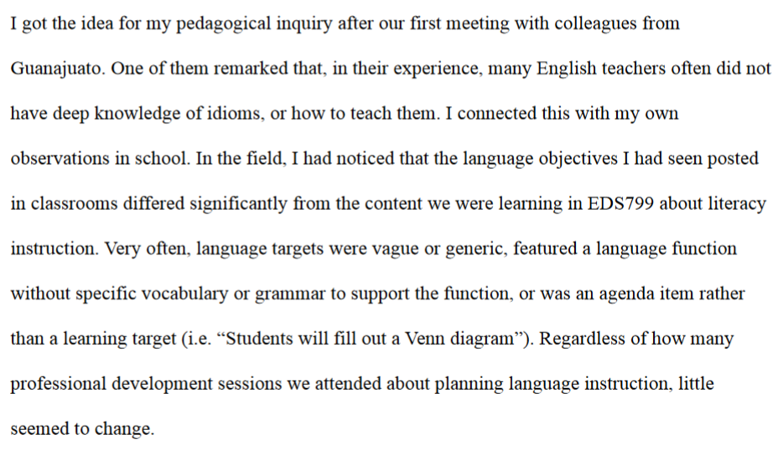
Sample 2:
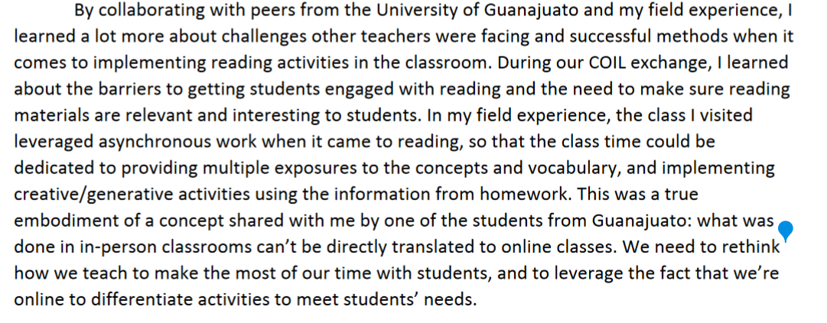
Sample 3:
